# INTODUCTION TO EXCEL

Excel 2016 supports 7 types of data types:

1. Whole Number
2. Decimal number
3. Text (only format which is aligned to left by default)
4. Boolean
5. Currency
6. Date
7. NA (Blank Field)

Some of the Data Source in excel are:

* File (TEXT, CSV, XML, JSON,)
* Databases (Microsoft, Oracle, Access, Analysis Services)
* Online services (Facebook, YouTube etc)
* Other sources (Wen, ODBC etc)

Important points:

* Formulas in excel can be entered only in cells with format “General” & Number.
* A cell with General format takes the format of referenced cell.
* Dates are stored as numbers within excel.
* If we enter a number in a cell having date format then that particular number will be converted to equivalent / corresponding date value.

Excel has following Tabs in the ribbon:

* File
* Home
* Insert
* Page Layout
* Formulas
* Data
* Review
* View
* Design
* Help

## CELL REFERENCE

There are two types of cell references in excel

1. Relative reference
2. Absolute reference

Relative and absolute references behave differently when copied and filled to other cells. Relative references change when a formula is copied to another cell. Absolute references, on the other hand, remain constant no matter where they are copied.

By default, all cell references are relative references. When copied across multiple cells, they change based on the relative position of rows and columns. For example, if you copy the formula =A1+B1 from row 1 to row 2, the formula will become =A2+B2. Relative references are especially convenient whenever you need to repeat the same calculation across multiple rows or columns.

An absolute reference is designated in a formula by the addition of a dollar sign ($). It can precede the column reference, the row reference, or both.

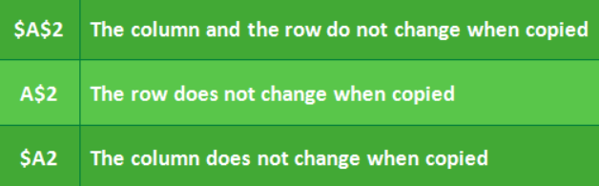

When writing a formula, you can press the F4 key on your keyboard to switch between relative and absolute cell references, as shown in the video below. This is an easy way to quickly insert an absolute reference.

## SHORTCUTS

Below are some important shortcuts in excel:

To edit a cell: F2

Delete dialogue box: SHIT + -

Add dialogue box: CTRL + SHIT + +

Hide the selected rows: Ctrl+ (

Hide the selected columns: Ctrl+)

Properties of cell: SHIFT + F10

Select current row: SHIFT + SPACE BAR

Select current column: CTRL+ SPACE BAR

Insert date: CTRL +:

Insert time: CTRL + SHIFT +:

Quick Analysis for selected cells: CTRL + Q

To copy formula down: CTRL + D

To copy formula across right: CTRL + R

To copy formula: F2 and then CTRL + Enter

Conditional formatting manager: ALT + O + D

Paste Special: CTRL + ALT + V

Formatting dialogue box: CTRL +!

General format: CTRL + SHIFT + ~

Number format: Ctrl + Shift+!

Time format: Ctrl + Shift+@

Date format: Ctrl + Shift+#

Currency format: Ctrl + Shift+$

Percentage format: Ctrl + Shift+%

Exponential number format: Ctrl + Shift+^

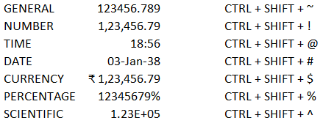

If we enter 000001, by default it will be changed to 1. Use ‘before entering numeric data. If we want 000001 then we will have to change it to text format using ‘.

## FORMATTING

Excel provides many options for displaying numbers as percentages, currency, dates, and so on. Below are the formatting options available in excel.

* General (Default format)
* Number
* Currency
* Accounting
* Date
* Time
* Percentage
* Fraction
* Scientific
* Text
* Special
* Custom format

### GENERAL FORMAT

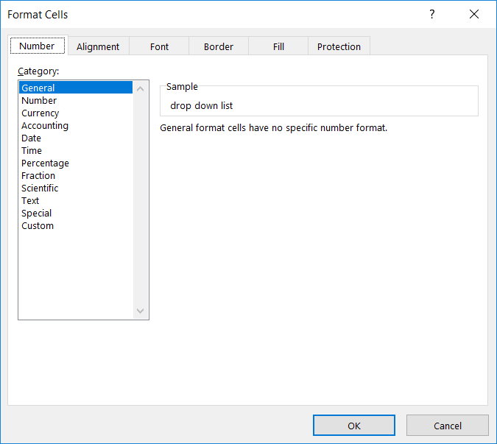

### NUMBER FORMAT

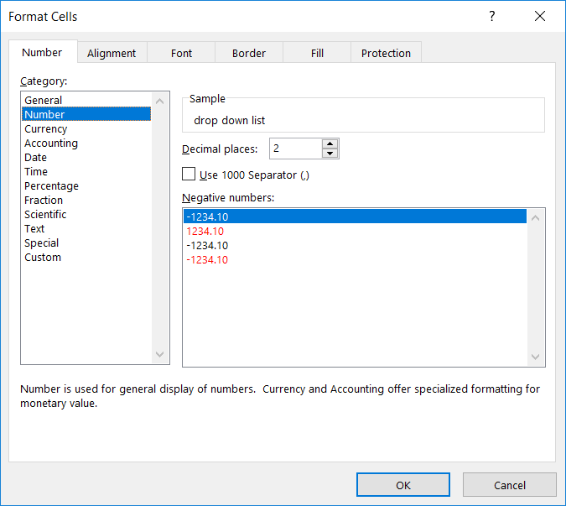

### CURRENCY FORMAT

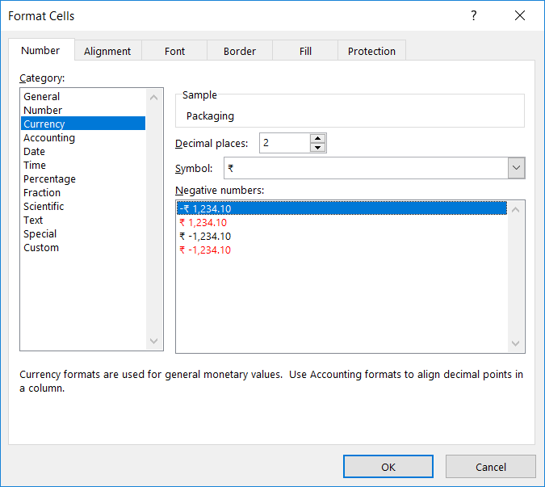

### ACCOUNTING FORMAT

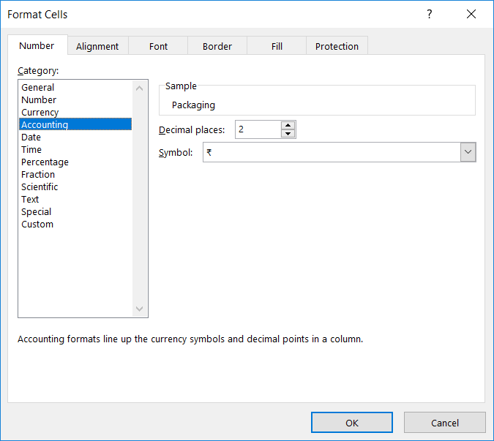

### DATE FORMAT

Dates are numbers in Excel. If the cell contains a year such as 2017 or 2018 etc it will be interpreted as 09/07/1905 and 10/07/1905 respectively.

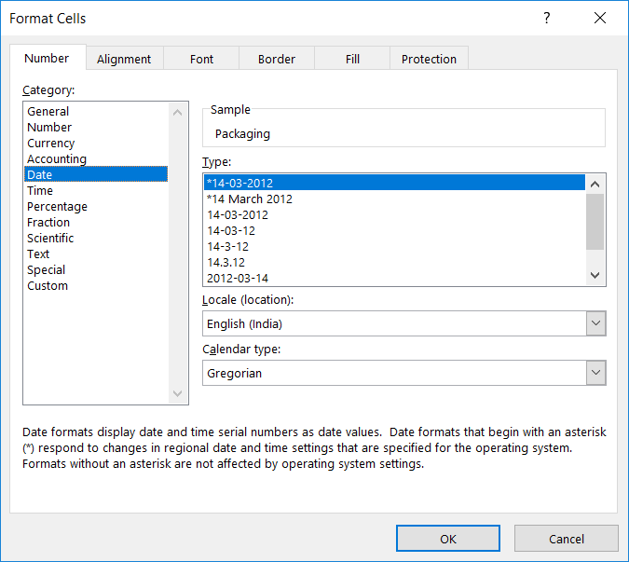

### TIME FORMAT

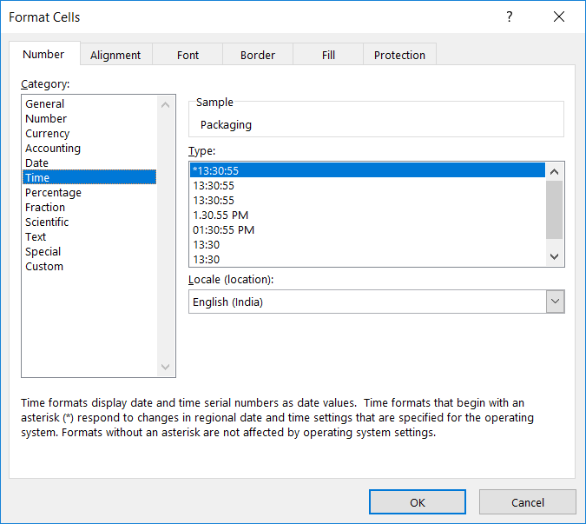

### PERCENTAGE FORMAT

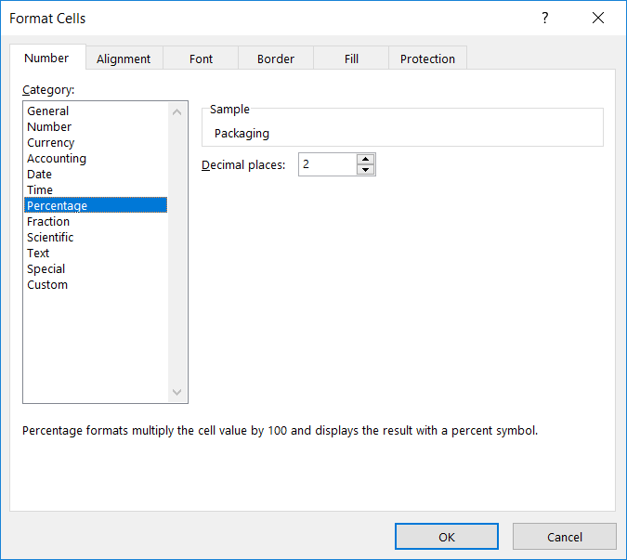

### FRACTION FORMAT

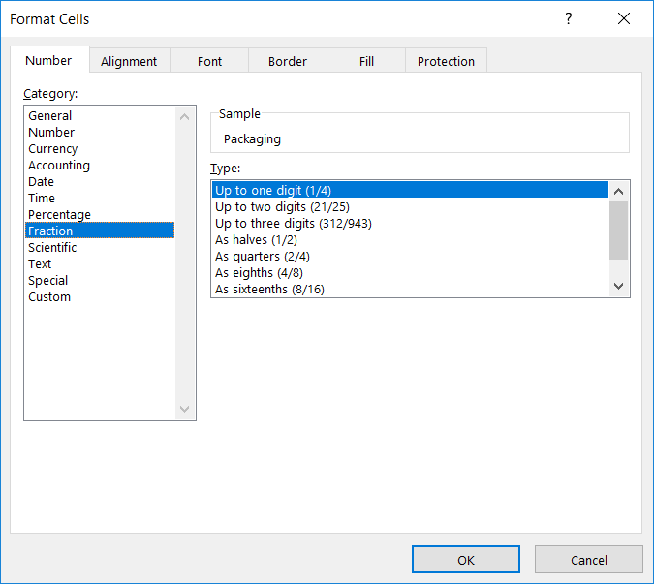

### SCIENTIFIC FORMAT

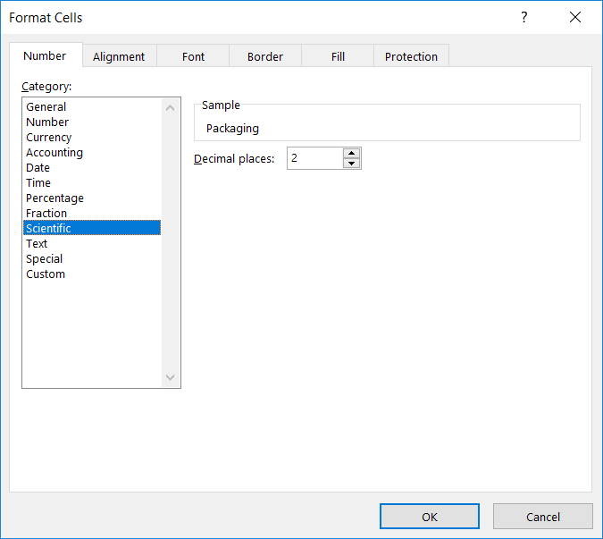

### TEXT FORMAT

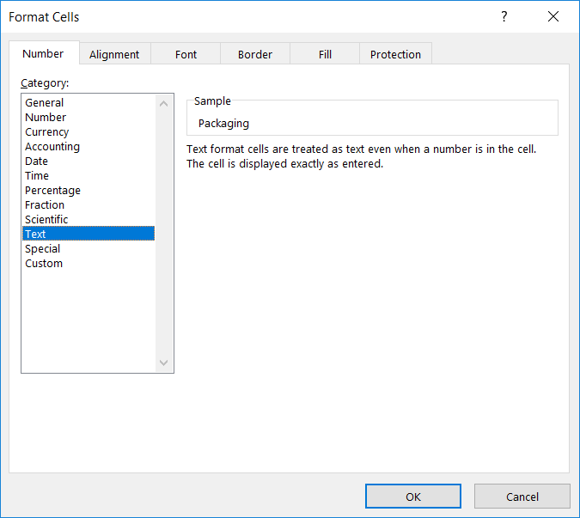

### SPECIAL FORMAT

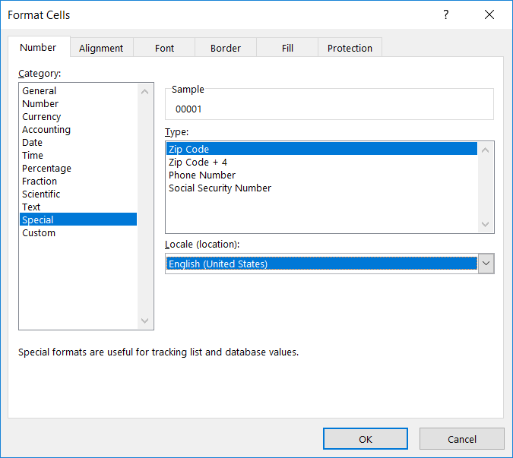

### CUSTOM FORMAT

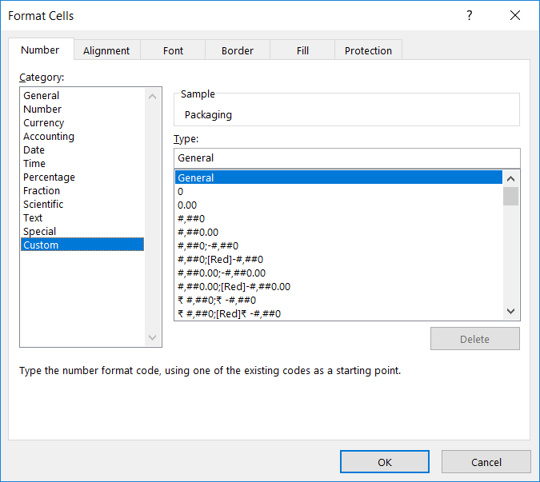

## CUSTOM FORMATTING

If built-in formats do not meet your needs, you can customize a built-in number format to create your own.

To create a custom number format, you start by selecting one of the built-in number formats as a starting point. You can then change any one of the code sections of that format to create your own custom number format.

A number format can have up to four sections of code, separated by semicolons. These code sections define the format for positive numbers, negative numbers, zero values, and text, in that order.

<POSITIVE>;<NEGATIVE>;<ZERO>;<TEXT>

You do not have to include all code sections in your custom number format. If you specify only two code sections for your custom number format, the first section is used for positive numbers and zeros, and the second section is used for negative numbers. If you specify only one code section, it is used for all numbers. If you want to skip a code section and include a code section that follows it, you must include the ending semicolon for the section that you skip.

### DIGITS AND PLACEHOLDERS

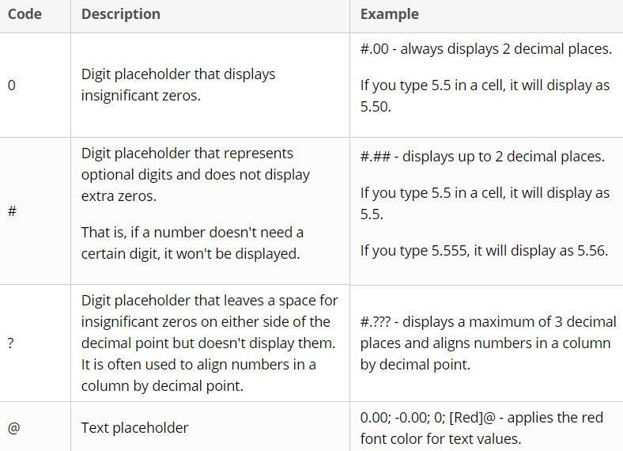

0 – Fixed place holder

# - Variable place holder

For example

0 and # before a decimal point will accommodate any number.

If we give 00 and we have input 1 then it will be displayed as 01

If we give 000 and we input 10 then it will be displayed as 010

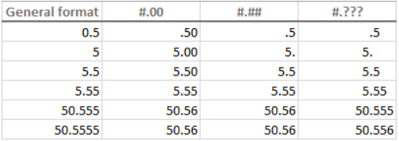

As you may have noticed in the above screenshot, the digit placeholders behave in the following way:

* If a number entered in a cell has more digits to the right of the decimal point than there are placeholders in the format, the number is "rounded" to as many decimal places as there are placeholders.

For example, if you type 2.25 in a cell with #.# format, the number will display as 2.3.

* All digits to the left of the decimal point are displayed regardless of the number of placeholders.

For example, if you type 202.25 in a cell with #.# format, the number will display as 202.3.

Below you will find a few more examples that will hopefully shed more light on number formatting in Excel.

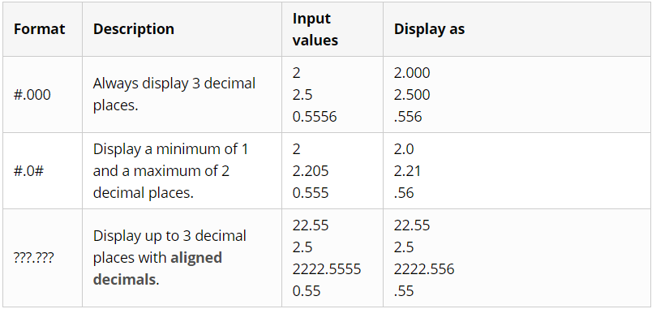

Theoretically, there are an infinite number of Excel custom number formats that you can make using a predefined set of formatting codes listed in the table below. And the following tips explain the most common and useful implementations of these format codes.

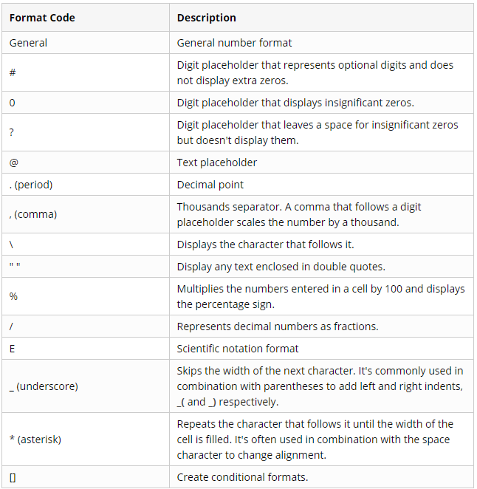

### CONTROLING THE NUMBER OF DECIMAL PLACES

The location of the decimal point in the number format code is represented by a period (.). The required number of decimal places is defined by zeros (0). For example:

0 or # - display the nearest integer with no decimal places.

0.0 or #.0 - display 1 decimal place.

0.00 or #.00 - display 2 decimal places, etc.

The difference between 0 and # in the integer part of the format code is as follows. If the format code has only pound signs (#) to the left of the decimal point, numbers less than 1 begin with a decimal point. For example, if you type 0.25 in a cell with #.00 format, the number will display as .25. If you use 0.00 format, the number will display as 0.25.

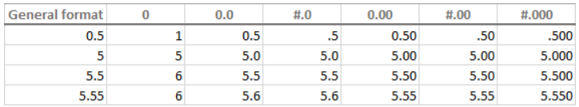

### HOW TO SHOW A THOUSAND SEPARATOR

To create an Excel custom number format with a thousand separator, include a comma (,) in the format code. For example:

Thousand separators without decimal:  OR 

Thousand separators with decimal:  OR 

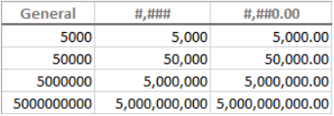

### ROUND NUMBERS BY THOUSAND, MILLION ETC

As demonstrated in the previous tip, Microsoft Excel separates thousands by commas if a comma is enclosed by any digit placeholders - pound sign (#), question mark (?) or zero (0). If no digit placeholder follows a comma, it scales the number by thousand, two consecutive commas scale the number by million, and so on.

A given number in Million: 

Custom thousand separator: 

For example, if a cell format is #.00, and you type 5000 in that cell, the number 5.00 is displayed. For more examples, please see the screenshot below:

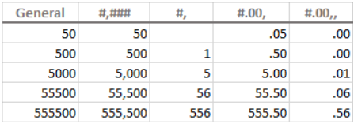

### TEXT AND SPACING IN CUSTOM EXCEL NUMBER FORMAT

To display both text and numbers in a cell, do the following:

* To add a single character, precede that character with a backslash (\).
* To add a text string, enclose it in double quotation marks (" ").

For example, to indicate that numbers are rounded by thousands and millions, you can add \K and \M to the format codes, respectively:

* To display thousands: #.00,\K
* To display millions: #.00,,\M

Tip: To make the number format better readable, include a space between a comma and backward slash.

The following screenshot shows the above formats and a couple more variations:

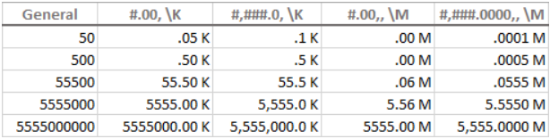

And here is another example that demonstrates how to display text and numbers within a single cell. Supposing, you want to add the word "Increase" for positive numbers, and "Decrease" for negative numbers. All you have to do is include the text enclosed in double quotes in the appropriate section of your format code:

#.00" Increase"; -#.00" Decrease"; 0

Tip: To include a space between a number and text, type a space character after the opening or before the closing quote depending on whether the text precedes or follows the number, like in "Increase ".

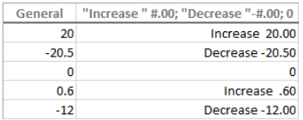

In addition, the following characters can be included in Excel custom format codes without the use of backslash or quotation marks:

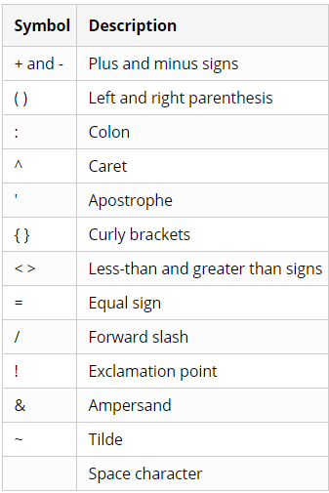

A custom Excel number format can also accept other special symbols such as currency, copyright, trademark, etc. These characters can be entered by typing their four-digit ANSI codes while holding down the ALT key. Here are some of the most useful ones:

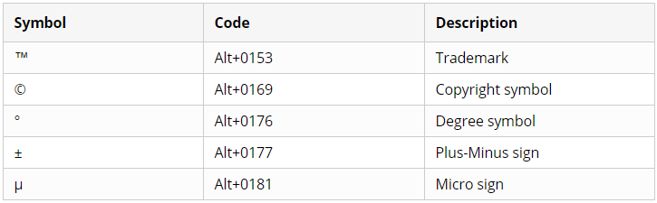

For example, to display temperatures, you can use the format code #"°F" or #"°C" and the result will look similar to this:

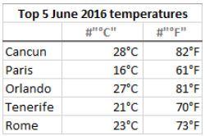

You can also create a custom Excel format that combines some specific text and the text typed in a cell. To do this, enter the additional text enclosed in double quotes in the 4th section of the format code before or after the text placeholder (@), or both.

For example, to proceed the text typed in the cell with some other text, say "Shipped in", use the following format code:

General; General; General; "Shipped in "@

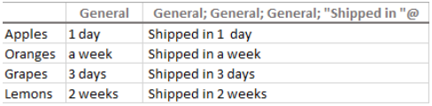

### INCLUDING CURRENCY SYMBOLS IN A CUSTOM NUMBER FORMAT

To create a custom number format with the dollar sign ($), simply type it in the format code where appropriate. For example, the format $#.00 will display 5 as $5.00.

Other currency symbols are not available on most of standard keyboards. But you can enter the popular currencies in this way:

* Turn NUM LOCK on, and
* Use the numeric keypad to type the ANSI code for the currency symbol you want to display.

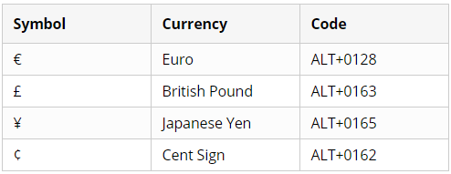

### PERCENTAGES IN EXCEL CUSTOM NUMBER FORMAT

To display a number as a percentage of 100, include the percent sign (%) in your number format.

For example, to display percentages as integers, use this format: #%. As the result, the number 0.25 entered in a cell will appear as 25%.

To display percentages with 2 decimal places, use this format: #.00%

To display percentages with 2 decimal places and a thousand separator, use this one: #,##.00%

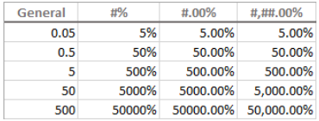

### FRACTIONS IN EXCEL NUMBER FORMAT

Fractions are special in terms that the same number can be displayed in a variety of ways. For example, 1.25 can be shown as 1 ¼ or 5/5.  Exactly which way Excel displays the fraction is determined by the format codes that you use.

For decimal numbers to appear as fractions, include **forward slash** (/) in your format code, and separate an integer part with a space. For example:

* **# #/#** - displays a fraction remainder with up to 1 digit.
* **# ##/##** - displays a fraction remainder with up to 2 digits.
* **# ###/###** - displays a fraction remainder with up to 3 digits.
* **###/###** - displays an improper fraction (a fraction whose numerator is larger than or equal to the denominator) with up to 3 digits.

To round fractions to a specific denominator, supply it in your number format code after the slash. For example, to display decimal numbers as eighths, use the following **fixed base** fraction format: **# #/8**

The following screenshot demonstrated the above format codes in action:

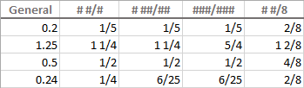

As you probably know, the predefined Excel [Fraction formats](https://www.ablebits.com/office-addins-blog/2016/07/01/excel-format-number-text/#fraction-format) align numbers by the fraction bar (/) and display the whole number at some distance from the remainder. To implement this alignment in your custom format, use the question mark placeholders (?) instead of the pound signs (#) like shown in the following screenshot:

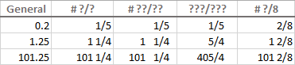

**Tip:** To enter a fraction in a cell formatted as *General*, preface the fraction with a zero and a space. For instance, to enter 4/8 in a cell, you type 0 4/8. If you type 4/8, Excel will assume you are entering a date, and change the cell format accordingly.

### CREATE A CUSTOM SCIENTIFIC NOTATION FORMAT

To display numbers in Scientific Notation format (Exponential format), include the capital letter **E**in your number format code. For example:

* **00E+00** - displays 1,500,500 as 1.50E+06.
* **#0.0E+0** - displays 1,500,500 as 1.5E+6
* **#E+#** - displays 1,500,500 as 2E+6

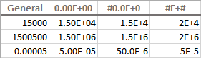

### SHOW NEGATIVE NUMBERS IN PARENTHESIS

At the beginning of this tutorial, we discussed the 4 code sections that make up an Excel number format: **Positive; Negative; Zero; Text**

Most of the format codes we've discussed so far contained just 1 section, meaning that the custom format is applied to all number types - positive, negative and zeros.

To make a custom format for negative numbers, you'd need to include at least 2 code sections: the first will be used for positive numbers and zeros, and the second - for negative numbers.

To show negative values in parenthesis, simply include them in the second section of your format code, for example: **#.00; (#.00)**

**Tip:** To line up positive and negative numbers at the decimal point, [add an indent](https://www.ablebits.com/office-addins-blog/2016/07/07/custom-excel-number-format/#Add-indents) to the positive values section, e.g. **0.00_); (0.00)**

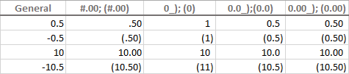

### DISPLAY ZEROES AS DASHES OR BLANKS

The built-in Excel [Accounting format](https://www.ablebits.com/office-addins-blog/2016/07/01/excel-format-number-text/#accounting-format) shows zeros as dashes. This can also be done in your custom Excel number format.

As you remember, the zero layout is determined by the 3rd section of the format code. So, to force zeros to appear as **dashes**, type **"-"** in that section. For example: **0.00;(0.00);"-"**

The above format code instructs Excel to display 2 decimal places for positive and negative numbers, enclose negative numbers in parenthesis, and turn zeros into dashes.

If you don't want any special formatting for positive and negative numbers, type *General* in the 1stand 2nd sections: **General; -General; "-"**

To turn zeroes into **blanks**, skip the third section in the format code, and only type the ending semicolon: **General; -General; ; General**

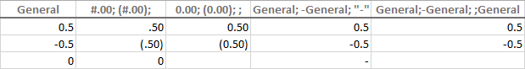

### ADD INDENTS WITH CUSTOM EXCEL FORMAT

If you don't want the cell contents to ride up right against the cell border, you can indent information within a cell. To add an indent, use the **underscore** (_) to create a space equal to the width of the character that follows it.

The commonly used indent codes are as follows:

* To indent from the left border: **_(**
* To indent from the right border: **_)**

Most often, the right indent is included in a positive number format, so that Excel leaves space for the parenthesis enclosing negative numbers.

For example, to indent positive numbers and zeros from the right and text from the left, you can use the following format code:

**0.00_);(0.00); 0_);_(@**

Or, you can add indents on both sides of the cell:

**_(0.00_);_((0.00);_(0_);_(@_)**

The indent codes move the cell data by one-character width. To move values from the cell edges by more than one-character width, include 2 or more consecutive indent codes in your number format. The following screenshot demonstrates indenting cell contents by 1 and 2 characters:  
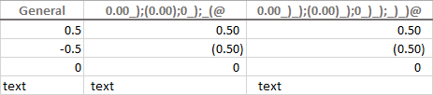

### CHANGE FONT COLOR WITH CUSTOM NUMBER FORMAT

Changing the font color for a certain value type is one of the simplest things you can do with a custom number format in Excel, which supports 8 main colors. To specify the color, just type one of the following color names in an appropriate section of your number format code.

|  |  |
| --- | --- |
| [Black] [Green] [White] [Blue] | [Magenta] [Yellow] [Cyan] [Red] |

**Note.** The color code must be the **first item** in the section.

For example, to leave the default General format for all value types, and change only the font color, use the format code similar to this:

**[Green]General; [Red]General; [Black]General; [Blue]General**

Or, combine color codes with the desired number formatting, e.g. display the [currency symbol](https://www.ablebits.com/office-addins-blog/2016/07/07/custom-excel-number-format/#currency-symbols), 2 [decimal places](https://www.ablebits.com/office-addins-blog/2016/07/07/custom-excel-number-format/#decimal-places), a thousand separator, and show [zeros as dashes](https://www.ablebits.com/office-addins-blog/2016/07/07/custom-excel-number-format/#zeros-as-dashes):

**[Blue]$#,##0.00; [Red]-$#,##0.00; [Black]"-"; [Magenta]@**

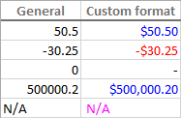

### REPEAT CHARACTERS WITH CUSTOM FORMAT CODES

To repeat a specific character in your custom Excel format so that it fills the column width, type an **asterisk** (*) before the character.

For example, to include enough equality signs after a number to fill the cell, use this number format: **#*=**

Or, you can include leading zeros by adding *0 before any number format, e.g. **\*0#**

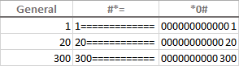

This formatting technique is commonly used to change cell alignment as demonstrated in the next formatting tip.

### CHANGING ALIGNMENT IN EXCEL WITH CUSTOM NUMBER FORMAT

A usual way to change alignment in Excel is using the *Alignment* tab on the ribbon. However, you can "hardcode" cell alignment in a custom number format if needed.

For example, to align numbers left in a cell, type an **asterisk** and a **space** after the number code, for example: "**#,###\***" (double quotes are used only to show that an asterisk is followed by a space, you don't need them in a real format code).

Making a step further, you could have numbers aligned left and text entries aligned right using this custom format:

**#,###* ; -#,###* ; 0* ;* @**

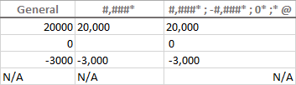

This method is used in the built-in Excel [Accounting format](https://www.ablebits.com/office-addins-blog/2016/07/01/excel-format-number-text/#accounting-format) . If you apply the Accounting format to some cell, then open the *Format Cells* dialog, switch to the *Custom* category and look at the *Type*box, you will see this format code:

**_($* #,##0.00_);_($* (#,##0.00);_($* "-"??_);_(@_)**

The asterisk that follows the currency sign tells Excel to repeat the subsequent space character until the width of a cell is filled.  This is why the Accounting number format aligns the currency symbol to the left, number to the right, and adds as many spaces as necessary in between.

### APPLY CUSTOM NUMBER FORMATS BASED ON CONDITIONS

To have your custom Excel format applied only if a number meets a certain condition, type the condition consisting of a comparison operator and a value, and enclose it in **square brackets** [].

For example, to displays numbers that are less than 10 in a red font color, and numbers that are greater than or equal to 10 in a green color, use this format code:

**[Red][<10];[Green][>=10]**

Additionally, you can specify the desired number format, e.g. show 2 decimal places:

**[Red][<10]0.00;[Green][>=10]0.00**

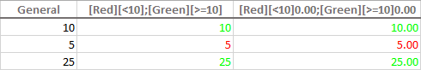

And here is another extremely useful, though rarely used formatting tip. If a cell [displays both numbers and text](https://www.ablebits.com/office-addins-blog/2016/07/07/custom-excel-number-format/#text-to-number), you can make a conditional format to show a noun in a singular or plural form depending on the number. For example:

**[=1]0" mile";0.##" miles"**

The above format code works as follows:

* If a cell value is equal to 1, it will display as "*1 mile*".
* If a cell value is greater than 1, the plural form "*miles*" will show up. Say, the number 3.5 will display as "*3.5 miles*".

Taking the example further, you can [display fractions](https://www.ablebits.com/office-addins-blog/2016/07/07/custom-excel-number-format/#numbers-into-fractions) instead of decimals:

**[=1]?" mile";# ?/?" miles"**

In this case, the value 3.5 will appear as "*3 1/2 miles*".

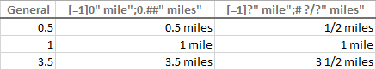

**Tip:** To apply more sophisticated conditions, use Excel's [Conditional Formatting](https://www.ablebits.com/office-addins-blog/2014/05/29/use-conditional-formatting-excel/) feature, which is specially designed to handle the task.

### DATES AND TIMES FORMATS IN EXCEL

Excel date and times formats are a very specific case, and they have their own format codes. For the detailed information and examples, please check out the following tutorials:

* [How to create a custom date format in Excel](https://www.ablebits.com/office-addins-blog/2015/03/11/change-date-format-excel/#custom-date-format)
* [How to create a custom time format in Excel](https://www.ablebits.com/office-addins-blog/2015/06/23/excel-time-format-now-time-functions/#custom-time-format)

Well, this is how you can change number format in Excel and create your own formatting. Finally, here's a couple of tips to quickly apply your custom formats to other cells and workbooks:

A custom Excel format is **stored in the workbook** in which it is created and is not available in any other workbook. To use a custom format in a new workbook, you can save the current file as a template, and then use it as the basis for a new workbook.

To apply a custom format to other cells in a click, save it as an **Excel style** - just select any cell with the required format, go to the *Home* tab > *Styles* group, and click *New Cell Style.*

## CONDITIONAL FORMATTING

Let's say you have a worksheet with thousands of rows of data. It would be extremely difficult to see patterns and trends just from examining the raw information. Similar to charts and sparklines, conditional formatting provides another way to visualize data and make worksheets easier to understand.

Conditional formatting allows you to automatically apply formatting—such as colors, icons, and data bars—to one or more cells based on the cell value. To do this, you'll need to create a conditional formatting rule. Below screenshot shows the options available

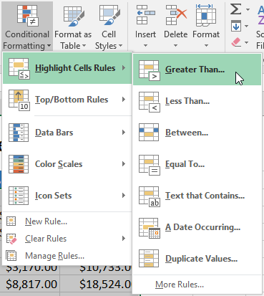

The conditional formatting will be applied to the selected cells. You can apply multiple conditional formatting rules to a cell range or worksheet, allowing you to visualize different trends and patterns in your data.

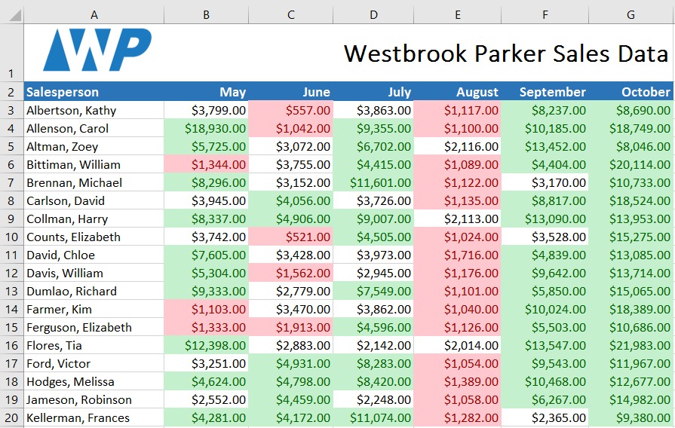

Excel has several predefined styles or presets you can use to quickly apply conditional formatting to your data. They are grouped into three categories:

Data Bars are horizontal bars added to each cell, much like a bar graph

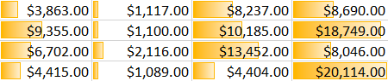

Color Scales change the color of each cell based on its value. Each color scale uses a two- or three-color gradient. For example, in the Green-Yellow-Red color scale, the highest values are green, the average values are yellow, and the lowest values are red.

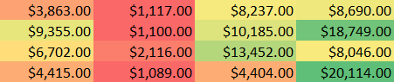

Icon Sets add a specific icon to each cell based on its value.

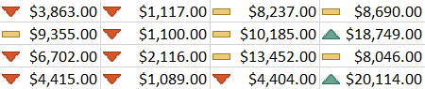

### REMOVING CONDITIONAL FORMATTING

To remove conditional formatting:

Click the Conditional Formatting command. A drop-down menu will appear.

Hover the mouse over Clear Rules and choose which rules you want to clear. In our example, we'll select Clear Rules from Entire Sheet to remove all conditional formatting from the worksheet.

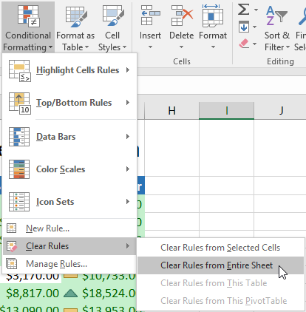

Click Manage Rules to edit or delete individual rules. This is especially useful if you've applied multiple rules to a worksheet.

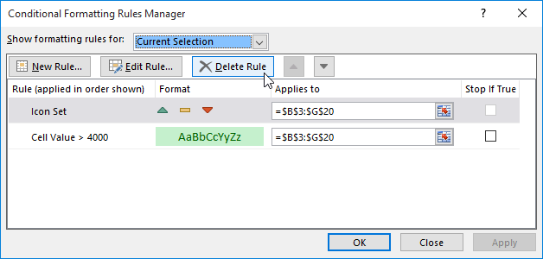

### CONDITIONAL FORMATTING WITH FORMULAS

For example, if you want to highlight cells equal to "apple" or "kiwi" or "lime"? Sure, you can create a rule for each value, but that's a lot of trouble. Instead, you can simply use one rule based on a formula with the OR function:

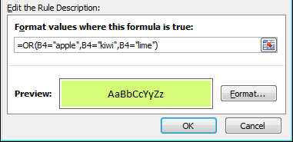

Here's the result of the rule applied to the range B4:F8 in this spreadsheet:

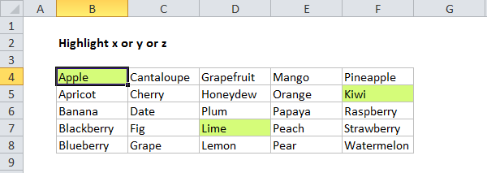

# TABLE

Before creating TABLE check:

* What type of data do we have? Same data types in same column or not?
* Is data in order?
* Are there any blank values in data?
* Is data properly formatted and aligned?
* Is data having proper headings?

After verifying data, select the data range and press CTRL + T to create table

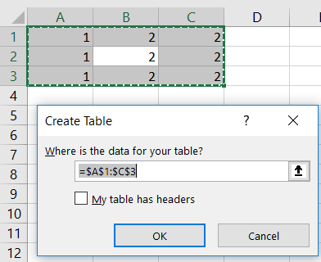

And then a table will be created as show below. As we can see our data was not having headers hence excel has given unique default headers.

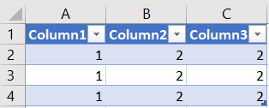

# SORTING DATA

In Excel, you can quickly sort your data by using the A-Z and Z-A Sort buttons on the Ribbon's Data tab. But, be careful, or one column may be sorted, while others are not.

Only use this technique if there are no blank rows or columns within the data.

* Select one cell in the column you want to sort.
* On the Excel Ribbon, click the Data tab.
* Click Sort A to Z (smallest to largest) or Sort Z to A (largest to smallest)

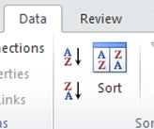

* Before you do anything else, check the data, to ensure that the rows have sorted correctly. If things look wrong, immediately click the Undo button on the toolbar. go to top

## PROBLEMS WITH SORTING EXCEL DATA

When you quickly sort data with the A-Z or Z-A button, things can go horribly wrong. If there is a blank row or blank columns within the data, part of the data might be sorted, while other data is ignored. Imagine the mess you'll have, if names and phone number no longer match, or if orders go to the wrong customers!

Follow these steps to help prevent problems when sorting Excel data:

* Select one cell in the column you want to sort.
* Press Ctrl + A, to select the entire region.
* Check the selected area, to make sure that all the data is included. For example, in the screen shot below, hidden column E is blank, so columns at the left are not selected.

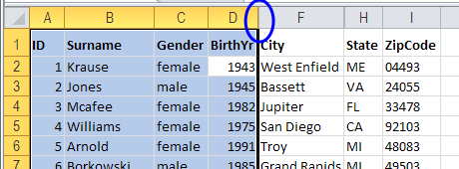

* If all the data was not selected, fix any blank columns or rows, and try again. Or, use the Sort Dialog box, as described in the next section.
* If all the data is selected, click Sort A to Z (smallest to largest) or Sort Z to A (largest to smallest)
* Before you do anything else, check the data, to ensure that the rows have sorted correctly. If things look wrong, click the Undo button on the toolbar. alt="undo button” go to top.

## SORT TWO OR MORE COLUMNS

If you want to sort 2 or more columns in an Excel table, you can use the Sort dialog box. In this example, we'll sort a table with personal data. First, the data will be sorted by Gender, then by State, and then by Birth Year.

* Select all the cells in the list.

This is the safest approach to sorting. In most cases, you can select one cell and Excel will correctly detect the rest of the list -- but it's not 100% certain. Some of the data may be missed.

* On the Excel Ribbon, click the Data tab.
* In the Sort & Filter group, click the Sort button.

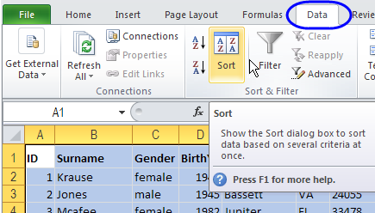

* Click the Add Level button, to add the first sorting level.
* From the Sort by dropdown, select the first column you want to sort. In this example, Gender will be the first column sorted.

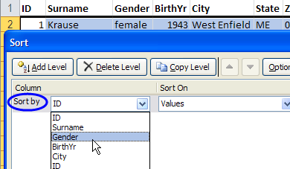

Note: If the dropdown is showing Column letters instead of headings, add a check mark to My data has headers.

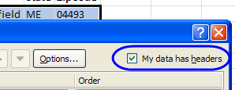

From the Sort On drop down, select the option that you want. We're sorting on the values in the Gender column, so leave the default setting of Values.



Next, from the Order drop down, select one of the options. The list of Order options will depend on what you selected in the Sort On column. Because we selected values, the Order options are A to Z, Z to A and Custom List. We'll select A to Z.

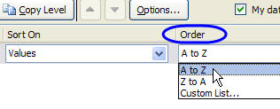

If you are sorting on multiple columns, click the Add Level button, to add the next level, and select options from its drop-down boxes.

Here we have selected Gender, State and BirthYr as the sort fields, and all are sorted on Values. Because the BirthYr column contains only numbers, its Order options are slightly different from the text column options.

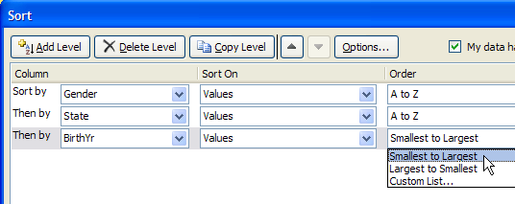

After you have selected all the Sort levels, and their options, click OK.

* The data will be sorted in the order that you specified. In the screen shot below:
* Gender column is sorted first, so all the female names are at the top.
* Next, the State column is sorted, so females from Alabama are at the top of the list.
* Finally, the BirthYr is sorted, with the earliest birth years at the top of each state.



## SORT IN A CUSTOM ORDER

In the Sort dialog box, or on the Excel Ribbon, you can select a sort order, such as A to Z, or Largest to Smallest. In addition to these standard options, you can sort in a custom order, such as month order, or weekday order. In this example, we'll sort a column with weekday names, using the Excel Ribbon command.

To sort in a custom order, follow these steps:

* Select one cell in the column you want to sort.
* Press Ctrl + A, to select the entire region.
* Check the selected area, to make sure that all the data is included.
* On the Excel Ribbon, click the Home tab
* In the Editing group, click the arrow on Sort & Filter.
* Click Custom Order.

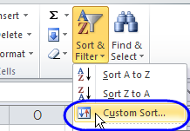

* In the Sort dialog box, select the Day column in the Sort By box.
* From the Order drop down, select Custom List.

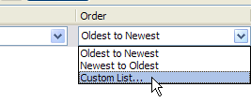

* In the Custom dialog box, select a custom list and then click OK, twice, to close the dialog boxes.

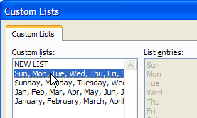

The Day column is sorted in weekday order, instead of alphabetical order, so Sunday appears at the top of the list.

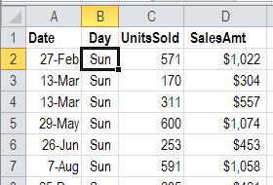

## SORTING A ROW

Instead of sorting your data by columns, you can sort the data by row. In this example, we'll sort a table of monthly sales, so the month with the largest sales total is at the left. To do this, we'll use a right-click popup menu.

To sort by a row, follow these steps:

* Select one cell in the row you want to sort.
* Press Ctrl + A, to select the entire region.
* Check the selected area, to make sure that all the data is included.
* Right-click a cell in the row that you want to sort
* In the popup menu, click Sort, then click Custom Sort.

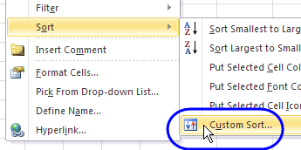

* In the Sort dialog box, select the Day column in the Sort By box.
* From the Order drop down, select Custom List.
* At the top of the Sort dialog box, click Options.

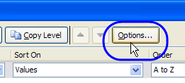

* In the Options dialog box, under Orientation, select Sort Left to Right.

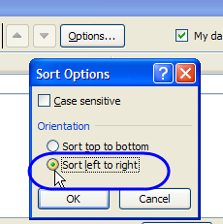

* Click OK, to close the Options dialog box.
* From the Sort By drop down, select the row that you want to sort. There are no headings available, so select the correct Row number.

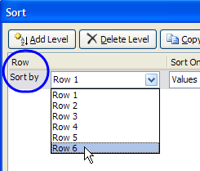

* Select the Sort On, and the Order options, then click OK.

The data is sorted by the values in the selected row. go to top

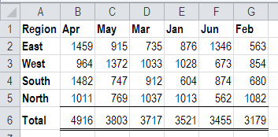

# FILTERING DATA

Excel Filter, aka AutoFilter, is a quick way to display only the information relevant at a given time and remove all other data from view. You can filter rows in Excel worksheets by value, by format and by criteria. After applying a filter, you can copy, edit, chart or print only visible rows without rearranging the entire list.

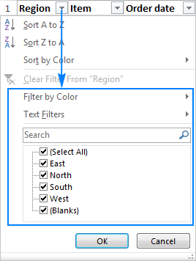

## EXCEL FILTER VS. EXCEL SORT

Apart from numerous filtering options, Excel AutoFilter provides the Sort options relevant to a given column:

* For text values: Sort A to Z, Sort Z to A, and Sort by Color.
* For numbers: Sort Smallest to Largest, Sort Largest to Smallest, and Sort by Color.
* For dates: Sort Oldest to Newest, Sort Newest to Oldest, and Sort by Color.

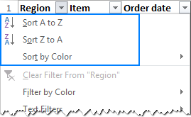

The difference between sorting and filtering in Excel is as follows:

* When you sort data in Excel, the entire table is rearranged, for example alphabetically or from the lowest to the highest value. However, sorting does not hide any entries, it only puts the data into a new order.
* When you filter data in Excel, only the entries you actually want to see are displayed, and all irrelevant items are temporarily removed from view.

## ADDING FILTER IN EXCEL

For Excel AutoFilter to work correctly, your data set should include a header row with the column names like shown in the screenshot below:

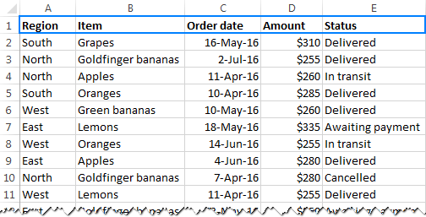

Once the column headings are in pace, select any cell within your dataset, and use one of the following methods to insert filter.

## 3 WAYS TO ADD FILTER IN EXCEL

On the Data tab, in the Sort & Filter group, click the Filter button.

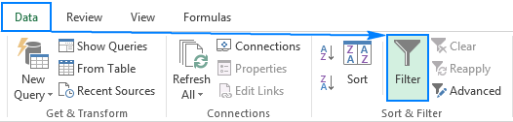

On the Home tab, in the Editing group, click Sort & Filter > Filter.

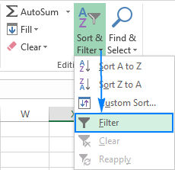

Use the Excel Filter shortcut to turn the filters on/off: Ctrl + Shift + L

Whatever method you use, the drop-down arrows will appear in each of the header cells:

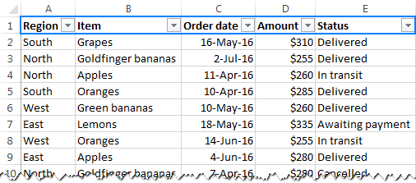

## HOW TO APPLY FILTER IN EXCEL

A drop-down arrow A drop-down arrow in the column heading means that filtering is added, but not applied yet. When you hover over the arrow, a screen tip display’s (Showing All).

To filter data in Excel, do the following:

* Click the drop-down arrow for the column you want to filter.
* Uncheck the Select All box to quickly deselect all data.
* Check the boxes next to the data you want to display, and click OK.

For example, this is how we can filter data in the Region column to view sales only for East and North:



The drop-down arrow in the filtered column changes to the Filter button Filter button, and hovering over that button displays a screen tip indicating which filters are applied:

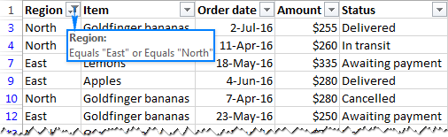

## FILTER MULTIPLE COLUMNS

To apply Excel filter to multiple columns, just repeat the above steps for as many columns as you want.

For example, we can narrow down our results to only show Apples for the East and North regions. When you apply multiple filters in Excel, the filter button appears in each of the filtered columns:

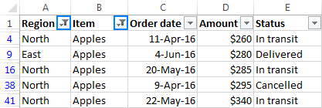

Tip. To make the Excel Filter window wider and/or longer, hover over the grip handle at the bottom, and as soon as the double-headed arrow appears, drag it down or to the right.

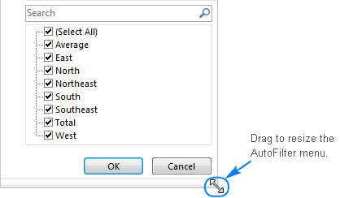

## FILTER TEXT DATA

When you want to filter a text column for something very specific, you can leverage a number of advanced options provided by Excel Text Filters such as:

* Filter cells that begin with or end with a specific character(s).
* Filter cells that contain or do not contain a given character or word anywhere in the text.
* Filter cells that are exactly equal or not equal to a specified character(s).

As soon as you add a filter to a column containing text values, Text Filters will appear automatically in the AutoFilter menu:

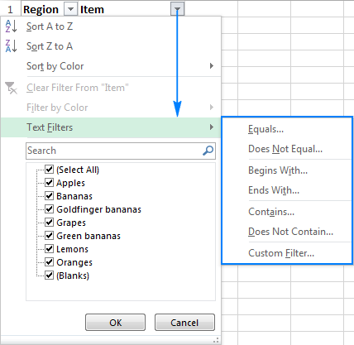

For instance, to filter out rows containing Bananas, do the following:

* Click the drop-down arrow in the column heading, and point to Text Filters.
* In the drop-down menu, select the desired filter (Does Not Contain… in this example).
* The Custom AutoFilter dialog box will show up. In the box to the right of the filter, type the text or select the desired item from the dropdown list.
* Click OK.

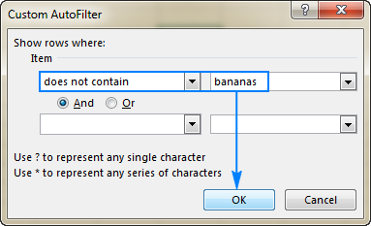

As the result, all of the Bananas rows, including Green bananas and Goldfinger bananas, will be hidden.

## FILTER COLUMN WITH 2 CRITERIA

To filter data in Excel with two text criteria, perform the above steps to configure the first criteria, and then do the following:

* Check And or Or radio button depending on whether both or either criterion should be true.
* Select the comparison operator for the second criterion, and enter a text value in the box right to it.

For example, this is how you can filter rows that contain either Bananas or Lemons:



## FILTER NUMBERS IN EXCEL

Excel's Number Filters allow you to manipulate numeric data in a variety of ways, including:

* Filter numbers equal or not equal to a certain number.
* Filter numbers, greater than, less than or between the specified numbers.
* Filter top 10 or bottom 10 numbers.
* Filter cells with numbers that are above average or below average.

The following screenshot shows the whole list of number filters available in Excel.

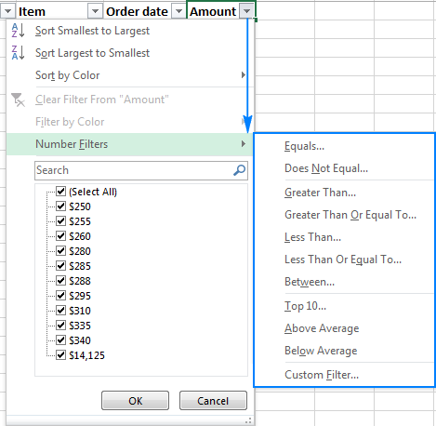

## FILTER DATES IN EXCEL

Excel Date Filters provide the greatest variety of choices that let you filter records for a certain time period quickly and easily.

By default, Excel AutoFilter groups all dates in a given column by a hierarchy of years, months, and days. You can expand or collapse different levels by clicking the plus or minus signs next to a given group. Selecting or clearing a higher-level group selects or clears data in all nested levels. For instance, if you clear the box next to 2016, all dates within the year 2016 will be hidden.

In addition, Date Filters allow you to display or hide data for a particular day, week, month, quarter, year, before or after a specified date, or between two dates. The screenshot below demonstrates all available date filters:

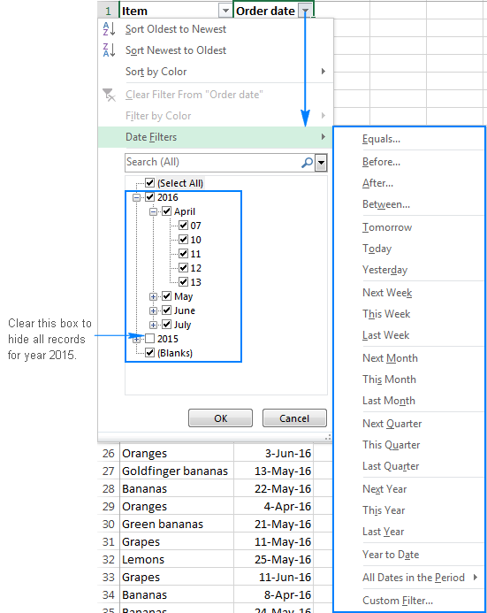

In most cases, Excel filter by date works in a single click. For instance, to filter rows containing records for the current week, you simply point to Date Filters and click This Week.

If you select the Equals, Before, After, Between operator or Custom Filter, the already familiar Custom AutoFilter dialog window will show up, where you specify the desired criteria.

For example, to display all items for the first 10 days of April 2016, click Between… and configure the filter in this way:

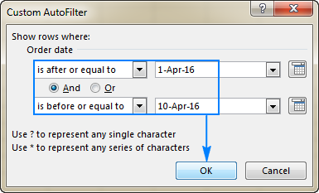

## RE-APPLY A FILTER AFTER CHANGING DATA

When you edit or delete data in filtered cells, Excel AutoFilter does not update automatically to reflect the changes. To re-apply the filter, click any cell within your dataset, and then either:

Click Reapply on the Data tab, in the Sort & Filter group.

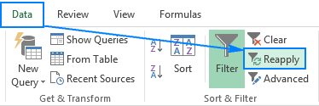

Click Sort & Filter > Reapply on the Home tab, in the Editing group.

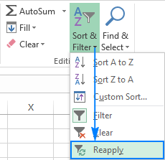

## REMOVE FILTER IN EXCEL

After applying a filter to a certain column, you may want to clear it in order to filter the data in another way.

To clear filter in Excel, do any of the following.

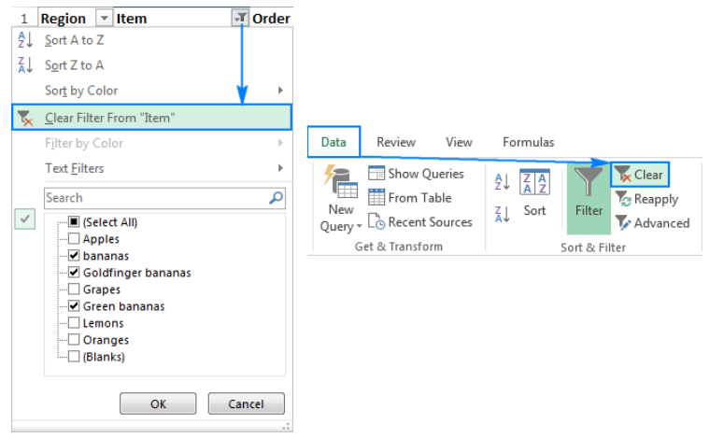

# FUNCTIONS AND FORMULAS

Some important functions in excel are as follows.

## VLOOKUP

VLOOKUP is an Excel function to look up and retrieve data from a specific column in table. VLOOKUP supports approximate and exact matching, and wildcards (*?) for partial matches. The "V" stands for "vertical".

* Lookup a value in a table by matching on the first column.
* Lookup values must appear in the first column of the table, with lookup columns to the right.
* VLOOKUP function cannot return values from left to the 1st column.
* VLOOKUP is designed to retrieve data in a table organized into vertical rows.

Syntax for VLOOKUP function is



Range_lookup is an optional argument. A logical value that specifies whether you want HLOOKUP to find an exact match or an approximate match. If TRUE or omitted, an approximate match is returned. In other words, if an exact match is not found, the next largest value that is less than lookup_value is returned. If FALSE, HLOOKUP will find an exact match. If one is not found, the error value #N/A is returned.

Use VLOOKUP when the lookup_value is along column i.e. when your comparison values are located in a column to the left of the data you want to find.

## LOOKUP

Use LOOKUP, one of the lookup and reference functions, when you need to look in a single row or column and find a value from the same position in a second row or column.

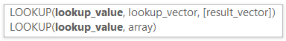

## HLOOKUP

HLOOKUP is an Excel function to look up and retrieve data from a specific row in table. The "H" in HLOOKUP stands for "horizontal", where lookup values appear in the first row of the table, moving horizontally to the right. HLOOKUP supports approximate and exact matching, and wildcards (* ?) for finding partial matches.



Use HLOOKUP If you have data organized horizontally.

## INDEX

An INDEX formula returns a cell reference from within a given array or range. In other words, you use INDEX when you know (or can calculate) the position of an element in a range and you want to get the actual value of that element.

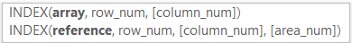

There are two versions of the INDEX function in Excel - array form and reference form.

The INDEX **array form** returns the value of an element in a table or an array based on the row and column numbers you specify.

INDEX array form - things to remember

* If the array argument consists of only one row or column, you may or may not specify the corresponding row_num or column_num argument.
* If the array argument includes more than one row and row_num is omitted or set to 0, the Excel INDEX function returns an array of the entire column. Similarly, if array includes more than one column and the column_num argument is omitted or set to 0, the INDEX formula returns the entire row. Here's a formula example that demonstrates this behaviour.
* The row_num and column_num arguments must refer to a cell within array; otherwise, the INDEX formula will return the #REF! error.

The INDEX **reference form** of the Excel INDEX function returns the cell reference at the intersection of the specified row and column.

* Reference - is one or several ranges.
* If you are entering more than one range, separate the ranges by commas and enclose the reference argument in parentheses, for example (A1:B5, D1:F5).
* If each range in reference contains only one row or column, the corresponding row_num or column_num argument is optional.
* row_num - the row number in the range from which to return a cell reference, it's similar to the array form.
* column_num - the column number from which to return a cell reference, also works similarly to the array form.
* area_num - an optional parameter that specifies which range from the reference argument to use. If omitted, the INDEX formula will return the result for the first range listed in reference.

For example

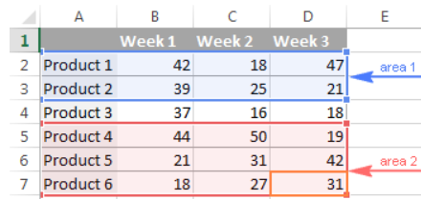

The formula =INDEX((A2:D3, A5:D7), 3, 4, 2) returns the value of cell D7, which is at the intersection of the 3rd row and 4th column in the second area (A5:D7).

INDEX formula can be used to filter rows based on multiple criteria and then find sum of the column values of matching rows. Below formula can be used

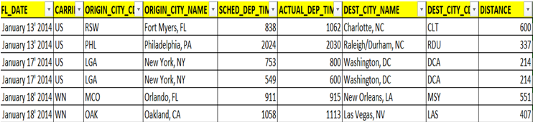





Below formula can be used to return the matching values from that array

=IF(ROWS(AWorking!D$7:D7)>COUNTIF(Data!$B$2:$B$7,AWorking!$B$2),"",INDEX(Data!$I$2:$I$7,SMALL(IF(Data!$B$2:$B$7=AWorking!$B$2,IF(Data!$D$2:$D$7=AWorking!$B$4,IF(Data!$G$2:$G$7=AWorking!$D$4,IF(Data!$A$2:$A$7=AWorking!$D$2,ROW(Data!$B$2:$B$7)-1)))),ROWS(AWorking!D$7:D7))))

## MATCH

In Microsoft Excel, there are many different lookup/reference functions that can help you find a certain value in a range of cells, and MATCH is one of them. Basically, it identifies a relative position of an item in a range of cells. However, the Excel MATCH function can do much more than its pure essence.



Match_type (optional) - defines the match type. It can be one of these values: 1, 0, -1. The Match_type argument set to 0 returns only the exact match, while the other two types allow for approximate match.

* 1 or omitted (default) - find the largest value in the lookup array that is less than or equal to the lookup value. Requires sorting the lookup array in ascending order, from smallest to largest or from A to Z.
* 0 - find the first value in the array that is exactly equal to the lookup value. No sorting is required.
* -1 - find the smallest value in the array that is greater than or equal to the lookup value. The lookup array should be sorted in descending order, from largest to smallest or from Z to A.

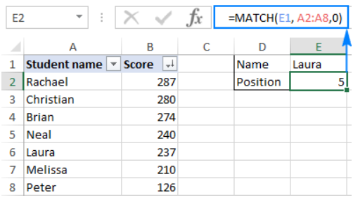

There are a few specificities that you should be aware of:

* The MATCH function returns the **relative position** of the lookup value in the array, not the value itself.
* MATCH is case-insensitive, meaning it does not distinguish between lowercase and uppercase characters when dealing with text values.
* If the lookup array contains several occurrences of the lookup value, the position of the first value is returned.
* If the lookup value is not found in the lookup array, the #N/A error is returned.

Like many other Excel functions, MATCH understands the following wildcard characters:

* Question mark (?) - replaces any single character
* Asterisk (*) - replaces any sequence of characters

Wildcards can only be used in Match formulas with Match_type set to 0.

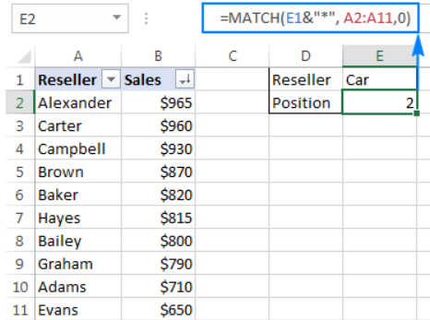

As mentioned in the beginning of this tutorial, the Excel MATCH function doesn't distinguish uppercase and lowercase characters. To make a case-sensitive Match formula, use MATCH in combination with the EXACT function that compares cells exactly, including the character case.

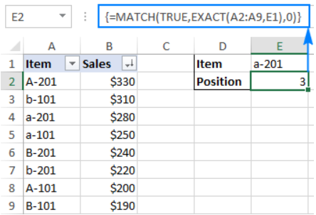

## OFFSET

OFFSET function returns a cell reference to a range that is offset from a starting cell or a range of cells by a specified number of rows and columns.



The first 3 arguments are required and the last 2 are optional. All of the arguments can be references to other cells or results returned by other Excel formulas.

Required arguments:

* Reference - a cell or a range of adjacent cells from which you base the offset. You can think of it as the starting point.
* Rows - The number of rows to move from the starting point, up or down. If rows is a positive number, the formula moves below the starting reference, in case of a negative number it goes above the starting reference.
* Cols - The number of columns you want the formula to move from the starting point. As well as rows, cols can be positive (to the right of the starting reference) or negative (to the left of the starting reference).

Optional arguments:

* Height - the height, in number of rows, of the returned reference.
* Width - the width, in number of columns, of the returned reference.

Both the height and width arguments must always be positive numbers. If either is omitted, the height or width of the starting reference is used.

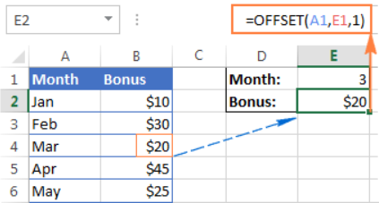

Excel OFFSET formulas - things to remember

* The OFFSET function is Excel doesn't actually move any cells or ranges, it just returns a reference.
* When an OFFSET formula returns a range of cells, the rows and cols arguments always refer to the upper-left cell in the returned rage.
* The reference argument must include a cell or range of adjacent cells, otherwise your formula will return the #VALUE! error.
* If the specified rows and/or cols move a reference over the edge of the spreadsheet, your Excel OFFSET formula will return the #REF! error.
* The OFFSET function can be used within any other Excel function that accepts a cell / range reference in its arguments.

For example, if you try to use the formula =OFFSET(A1,3,1,1,3) on its own, it will throw a #VALUE! error, since a range to return (1 row, 3 columns) does not fit into a single cell. However, if you embed it into the SUM function, like this:

=SUM(OFFSET(A1,3,1,1,3))

The formula will return the sum of values in a 1-row by 3-column range that is 3 rows below and 1 column to the right of cell A1, i.e. the total of values in cells B4:D4.

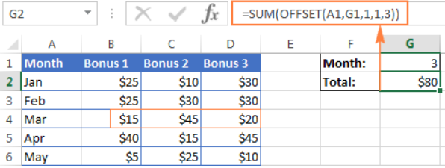

The Excel OFFSET formula is very good for:

* Creating dynamic ranges: References like B1:C4 are static, meaning they always refer to a given range. But some tasks are easier to perform with dynamic ranges. This is particularly the case when you work with changing data, e.g. you have a worksheet where a new row or column is added every week.
* Getting the range from the starting cell. Sometimes, you may not know the actual address of the range, though you do know it starts from a certain cell. In such scenarios, using OFFSET in Excel is the right way to go.

OFFSET for creating dynamic range (if your data does not contain header) via named range

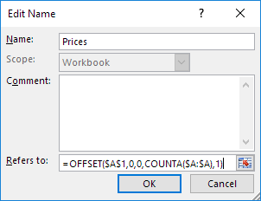

OFFSET formula can be used for dynamic SUM

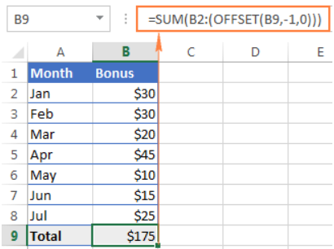

OFFSET formula can be used to sum the last N rows as shown below

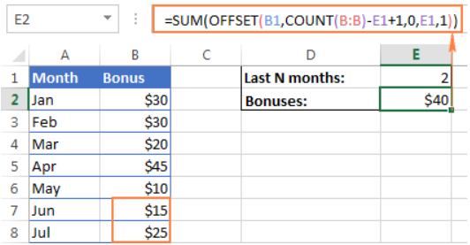

Used in conjunction with COUNTA, the OFFSET function can help you make a dynamic range that may prove useful in many scenarios, for example to create automatically updatable drop-down lists.



Where

* Reference is the starting point from which you base the offset, for example Sheet1!$A$1.
* Rows and Cols are both 0 because there are no columns or rows to offset.
* Width is 1 column.

One of the most infamous limitations of the Excel VLOOKUP function is inability to look at its left, meaning that VLOOKUP can only return a value to the right of the lookup column.

To handle a left-side lookup, you need a more versatile function that does not really care where the return column resides. One of possible solutions is using a combination of INDEX and MATCH functions. Another approach is using OFFSET, MATCH and ROWS.

## IF

The IF function can perform a logical test and return one value for a TRUE result, and another for a FALSE result. For example, to "pass" scores above 70: =IF(A1>70,"Pass","Fail").



More than one condition can be tested by nesting IF functions. The IF function can be combined with logical functions like AND & OR.





## SUMIF

The SUMIF function, also known as Excel conditional sum, is used to add cells based on a certain condition, or criteria.



If you aim to conditionally sum cells based on a “text” criterion and you want to sum by partial match, then you need to use wildcard characters in your SUMIF formula.

The following wildcards are available to us:

* Asterisk (*) - represents any number of characters
* Question mark (?) - represents a single character in a specific position

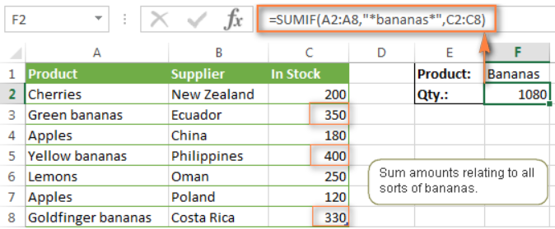

To use wildcards with cell references, combine them with the help of the concatenation operator (&). In this example, you could also use the following formula to sum all "bananas" in stock:

SUMIF (A2:A8, "*"&F1&"*", C2:C8)

To find a literal question mark or asterisk, use a tilde (~) in front question mark or asterisk (i.e. ~?, ~*).

## SUMIFS

SUMIFS is a function to sum cells that meet multiple criteria. SUMIFS can be used to sum values when adjacent cells meet criteria based on dates, numbers, and text. SUMIFS supports logical operators (>, <, <>, =) and wildcards (*,?) for partial matching.

Usage notes:

* Each additional range must have the same number of rows and columns as the sum_range.
* Non-numeric criteria must be enclosed in double quotes, but numeric criteria don’t need quotes except with operators, i.e. ">32"
* The wildcard characters? and * can be used in criteria. A question mark matches any one character and an asterisk matches any sequence of characters.
* To find a literal question mark or asterisk, use a tilde (~) in front question mark or asterisk (i.e. ~?, ~*).
* SUMIF and SUMIFS can handle ranges, but not arrays. This means you can't use other functions like YEAR on the criteria range, since the result is an array. If you need this functionality, use the SUMPRODUCT function.
* The order of arguments is different between the SUMIFS and SUMIF functions. Sum_range is the first argument in SUMIFS, but the third argument in SUMIF.

## SUMPRODUCTS

The SUMPRODUCT function in Excel multiplies the numbers in the specified arrays and returns the sum of those products.

The syntax of the SUMPRODUCT function:



Where array1, array2, etc. are continuous ranges of cells or arrays whose elements you want to multiply, and then add.

The minimum number of arrays is 1. In this case, a SUMPRODUCT formula simply adds up all of the array elements and returns the sum.

The maximum number of arrays is 255 in Excel 2016, Excel 2013, Excel 2010, and Excel 2007, and 30 in earlier Excel versions.

Although SUMPRODUCT works with arrays, it does not require using the array shortcut (Ctrl + Shift + Enter). You compete a SUMPRODUCT formula in a usual way by pressing the Enter key.

Notes:

* All arrays in a SUMPRODUCT formula must have the same number of rows and columns, otherwise you get the #VALUE! error.
* If any array argument contains non-numeric values, they will be treated as zeros.
* If an array is a logical test, it results in TRUE and FALSE values. In most cases, you'd need to convert them to 1 and 0 by using the double unary operator (--). Please see the SUMPRODUCT with multiple criteria example for more details.
* SUMPRODUCT does not support wildcard characters.

When it comes to comparing two or more arrays, especially with multiple criteria, SUMPRODUCT is the most effective, if not the only, solution. Well, either SUMPRODUCT or array formula.

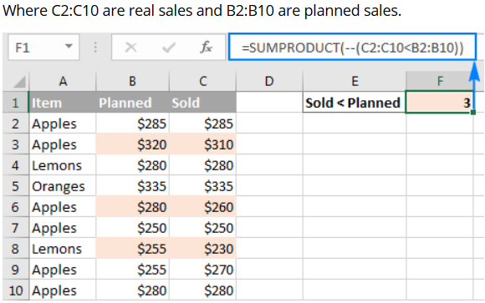

But what if you had more than one condition? Let's say, you want to count how many times Apples performed worse than planned. The solution is to add one more criterion to the SUMPRODUCT formula:

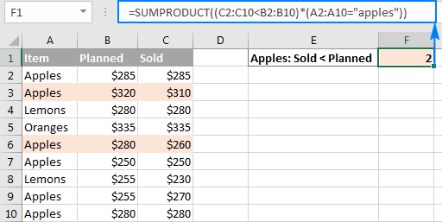

For starters, let's break down a simpler formula that compares numbers in 2 columns row-by-row, and tells us how many times column C is less than column B:

=SUMPRODUCT(--(C2:C10<B2:B10))

If you select the portion (C2:C10<B2:B10) in the formula bar, and press F9 to view the underlying values, you will see the following array:



What we have here is an array of Boolean values TRUE and FALSE, where TRUE means the specified condition is met (i.e. a value in column C is less than a value in column B in the same row), and FALSE signifies the condition is not met.

The double negative (--), which is technically called the double unary operator, coerces TRUE and FALSE into ones and zeros: {0;1;0;0;1;0;1;0;0}.

Another way to convert the logical values into the numeric values is multiple the array by 1:

=SUMPRODUCT((C2:C10<B2:B10)*1)

Either way, since there is just one array in the SUMPRODUCT formula, it simply adds up 1's in the resulting array and we get the desired count. Easy, isn't it?

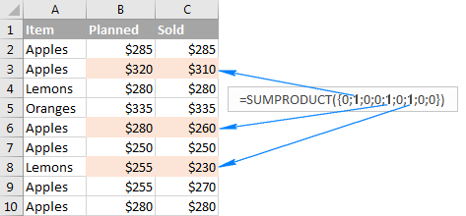

When an Excel SUMPRODUCT formula contains two or more arrays, it multiplies the elements of all the arrays, and then adds up the results.

The only tech difference between the formulas is the method of coercing TRUE and FALSE into 1 and 0 - by using the double unary or multiplication operation. As the result, we get two arrays of ones and zeros



The multiplication operation performed by SUMPRODUCT joins them into a single array. And since multiplying by zero always gives zero, 1 appears only when both conditions are met, and consequently only those rows are counted:

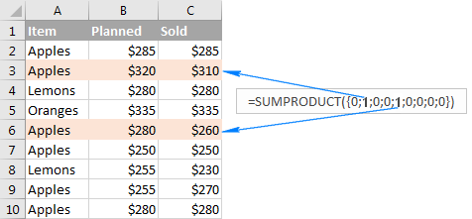

In many situations, you might need to conditionally count or sum cells with AND logic and OR logic at a time. Even in the latest versions of Excel, the IFs series of functions is not capable of that.

One of the possible solutions is combining two or more functions SUMIFS + SUMIFS or COUNTIFS + COUNTIFS.

Another way is using the Excel SUMPRODUCT function where:

* Asterisk (*) is used as the AND operator.
* Plus symbol (+) is used as the OR operator.

## COUNTIF

Excel COUNTIF function is used for counting cells within a specified range that meet a certain criterion, or condition.

For example, you can write a COUNTIF formula to find out how many cells in your worksheet contain a number greater than or less than the number you specify. Another typical use of COUNTIF in Excel is for counting cells with a specific word or starting with a particular letter(s).

The syntax of the COUNTIF function is very simple:



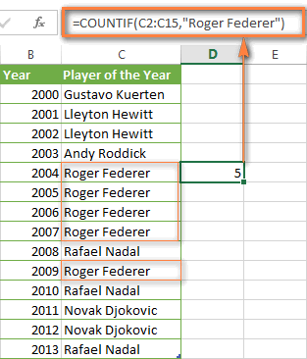

Note. A criterion is case insensitive, meaning that if you type "roger federer" as the criteria in the above formula, this will produce the same result.

As you have just seen, the syntax of the COUNTIF function is very simple. However, it allows for many possible variations of the criteria, including wildcard characters, the values of other cells, and even other Excel functions. This diversity makes the COUNTIF function really powerful and fit for many tasks, as you will see in the examples that follow.

Instead of typing text, you can use a reference to any cell containing that word or words and get absolutely the same results.

Similarly, COUNTIF formulas work for numbers. As shown in the screenshot below, the formula =COUNTIF(D2:D9,5) perfectly counts cells with quantity 5 in Column D.

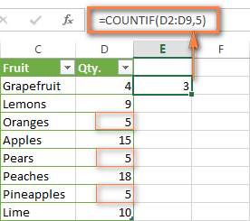

COUNTIF FORMULAS WITH WILDCARD CHARACTERS (PARTIAL MATCH)

In case your Excel data include several variations of the keyword(s) you want to count, then you can use a wildcard character to count all the cells containing a certain word, phrase or letters as part of the cell's contents.

Suppose, you have a list of tasks assigned to different persons, and you want to know the number of tasks assigned to Danny Brown. Because Danny's name is written in several different ways, we enter "*Brown*" as the search criteria =COUNTIF(D2:D10, "*Brown*").

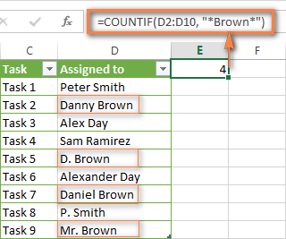

An asterisk (*) is used to find cells with any sequence of leading and trailing characters, as illustrated in the above example. If you need to match any single character, enter a question mark (?) instead, as demonstrated below.

Tip. It is also possible to use wildcards with cell references with the help of the concatenation operator (&). For example, instead of supplying "*Brown*" directly in the formula, you can type it in some cell, say F1, and use the following formula to count cells containing "Brown": =COUNTIF(D2:D10, "*"&F1&"*")

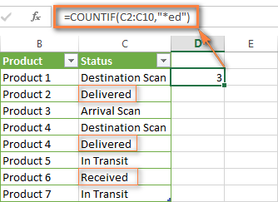

If you are looking for a count of cells that start or end with certain letters and contain the exact number of characters, you use the Excel COUNTIF function with the question mark character (?) in the criteria:

=COUNTIF (D2:D9,"??own") - counts the number of cells ending with the letters "own" and having exactly 5 characters in cells D2 through D9, including spaces.

=COUNTIF (D2:D9,"Mr??????") - counts the number of cells starting with the letters "Mr" and having exactly 8 characters in cells D2 through D9, including spaces.

Tip: To find the number of cells containing an actual question mark or asterisk, type a tilde (~) before the? or * character in the formula. For example, =COUNTIF(D2:D9,"*~?*") will count all cells containing the question mark in the range D2:D9.

EXCEL COUNTIF FOR BLANK AND NON-BLANK CELLS

In some of other Excel COUNTIF tutorials, you may come across formulas for counting non-blank cells in Excel similar to this one:

=COUNTIF (range,"*")

But the fact is, the above formula counts only cells containing any text values, meaning that cells with dates and numbers will be treated as blank cells and not included in the count!

If you need a universal COUNTIF formula for counting all non-blank cells in a specified range, here you go:

=COUNTIF (range,"<>"&"")

This formula works correctly with all value types - text, dates and numbers - as you can see in the screenshot below.

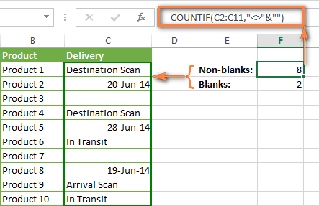

COUNTIF GREATER THAN, LESS THAN OR EQUAL TO

To count cells with values greater than, less than or equal to the number you specify, you simply add a corresponding operator to the criteria, as shown in the table below. Please pay attention that in COUNTIF formulas, an operator with a number are always enclosed in quotes.

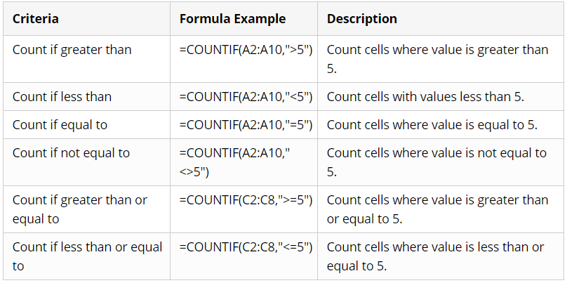

In case of a cell reference, you have to enclose the operator in quotes and add an ampersand (&) before the cell reference. For example, to count cells in the range D2:D9 with values greater than a value in cell D3, you use this formula =COUNTIF(D2:D9,">"&D3)

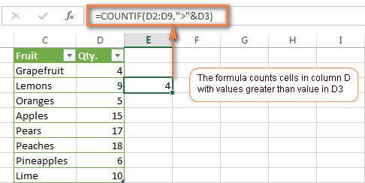

If you want to count cells with dates that are greater than, less than or equal to the date you specify or date in another cell, you proceed in the already familiar way using formulas similar to the ones we discussed a moment ago. All of the above formulas work for dates as well as for numbers. Let me give you just a few examples:

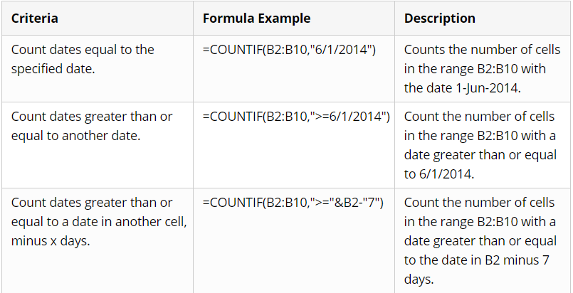

Apart from these common usages, you can utilize the COUNTIF function in conjunction with specific Excel Date and Time functions such as TODAY() to count cells based on the current date.

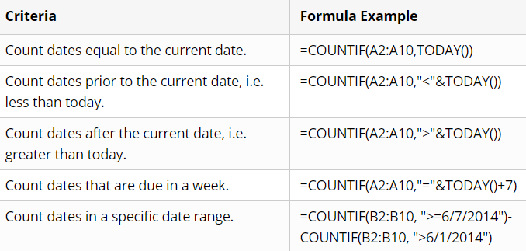

Here is an example of using such formulas on real data (at the moment of writing today was 25-Jun-2014):

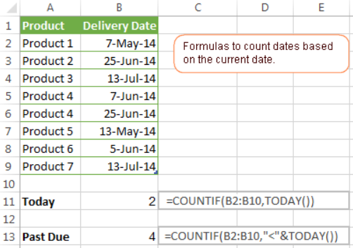

EXCEL COUNTIF WITH MULTIPLE CRITERIA

In fact, Excel COUNTIF function is not exactly designed to count cells with multiple criteria. In most cases, you'd use its plural counterpart, the COUNTIFS function to count cells that match two or more criteria (AND logic). However, some tasks can be solved by combining two or more COUNTIF functions in one formula.

COUNTIF - COUNTIF TO COUNT NUMBERS WITHIN A RANGE

One of the most common applications of Excel COUNTIF function with 2 criteria is counting numbers within a specific range, i.e. less than X but greater than Y. For example, you can use the following formula to count cells in the range B2:B9 where a value is greater than 5 and less than 15.  
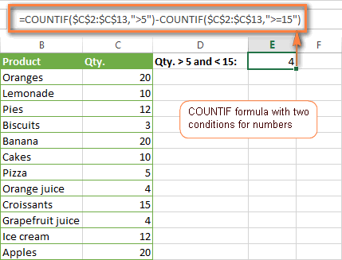

COUNTIF + COUNTIF TO COUNT CELLS WITH MULTIPLE OR CRITERIA

In situations when you want to get several different items in a range, add 2 or more COUNTIF functions together. Supposing, you have a shopping list and you want to find out how many soft drinks are included. To have it done, use a formula similar to this:

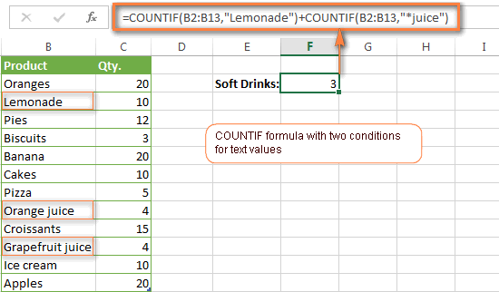

USING COUNTIF FUNCTION TO FIND DUPLICATES AND UNIQUE VALUES

Another possible usage of the COUNTIF function in Excel is for finding duplicates in one column, between two columns, or in a row.

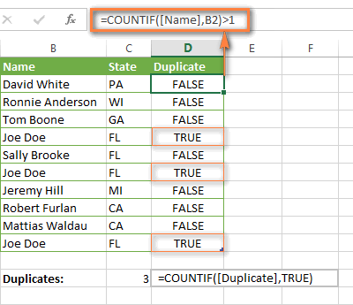

COUNT DUPLICATES BETWEEN TWO COLUMNS

If you have two separate lists, say lists of names in columns B and C, and you want to know how many names appear in both columns, you can use Excel COUNTIF in combination with the SUMPRODUCT function to count duplicates:

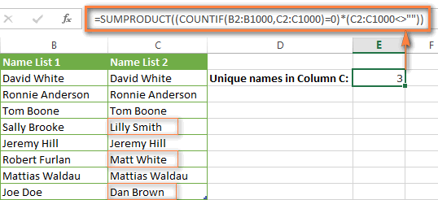

COUNT DUPLICATES AND UNIQUE VALUES IN A ROW

If you want to count duplicates or unique values in a certain row rather than a column, use one of the below formulas. These formulas might be helpful, say, to analyze the lottery draw history.

Count duplicates in a row:

=SUMPRODUCT((COUNTIF(A2:I2,A2:I2)>1)*(A2:I2<>""))

Count unique values in a row:

=SUMPRODUCT((COUNTIF(A2:I2,A2:I2)=1)*(A2:I2<>""))

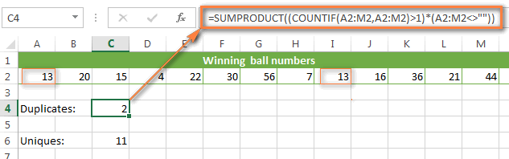

COUNTIF ON A NON-CONTIGUOUS RANGE OF CELLS

Excel COUNTIF does not work on non-adjacent ranges, nor does its syntax allow specifying several individual cells as the first parameter. Instead, you can use a combination of several COUNTIF functions:

Wrong: =COUNTIF(A2,B3,C4,">0")

Right: =COUNTIF(A2,">0") + COUNTIF(B3,">0") + COUNTIF(C4,">0")

## COUNTFS

Excel COUNTIFS function is purposed for counting cells across multiple ranges based on one or several conditions



Excel COUNTIFS - things to remember

* You can use the COUNTIFS function in Excel to count cells in a single range with a single condition as well as in multiple ranges with multiple conditions. If the latter, only those cells that meet all of the specified conditions are counted.
* Each additional range must have the same number of rows and columns as the first range (criteria_range1 argument).
* Both contiguous and non-contiguous ranges are allowed.
* If the criteria a reference to an empty cell, the COUNTIFS function treats it as a zero value (0).
* You can use the wildcard characters in criteria - asterisk (*) and question mark (?). See this example for full details.

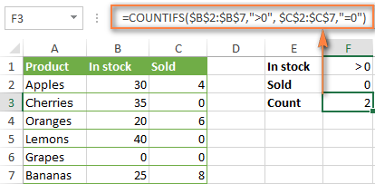

To get the count of "Cancelled" and "Pending" orders for "Apples" use this formula:

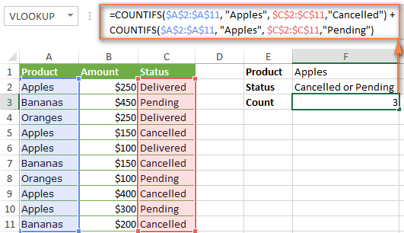

In situations when you have to evaluate a lot of criteria, the above approach is not the best way to go because your formula would grow too big in size. To perform the same calculations in a more compact formula, list all of your criteria in an array constant, and supply that array to the criteria argument of the COUNTIFS function. To get the total count, embed COUNTIFS inside the SUM function, like this:

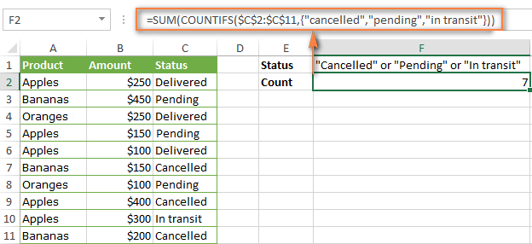

In a similar manner, you can count cells based on two or more criteria_range / criteria pairs. For instance, to get the number of "Apples" orders that are "Cancelled" or "Pending" or "In transit", use this formula:

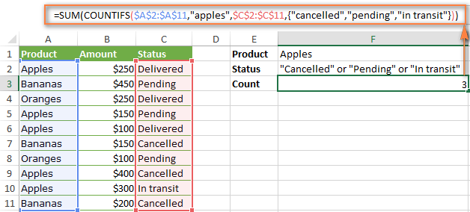

COUNTIFS to count cells between two numbers

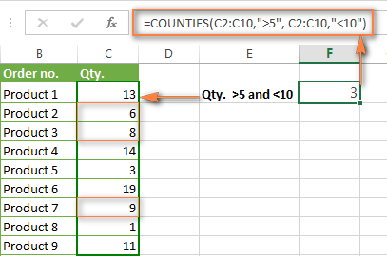

In Excel COUNTIFS formulas, you can use the following wildcard characters:

* Question mark (?) - matches any single character, use it to count cells starting and/or ending with certain characters.
* Asterisk (*) - matches any sequence of characters, you use it to count cells containing a specified word or a character(s) as part of the cell's contents.

Suppose, you have a list of projects in column A. You wish to know how many projects are already assigned to someone, i.e. have any name in column B. And because we are learning how to use the COUNTIFS function with multiple criteria, let's add a second condition - the End Date in column D should also be set.

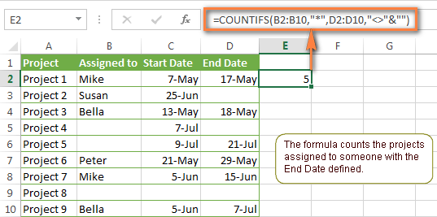

COUNTIFS and COUNTIF with multiple criteria for dates

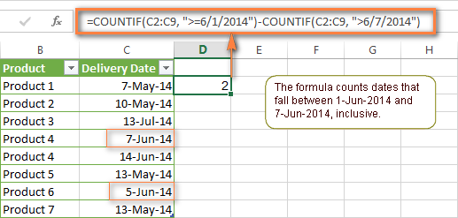

You can use Excel's TODAY() function in combination with COUNTIF to count dates based on the current date.

For example, the following COUNTIF formula with two ranges and two criteria will tell you how many products have already been purchased but not delivered yet.

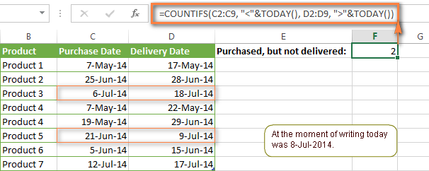

## TEXT

TEXT in Excel is used to convert a numeric value to a text string in a specific format. The syntax for the Excel TEXT function is as follows:



Generally, an Excel TEXT formula is used in the following situations:

* To display numbers in a more readable way or in a format that makes more sense for your users.
* To display dates in a specific format.
* To combine numbers or dates with certain text or characters.

For example, if you want to pull the date from cell A2 and show it in another cell in the traditional date format like "January 1, 2016", you use the following Excel TEXT formula:

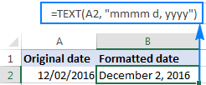

Important note! The TEXT function in Excel converts a numeric value to a text string. Consequently, you won't be able to use the result of your Text formula in other calculations. If there's such a need, you can keep the original values (hidden or kept out of sight), and use them in other formulas.

EXCEL TEXT FUNCTION FORMAT CODES

As you have just seen, the syntax of the Excel TEXT function is very straightforward, a tricky part is supplying a proper format code that will output your number the way you want. Essentially, the TEXT function accepts most of the format codes used in Excel number formats. The table below lists the most common and frequently used ones.

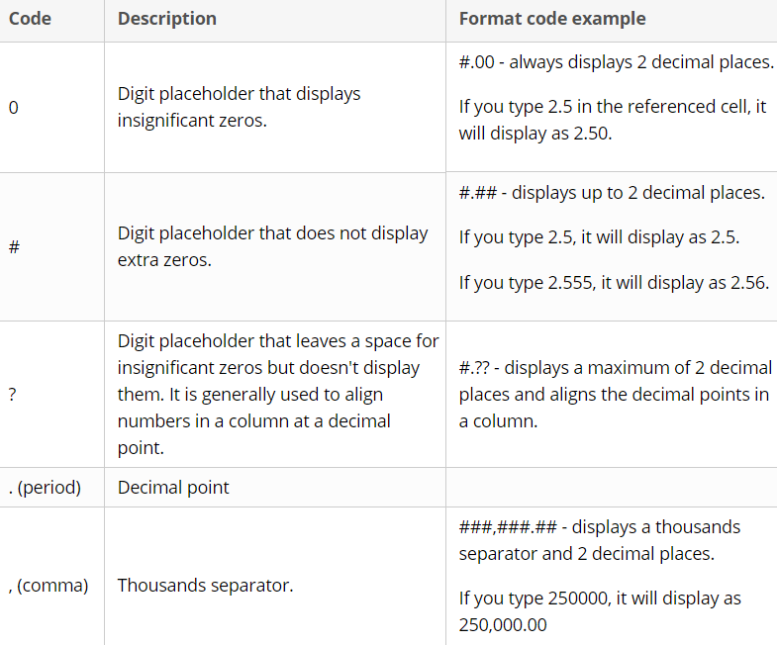

Additionally, you can include any of the following characters in the format code, and they will be displayed exactly as entered.

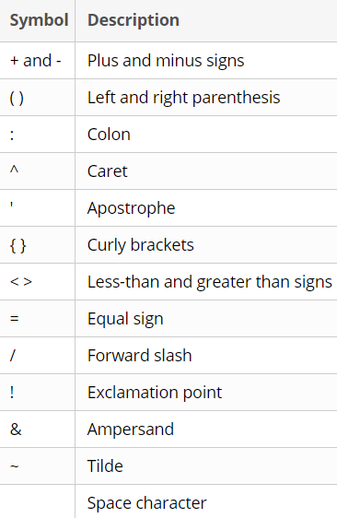

When using the Excel TEXT function with dates and times, you can use any of the following format codes.

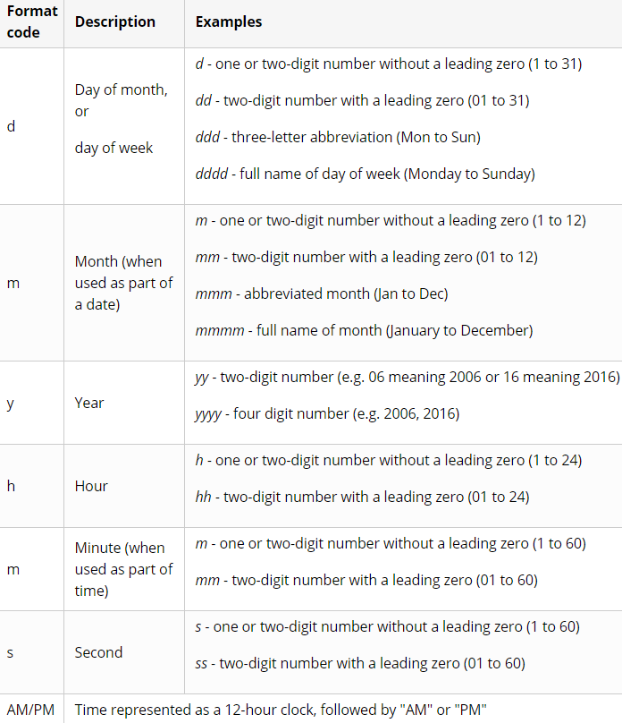

The following spreadsheet shows a few Excel Text formulas for dates:

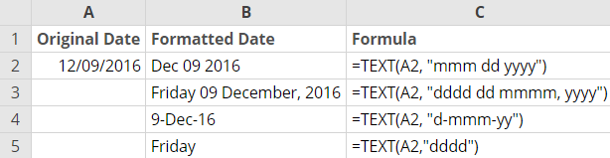

When creating summary sheets or reports, you may often want not only calculate totals, percentages and the like, but also explain to your users what this or that number means. To do this, use the CONCATENATE function to join text and numbers, and the TEXT function to display the number (or date) like you want it.

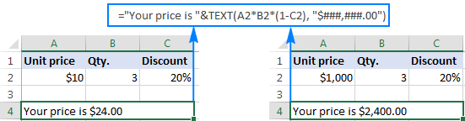

Another example

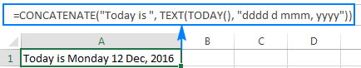

Another example



Another example, converting number in general format to TIME format

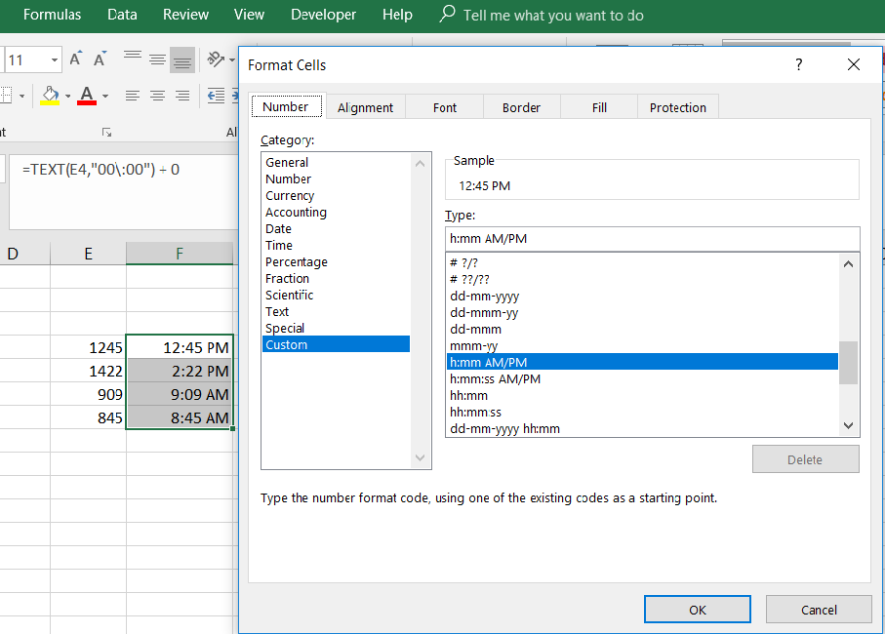

## DATE

The Excel DATE function is a built-in function that allows you to create a date with individual year, month, and day components. The DATE function is especially useful when supplying dates as inputs to other functions like SUMIFS or COUNTIFS, since you can easily assemble a date using year, month, and day values that come from a cell reference or formula result.



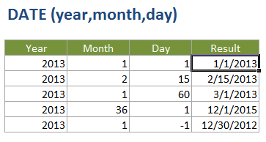

HOW TO DISTINGUISH NORMAL EXCEL DATES FROM "TEXT DATES"

When importing data into Excel, there is often a problem with date formatting. The imported entries may look like normal Excel dates to you, but they don't behave like dates. Microsoft Excel treats such entries as text, meaning you cannot sort your table by date properly, nor can you use those "text dates" in formulas, PivotTables, charts or any other Excel tool that recognizes dates.

There are a few signs that can help you determine whether a given entry is a date or a text value.

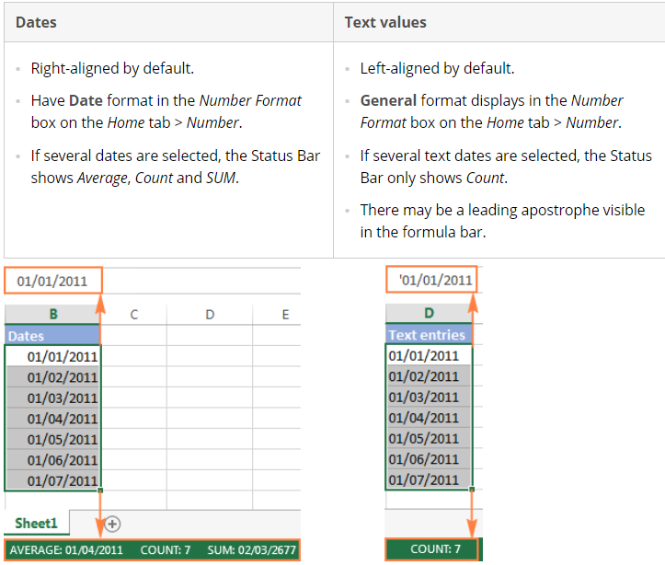

## DATEVALUE

The DATEVALUE function in Excel converts a date in the text format to a serial number that Excel recognizes as a date. The syntax of Excel's DATEVALUE is very straightforward:



Because the Excel DATEVALUE function converts a text date to a serial number, you will have to make that number look like a date by applying the Date format to it, as we discussed a moment ago.

The following screenshots demonstrates a few Excel DATEVALUE formulas in action:

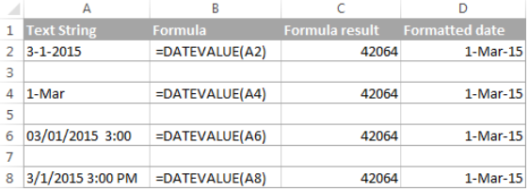

## DATEDIF

As its name suggests, the DATEDIF function is purposed for calculating the difference between two dates.

DATEDIF is one of very few undocumented functions in Excel, and because it is "hidden" you won't find it on the Formula tab, nor will you get any hint on which arguments to enter when you start typing the function's name in the formula bar. That is why it's important to know the complete syntax of Excel DATEDIF to be able to use it in your formulas.



Note. In your formulas, the end date must always be greater than the start date, otherwise the Excel DATEDIF function returns the #NUM! error.

Unit - the time unit to use when calculating the difference between two dates. By supplying different units, you can get the DATEDIF function to return the date difference in days, months or years. Overall, 6 units are available, which are described in the following table.

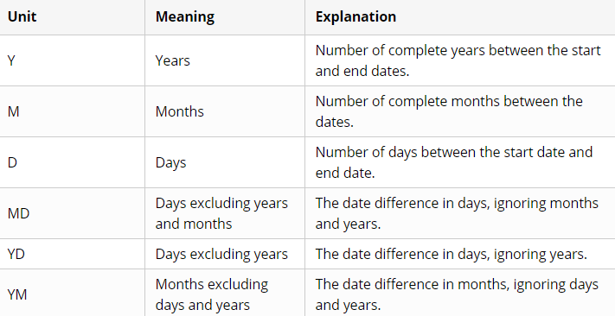

Getting number of days between 2 dates

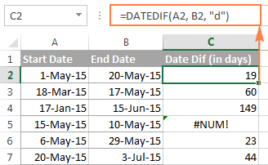

Count days ignoring year

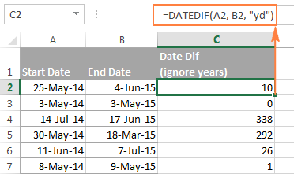

In row 4 and 5, since start date is > than end date if we ignore year hence system by default calculates the difference considering end date > start date even though year is ignored.

Count days ignoring month

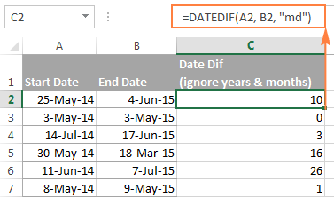

Date difference in weeks

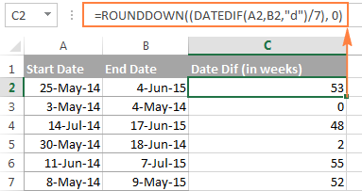

Month difference between two dates

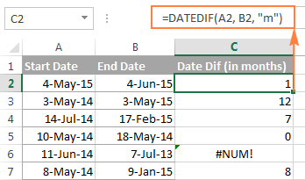

Count of months between two dates ignoring years

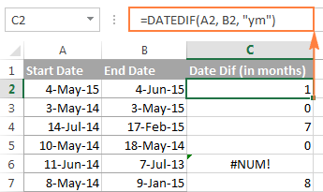

Year difference between two dates



To count the number of complete years, months and days between two dates in a single formula, you simply concatenate three DATEDIF functions:

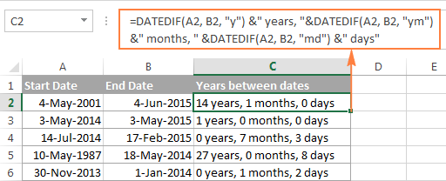

## TIME

The Excel TIME function is a built-in function that allows you to create a time with individual hour, minute, and second components. The TIME function is useful when you want to assemble a proper time inside another formula.

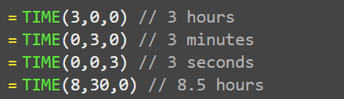

As you probably know, times in Excel are usual decimal numbers formatted to look like times. And because they are numbers, you can add and subtract times just as any other numerical values.

The simplest and most obvious Excel formula to calculate time difference is this:



Depending on you data structure, the actual time difference formula may take various shapes, for example:

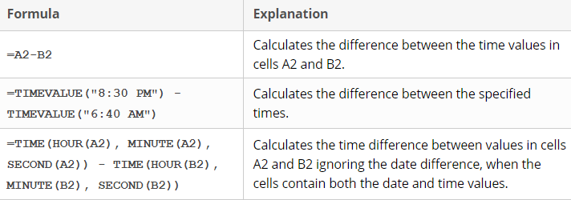

Remembering that in the internal Excel system, times are represented by fractional parts of decimal numbers, you are likely to get the results similar to this:

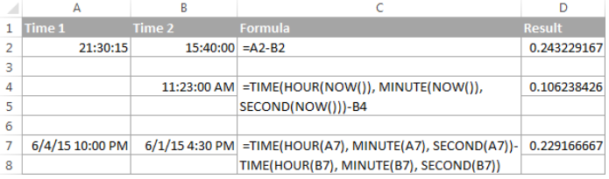

The decimals in column D are perfectly true but not very meaningful. To make them more informative, you can apply custom time formatting with one of the following codes:

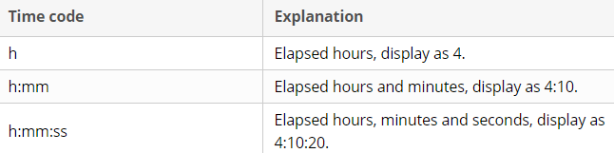

The elapsed time is displayed differently depending on the time format applied to the column:

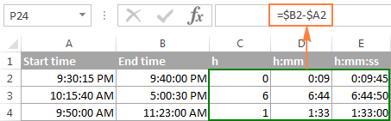

Note. If the elapsed time is displayed as hash marks (#####), then either a cell with the formula is not wide enough to fit the time or the result of your time calculations is a negative value.

Calculating time difference with TEXT function:

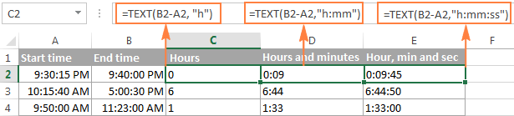

The value returned by the TEXT function is always text. Please notice the left alignment of text values in columns C:E in the screenshot above. In certain scenarios, this might be a significant limitation because you won't be able to use the returned "text times" in other calculations.

If the result is a negative number, the TEXT formula returns the #VALUE! error.

E.g. Calculate hours between two times:

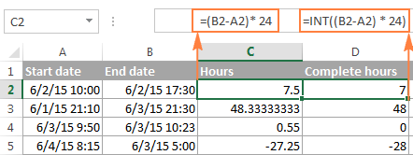

E.g. **Total minutes between two times:**

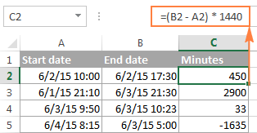

E.g. **Total seconds between two times:**

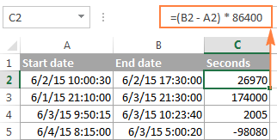

Note. For the results to display correctly, the General format should be applied to the cells with your time difference formula.

Calculate difference in one-time unit ignoring others

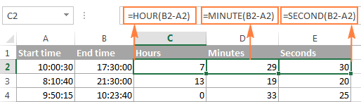

 Calculate elapsed time from a start time to now

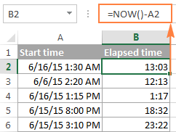

In case the elapsed time exceeds 24 hours, use one of these time formats, for example d "days" h:mm:ss

## TIMEVALUE

The Excel TIMEVALUE function converts a time represented as text into a proper Excel time. For example, the formula =TIMEVALUE ("9:00 AM") returns 0.375, the numeric representation of 9:00 AM in Excel's time system. Numeric time values are more useful than text since they can be directly manipulated with formulas and pivot tables.



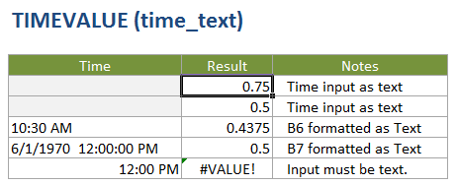

The TIMEVALUE function creates a time in serial number format from a date and/or time in an Excel text format. TIMEVALUE will return a decimal number between 0 and 0.99988426, representing 12:00:00 AM to 11:59:59 PM.

Note: date information is ignored.

## RANK

The RANK function in Excel returns the order (or rank) of a numeric value compared to other values in the same list. In other words, it tells you which value is the highest, the second highest, etc.

In a sorted list, the rank of a certain number would be its position. The RANK function in Excel can determine the rank starting with the largest value (as if sorted in descending order) or the smallest value (as if sorted in ascending order).

The syntax of the Excel RANK function is as follows:



Rank with descending order

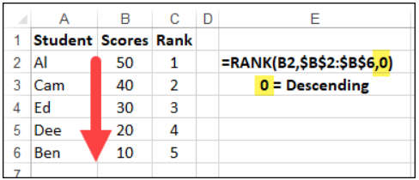

Rank with ascending order

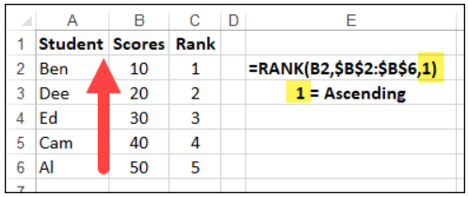

### RANK.EQ

RANK.EQ is an improved version of the RANK function, introduced in Excel 2010. It has the same syntax as RANK and works with the same logic: if several values are ranked equally, the top rank of that group of values is returned (EQ stands for "equal").



In Excel 2007 and lower versions, you should always use the RANK function. In Excel 2010, Excel 2013, and Excel 2016, you can go with either RANK or RANK.EQ. However, it'd be wise to use RANK.EQ because RANK can be discontinued at any moment.

### RANK.AVG

RANK.AVG is another function to find rank in Excel that is available only in Excel 2010, Excel 2013, Excel 2016 and later.

It has the same syntax as the other two functions:



The difference is that if more than one number has the same rank, the average rank is returned (AVG stands for "average").

Things you should know about RANK in Excel

* Any Rank formula in Excel works only for numeric values: positive and negative numbers, zeros, date and time values. Non-numeric values in the ref argument are ignored.
* All RANK functions return the same rank for duplicate values, and skip subsequent ranking, as shown in the example below.
* In Excel 2010 and later versions, the RANK function has been replaced with RANK.EQ and RANK.AVG. For backward compatibility, RANK still works in all versions of Excel, but it may not be available in the future.
* If number is not found within ref, any Excel Rank function would return the #N/A error.

Example

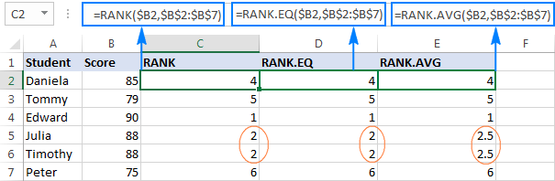

The difference is in how these formulas process duplicate values. As you see, the same score appears twice, in cells B5 and B6, which affects subsequent ranking:

* The RANK and RANK.EQ formulas give a rank of 2 to both duplicate scores. The next highest score (Daniela) is ranked 4th. A rank of 3 is not given to anyone.
* The RANK.AVG formula assigns a different rank to each duplicate behind the scenes (2 and 3 in this example), and returns the average of those ranks (2.5). Again, the 3rd rank is not assigned to anyone.

To get unique rank we can use below work around

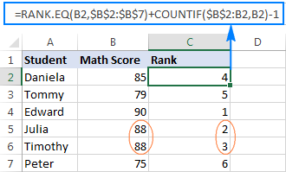

## CELL

The Excel CELL function returns information about a cell in a worksheet. The type of information to be returned is specified as info_type. CELL can get things like address and filename, as well as detailed info about the formatting used in the cell. See below for a full list of information available.



For the formula: =CELL("col", C10) will return 3. See below for a full list of info_type and a key to the codes that CELL returns when the info_type is format.

Note that when reference refers to more than one cell, CELL will return information about the first cell in reference.

The following info_type can be used with the CELL function:

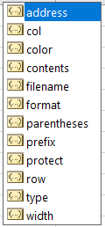

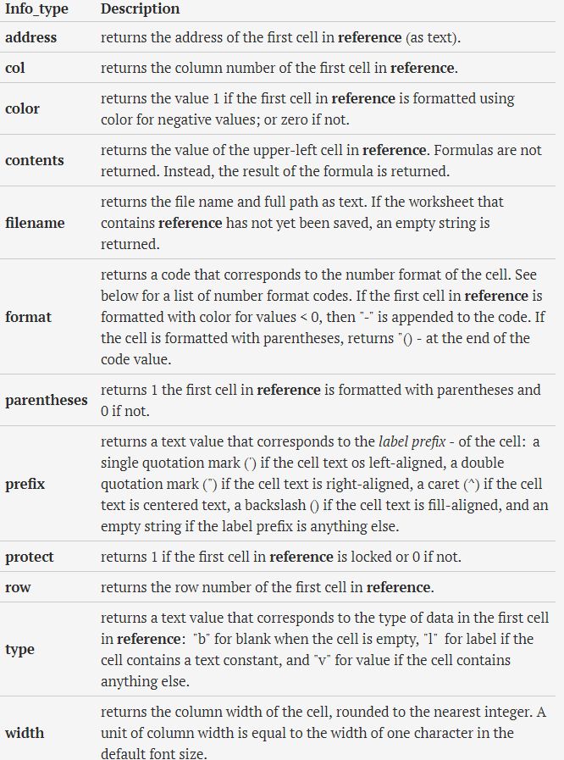

The following table is a key for the text codes that are returned from CELL when "format" is used for info_type.

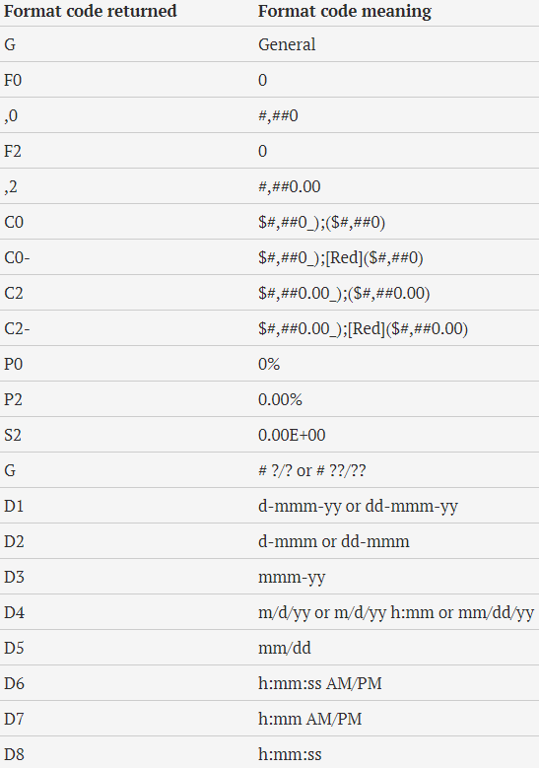

In the following example spreadsheet, the Excel Cell function is used to return different properties of the cell A1. It should be noted that, in the spreadsheet, cell A1 is formatted with the Custom Format #,##0; [Red] - #,##0.

Note that, in cell B6 of the above example spreadsheet, the "format" type is returned as ",0-". This is comprised of two parts: the ",0" part, which represents the #,##0 number format, and the "-" part, which indicates that the cell is formatted in color for negative values.

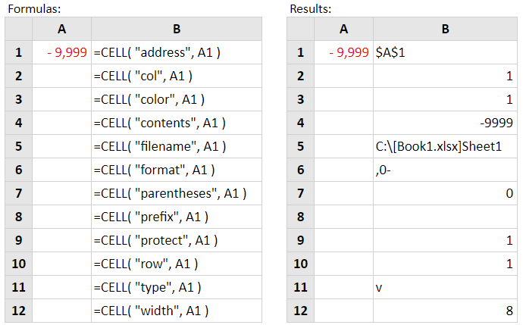

## INDIRECT

As its name suggests, Excel INDIRECT is used to indirectly reference cells, ranges, other sheets or workbooks. In other words, the INDIRECT function lets you create an Excel dynamic cell reference or range reference rather than "hard coding" those references into your Excel formulas. As a result, you can change a cell reference within a formula without changing the formula itself. Moreover, these indirect references won't change when some new rows or columns are inserted in the worksheet or when you delete any existing ones.

All this may be easier to understand from an example. However, to be able to write a formula, even the simplest one, you need to know the function's arguments, right? So, let's have a quick look at Excel INDIRECT syntax first.



ref_text - is a cell reference, or a reference to a cell in the form of a text string, or a named range.

a1 - is a logical value that specifies what type of reference is contained in the ref_text argument:

* If TRUE or omitted, ref_text is interpreted as an A1-style cell reference.
* If FALSE, ref_text is treated as a R1C1 reference.

While the R1C1 reference type might be useful in certain situations, you'll probably want to use the familiar A1 references most of the time.

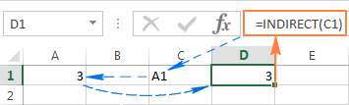

So, what the INDIRECT function actually does in this example is converting a text string into a cell reference.

In an INDIRECT formula, you can use either reference type on the same sheet if you want to. Before we move any further, you may want to know the difference between A1 and R1C1 reference styles.

A1 style is the usual reference type in Excel that refers to a column followed by a row number. For example, B2 refers to the cell at the intersection of column B and row 2.

R1C1 style is the opposite reference type - rows followed by columns, which does take some time getting used to. For example, R4C1 refers to cell A4 which is in row 4, column 1 in a sheet. If no number comes after the letter, then you are referring to the same row or column.

And now, let's see how the INDIRECT function handles A1 and R1C1 references:

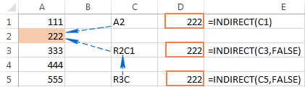

Another example

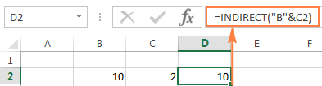

Indirect function to work with named ranges

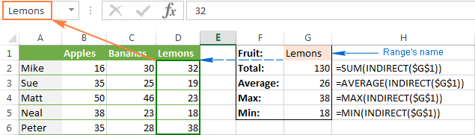

Using INDIRECT with Data Validation in Excel to create cascading drop down list

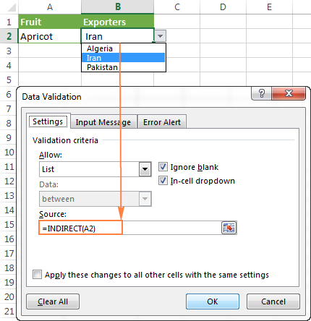

## ADDRESS

The Excel ADDRESS function returns the address for a cell based on a given row and column number. For example, =ADDRESS (1,1) returns $A$1. ADDRESS can return an address in relative or absolute format, and can be used to construct a cell reference inside a formula.



Below are the different values for the optional arguments [abs_num] and [a1]

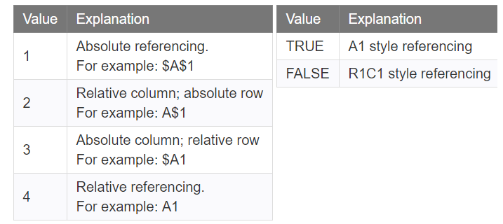

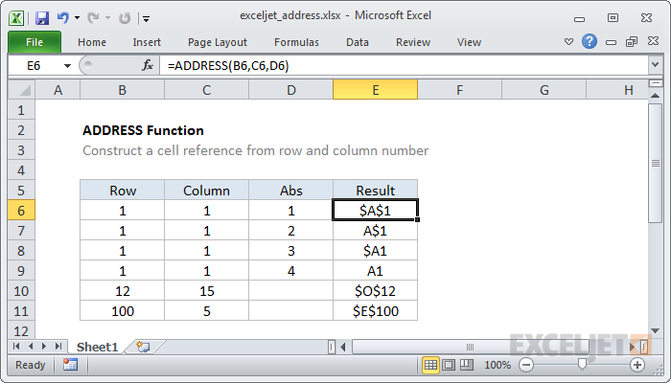

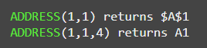

Another example using sheet reference as well in the address formula

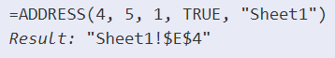

## IFERROR

The IFERROR function in Excel is designed to trap and manage errors in formulas and calculations. More specifically, IFERROR checks a formula, and if it evaluates to an error, returns another value you specify; otherwise, returns the result of the formula.

The syntax of the Excel IFERROR function is as follows:



For example, when dividing two columns of numbers, you may get a bunch of different errors if one of the columns contains empty cells, zeros or text.

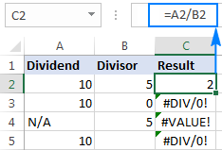

To prevent that from happening, use the IFERROR function to catch and handle errors the way you want.

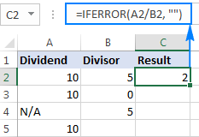

Things you should know about Excel IFERROR function

* The IFERROR function in Excel handles all error types including #DIV/0!, #N/A, #NAME?, #NULL!, #NUM!, #REF!, and #VALUE!.
* Depending on the contents of the value_if_error argument, IFERROR can replace errors with your custom text message, number, date or logical value, the result of another formula, or an empty string (blank cell).
* If the value argument is a blank cell, it is treated as an empty string (''') but not an error.
* IFERROR was introduced in Excel 2007 and is available in all subsequent versions of Excel 2010, Excel 2013, and Excel 2016.
* To trap errors in Excel 2003 and earlier versions, use the ISERROR function in combination with IF, as shown in this example.

NESTED IFERROR FUNCTIONS TO DO SEQUENTIAL VLOOKUP’S IN EXCEL

In situations when you need to perform multiple VLOOKUP’s based on whether the previous VLOOKUP succeeded or failed, you can nest two or more IFERROR functions one into another.

Supposing you have a number of sales reports from regional branches of your company, and you want to get an amount for a certain order ID. With A2 as the lookup value in the current sheet, and A2:B5 as the lookup range in 3 lookup sheets (Report 1, Report 2 and Report 3), the formula goes as follows:

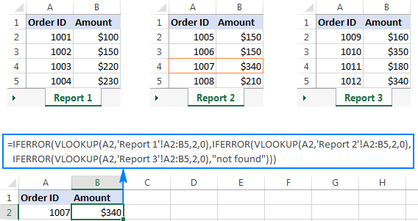

IFERROR can be used with arrays as well, the normal formula works fine as long as the divisor range does not have zeros or empty cells. If there is at least one 0 value or blank cell, the #DIV/0! error is returned, to solve the issue we can use IFERRO

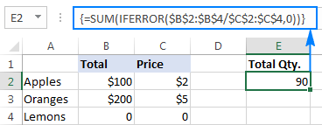

## IFNA

IFNA is one more function to check a formula for errors. Its syntax is similar to that of IFERROR:



In what way is IFNA different from IFERROR? The IFNA function catches only #N/A errors while IFERROR handles all error types.

## LARGE

The Excel LARGE function returns numeric values based on their position in a list when sorted by value. In other words, it can retrieve "nth largest" values - largest value, 2nd largest value, 3rd largest value, etc.

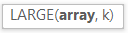

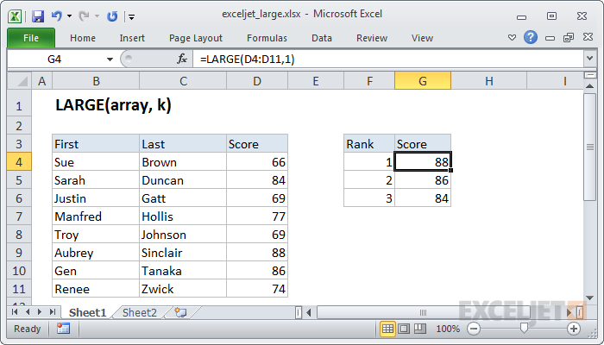

LARGE function can handle arrays as well

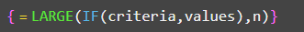

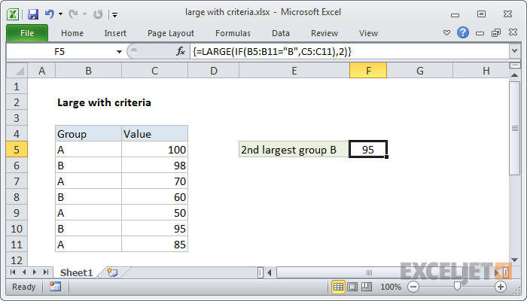

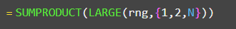

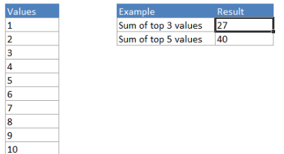

## SMALL

The Excel SMALL function returns numeric values based on their position in a list ranked by value. In other words, it can retrieve "nth smallest" values - smallest value, 2nd smallest value, 3rd smallest value, etc.



Example below:

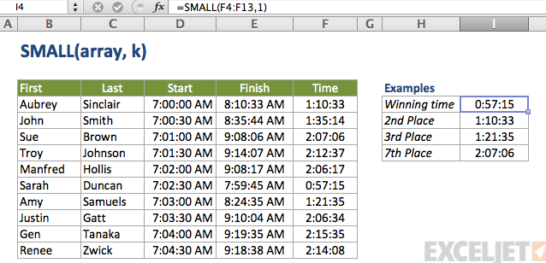

Highlight bottom 5 values

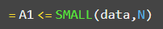

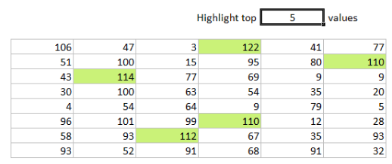

## ROW

The Excel ROW function returns the row number for a reference. For example, ROW(C5) returns 5, since C5 is the first row in the spreadsheet. When no reference is provided, ROW returns the row number of the cell which contains the formula.

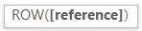

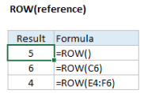

Use the ROW function to get the row number for a cell reference or a range.

* Reference is optional and will default to the cell in which the COLUMN function exists.
* Reference cannot include multiple references or addresses.

## ROWS

The Excel ROWS function returns the count of rows in a given reference. For example, ROWS (A1:A3) returns 3, since the range A1:A3 contains 3 columns.



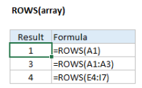

Use ROWS to get the column count of a reference. For example, the formula =ROWS (A1:A10) returns the number 10.

## COLUMN

The Excel COLUMN function returns the column number for a reference. For example, COLUMN(C5) returns 3, since C is the third column in the spreadsheet. When no reference is provided, COLUMN returns the column number of the cell which contains the formula.

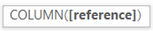

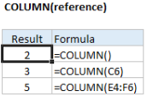

## COLUMNS

The Excel COLUMNS function returns the count of columns in a given reference. For example, COLUMNS (A1:C3) returns 3, since the range A1:C3 contains 3 columns.

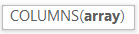

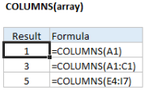

## SUBTOTAL

Microsoft defines Excel SUBTOTAL as the function that returns a subtotal in a list or database. In this context, "subtotal" is not just totalling numbers in a defined range of cells. Unlike other Excel functions that are designed to do only one specific thing, SUBTOTAL is amazingly versatile - it can perform different arithmetic and logical operations such as counting cells, calculating average, finding the minimum or maximum value, and more.



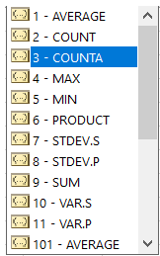

Where:

* Function_num - a number that specifies which function to use for the subtotal.
* Ref1, Ref2, … - one or more cells or ranges to subtotal. The first ref argument is required, others (up to 254) are optional.

The function_num argument can belong to one of the following sets:

* 1 - 11 ignore filtered-out cells, but include manually hidden rows.
* 101 - 111 ignore all hidden cells - filtered out and hidden manually.

When you use a Subtotal formula with a summary function like SUM or AVERAGE, it calculates only cells with numbers ignoring blanks and cells containing non-numeric values.

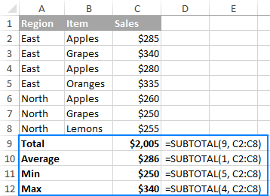

REASONS TO USE SUBTOTAL IN EXCEL

1. Calculate values in filtered rows

Because the Excel SUBTOTAL function ignores values in filtered-out rows, you can use it to create a dynamic data summary where subtotal values are re-calculated automatically according to the filter.

For example, if we filter the table to show sales only for the East region, the Subtotal formula will automatically adjust so that all other regions are removed from the total:

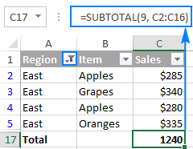

1. Calculate only visible cells

As you remember, Subtotal formulas with function_num 101 to 111 ignore all hidden cells - filtered out and hidden manually. So, when you use Excel's Hide feature to remove irrelevant data from view, use function number 101-111 to exclude values in hidden rows from subtotals.

The following example will help you gain more understanding of how it works: Subtotal 9 vs. Subtotal 109.

1. Ignore values in nested Subtotal formulas

If the range supplied to your Excel Subtotal formula contains any other Subtotal formulas, those nested subtotals will be ignored, so the same numbers won't be calculated twice. Awesome, isn't it?

In the screenshot below, the Grand Average formula SUBTOTAL (1, C2:C10) ignores the results of the Subtotal formulas in cells C3 and C10, as if you used an Average formula with 2 separate ranges AVERAGE(C2:C5, C7:C9)

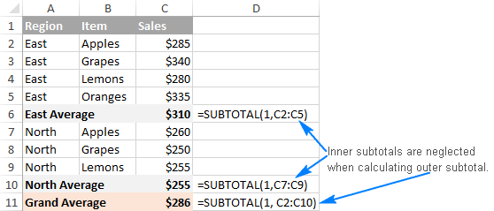

SUBTOTAL 9 VS. SUBTOTAL 109

As you already know, Excel SUBTOTAL accepts 2 sets of functions numbers: 1-11 and 101-111. Both sets ignore filtered-out rows, but numbers 1-11 include manually hidden rows whereas 101-111 exclude them. To better understand the difference, let's consider the following example.

To total filtered rows, you can use either Subtotal 9 or Subtotal 109 formula like shown in the screenshot below:

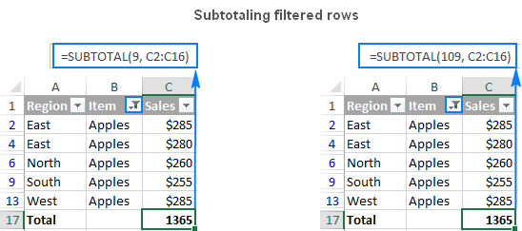

But if have hidden irrelevant items manually by using the Hide Rows command on the Home tab > Cells group > Format > Hide & Unhide, or by right clicking the rows, and then clicking Hide, and now you want to total values only in visible rows, Subtotal 109 is the only option:

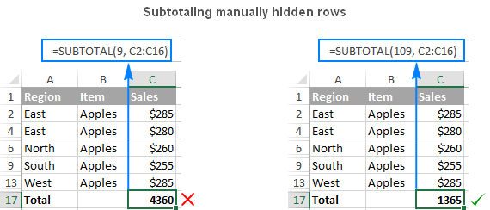

Note. The Excel SUBTOTAL function with function_num 101-111 neglects values in hidden rows, but not in hidden columns. For example, if you use a formula like SUBTOTAL(109, A1:E1) to sum numbers in a horizontal range, hiding a column won't affect the subtotal.

EXCEL SUBTOTAL NOT WORKING - COMMON ERRORS

If your Subtotal formula returns an error, it's likely to be because of one of the following reasons:

* #VALUE! - the function_num argument is other than an integer between 1 - 11 or 101 - 111; or any of the ref arguments contains a 3-D reference.
* #DIV/0! - occurs if a specified summary function has to perform a division by zero (e.g. calculating an average or standard deviation for a range of cells that does not contain a single numeric value).
* #NAME? - the name of the Subtotal function is misspelled - the easier error to fix.

Tip. If you don't feel comfortable with the SUBTOTAL function yet, you can use the built-in SUBTOTAL feature and have the formulas inserted for you automatically.

## LEFT

The LEFT function in Excel returns the specified number of characters (substring) from the start of a string. The syntax of the LEFT function is as follows:

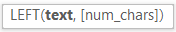

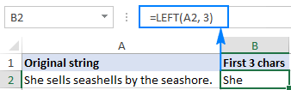

Important note! LEFT belongs to the category of Text functions, therefore the result of a Left formula is always a text string, even if the original value from which you extract characters is a number. If you are working with a numeric dataset and want the LEFT function to return a number, use it in conjunction with the VALUE function as demonstrated in example below:

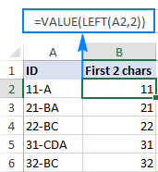

## RIGHT

The RIGHT function in Excel returns the specified number of characters from the end of a text string. The syntax of the RIGHT function is as follows:



For example, to extract the last 3 characters from the string in cell A2, use this formula:

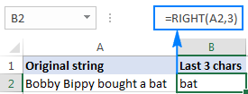

The Excel RIGHT function always returns a text string, even if the original value is a number. To force a Right formula to output a number, use it in combination with the VALUE function.

## MID

MID function in Excel is designed to pull a substring from the middle of the original text string. Technically speaking, the MID function returns the specified number of characters starting at the position you specify.

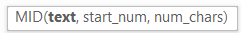

The Excel MID function has the following arguments:

Where:

* Text is the original text string.
* Start_num is the position of the first character that you want to extract.
* Num_chars is the number of characters to extract.

All 3 arguments are required.

For example, to pull 7 characters from the text string in A2, starting with the 8th character, use this formula:

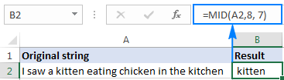

* The MID function always returns a text string, even if the extracted substring contains only digits. This may be critical if you wish to use the result of your Mid formula within other calculations. To convert an output into a number, use MID in combination with the VALUE function as shown in this example.
* If start_num is greater than the overall length of the original text, an Excel Mid formula returns an empty string ("").
* If start_num is less than 1, a Mid formula returns the #VALUE! error.
* If num_chars is less than 0 (negative number), a Mid formula returns the #VALUE! error. If num_chars is equal to 0, it outputs an empty string (blank cell).
* If the sum of start_num and num_chars exceeds the total length of the original string, the Excel MID function returns a substring starting from start_num and up to the last character.

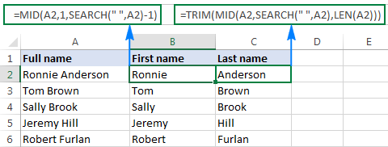

Like other Text functions, Excel MID always returns a text string, even if it contains only digits and looks much like a number. To turn the output into a number, simply "warp" your Mid formula into the VALUE function that converts a text value representing a number to a number.

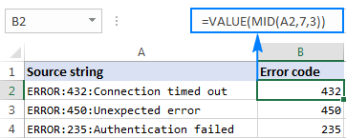

## FIND

The FIND function in Excel is used to return the position of a specific character or substring within a text string. The syntax of the Excel Find function is as follows



If the FIND function does not find the find_text character(s), a #VALUE! error is returned.

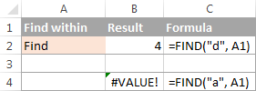

EXCEL FIND FUNCTION - THINGS TO REMEMBER!

To correctly use a FIND formula in Excel, keep in mind the following simple facts:

* The FIND function is case sensitive. If you are looking for a case-insensitive match, use the SEARCH function.
* The FIND function in Excel does not allow using wildcard characters.
* If the find_text argument contains several characters, the FIND function returns the position of the first character. For example, the formula FIND ("ap", "happy") returns 2 because "a" in the 2nd letter in the word "happy".
* If within_text contains several occurrences of find_text, the first occurrence is returned. For example, FIND ("l", "hello") returns 3, which is the position of the first "l" character in the word "hello".
* If find_text is an empty string "", the Excel FIND formula returns the first character in the search string.
* The Excel FIND function returns the #VALUE! error if any of the following occurs:
  + Find_text does not exist in within_text.
  + Start_num contains more characters than within_text.
  + Start_num is 0 (zero) or a negative number.

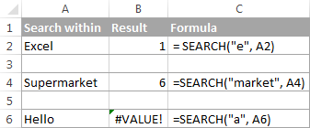

To extract first name and last name

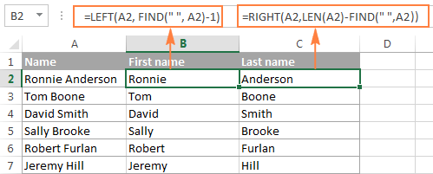

Argument containing leading zero

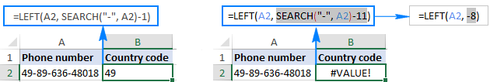

LEFT function does not work well with DATES

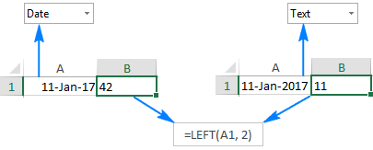

To extract a specific part of a date, use one of the following functions: DAY, MONTH or YEAR. In case your dates are entered as text strings, the LEFT function will work without a hitch.

## SEARCH

The SEARCH function in Excel is very similar to FIND in that it also returns the location of a substring in a text string. Its syntax and arguments are similar to those of FIND:

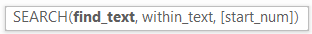

Unlike FIND, the SEARCH function is case-insensitive and it allows using the wildcard characters, as demonstrated in the following example.



Like FIND, Excel's SEARCH function returns the #VALUE! error if:

* The value of the find_text argument is not found.
* The start_num argument is greater than the length of within_text.
* Start_num is equal to or less than zero.

Excel FIND vs. Excel SEARCH

As already mentioned, the FIND and SEARCH functions in Excel are very much alike in terms of syntax and uses. However, they do have a couple of differences.

1. The most essential difference between the Excel SEARCH and FIND functions is that SEARCH is case-insensitive, while FIND is case-sensitive.

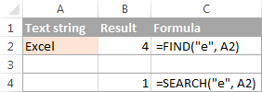

1. Unlike FIND, the Excel SEARCH function allows using wildcards in the find_text argument:

* A question mark (?) matches one character, and
* An asterisk (*) matches any series of characters.

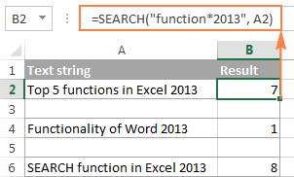

As you see in the screenshot above, the formula SEARCH ("function*2013", A2) returns the position of the first character ("f") in the substring if the text string referred to in the within_text argument contains both "function" and "2013", no matter how many other characters there are in between.

Tip. To find an actual question mark (?) or asterisk (*), type a tilde (~) before the corresponding character.

## REPLACE

The REPLACE function in Excel allows you to swap one or several characters in a text string with another character or a set of characters.



As you see, the Excel REPLACE function has 4 arguments, all of which are required.

* Old_text - the original text (or a reference to a cell with the original text) in which you want to replace some characters.
* Start_num - the position of the first character within old_text that you want to replace.
* Num_chars - the number of characters you want to replace.
* New_text - the replacement text.

For example, to change the word "sun" to "son", you can use the following formula:

And if you put the original word in some cell, say A2, you can supply the corresponding cell reference in the old_text argument:

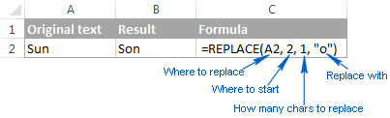

NOTE: If the start_num or num_chars argument is negative or non-numeric, an Excel Replace formula returns the #VALUE! error.

The REPLACE function in Excel is designed to work with text strings. Of course, you can use it to replace numeric characters that are part of a text string, for example:

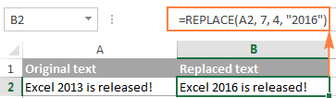

Notice that we enclose "2016" in double quotes as you usually do with text values. In a similar manner, you can replace one or more digits within a number. For example:

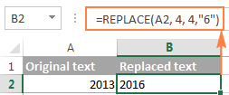

To replace DATEs using REPLACE function, use text else we will get wrong output

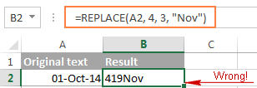

Because "01-Oct-14" is only a visual representation of the underlying serial number (41913) that represents the date. So, our Replace formula changes the last 3 digits in the above serial number to "Nov" and returns the text string "419Nov".

To get the Excel REPLACE function to correctly work with dates, you can convert dates to text strings first by using the TEXT function

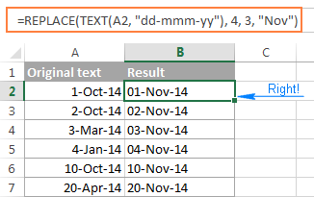

Please remember that the result of the above formula is a text string, and therefore this solution works only if you are not planning to use the modified dates in further calculations. If you do need dates rather than text strings, use the DATEVALUE function to turn the values returned by the Excel REPLACE function back to dates.

## SUBSTITUTE

The SUBSTITUTE function in Excel replaces one or more instances of a given character or text string with a specified character(s). The syntax of the Excel SUBSTITUTE function is as follows:



The first three arguments are required and the last one is optional.

* Text - the original text in which you want to substitute characters. Can be supplied as a test string, cell reference, or a result of another formula.
* Old_text - the character(s) you want to replace.
* New_text - the new character(s) to replace old_text with.
* Instance_num - the occurrence of old_text you want to replace. If omitted, every occurrence of the old text will be changed to the new text.

For example, all of the below formulas substitute "1" with "2" in cell A2, but return different results depending on which number you supply in the last argument:

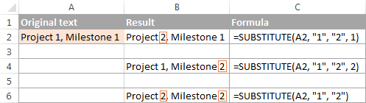

The SUBSTITUTE function in Excel is case-sensitive. For example, the following formula replaces all instances of the uppercase "X" with "Y" in cell A2, but it won't replace any instances of the lowercase "x".

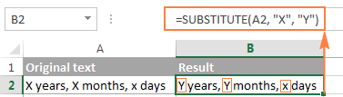

EXCEL REPLACE VS. EXCEL SUBSTITUTE

The Excel REPLACE and SUBSTITUTE functions are very similar to each other in that both are designed to swap text strings. The differences between the two functions are as follows:

* SUBSTITUTE replaces one or more instances of a given character or a text string. So, if you know the text to be replaced, use the Excel SUBSTITUTE function.
* REPLACE changes characters in a specified position of a text string. So, if you know the position of the character(s) to be replaced, use the Excel REPLACE function.
* The SUBSTITUTE function in Excel allows adding an optional parameter (instance_num) that specifies which occurrence of old_text should be changed to new_text.

This is how you use the SUBSTITUTE and REPLACE functions in Excel. Hopefully, these examples will prove useful in solving your tasks. For better understanding of the formulas discussed in this tutorial, you are welcome download the Sample Replace & Substitute worksheet. I thank you for reading and hope to see on our blog next week.

# EXCEL ERROR TYPES

Excel functions like VLOOKUP, MATCH, and INDEX are great tools, but when they don’t work, they throw errors that can break an entire spreadsheet if referenced incorrectly. Error messages can be especially bad if they show up on end-user worksheets like reports and dashboards. Fortunately, Excel has a way to catch errors like #VALUE! #NUM! and #REF! before they show up. Learn how to handle error messages in Excel here.

When you use functions in Excel, they expect their inputs to have certain characteristics. When you use SUM to add cells together, Excel assumes that the references are numbers. When you use VLOOKUP to find a value in cell range, Excel trusts that the value is there. Whenever Excel doesn’t find what it expects, it will return an error message.

1. #VALUE!

#VALUE! is likely the most common of errors. It occurs whenever the data type passed to function doesn’t match with what it is expecting. A simple example would be adding a text value to a number:

="A"+1

1. #REF!

#REF! errors happen when a cell reference is deleted or moved. Excel tries to automatically update all references, but when it can’t do so, it replaces the actual cell reference with the error. For example, if we added the contents of cells A1 and B1, the function would look like this:

=A1+B1

After deleting cell B1, the function would revert to this:

=A1+#REF!

1. #DIV/0!

#DIV/0! happens when a mathematical operation attempts to divide by zero (which isn’t possible). Usually, this occurs because a COUNT or SUM results in zero and another cell is operating on its result. A simple example is dividing any number by zero: =1/0

1. #NAME?

#NAME? appears when Excel can’t find a named range. Excel assumes that any un-quoted string that isn’t a function name is a named range. You will most likely encounter this when you forget to quote a string or mis-type a cell reference. For example: =A+1

1. #NULL!

#NULL! gets returned when Excel can’t figure out the range specified in a cell. This can happen when you put a space between function inputs instead of using a comma. For example:

=SUM (A1 C1)

1. #N/A

#N/A happens when a function like MATCH or VLOOKUP cannot find the value it is being asked to look for. For example: =MATCH ("A", {"B","C"},0)

# EXCEL ERROR HANDLING FUNCTIONS

Excel has a library of functions that can catch error messages before they are displayed. They can beautify a dashboard or report, and they can allow for nested lookup functions and more sophisticated worksheets.

1. ISNA

The ISNA function evaluates an #N/A error and returns a TRUE boolean. If the input isn’t an #N/A error, it returns FALSE. The syntax is as follows:

=ISNA (value)

1. ISERR

The ISERR function evaluates all error types except for #N/A. If the input is a #VALUE!, #REF!, #DIV/0, #NAME?, or #NULL! error, IFERR returns a TRUE boolean. If it is none of those error types, it returns FALSE. The syntax is as follows:

=ISERR (value)

1. ISERROR

The ISERROR function catches all error types and returns a TRUE boolean. If the input is a #VALUE!, #REF!, #DIV/0, #NAME?, #NULL! or #N/A error, it returns TRUE. If it is not an error, it returns FALSE. The syntax is as follows:

=ISERROR (value)

1. ERROR.TYPE

The ERROR.TYPE function will return a number from 1 through 8 that corresponds to the type of error in its input cell reference. If the cell reference doesn’t contain an error, the function returns its own #N/A error. The possible output values for ERROR.TYPE are as follows:

For example, if cell A1 contains a #VALUE! error:

=ERROR.TYPE(A1)

Returns 3 as a numeric value.

1. IFERROR

The IFERROR function combines the IF and ISERROR functions to allow an alternate function to be used if an error occurs. The syntax is as follows:

=IFERROR (value, value_if_error)

# DROP-DOWN LIST

On the whole, there are 4 ways to make a drop-down menu in Excel, and all of them have their own strong and weak points.

A drop-down list can be created using data validation option either by

* Hardcoding the list values
* Based on range of cells containing values
* Based to a named range
* Based to a table containing column with list values

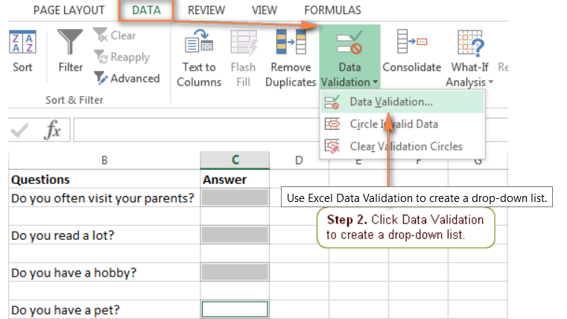

If you often edit the items in the drop-down menu, you may want to create a dynamic drop-down list in Excel. In this case, your list will get updated automatically in all the cells that contain it, once you remove or add new entries to the source list.

The easiest way to create such a dynamically updated drop-down list in Excel is by creating a named list based on a table as table range will be automatically increased as we add data.

If for some reason you prefer a usual named range, then reference it using the OFFSET formula, as explained below.

Create a named range using Name Manager with OFFSET formula

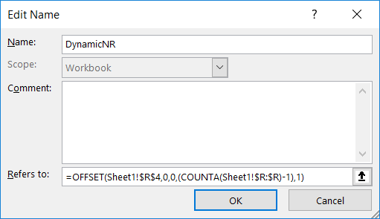

Then create a data validation list in the cell where you want to create the list and pass this name and a dynamic list will be created.

## MAKING DROP-DOWN LIST EDITABLE

By default, the drop-down list you create in Excel is non-editable, i.e. restricted to the values in the list. However, you can allow your users to enter their own values.

Technically, this turns a drop-down list into an Excel combo box. The term "combo box" means an editable dropdown that allows users to either select a value from the list or type a value directly in the box.

In the Data Validation dialog (Data tab > Data Validation), go to the Error Alert tab.

Select the "Show error alert after invalid data is entered" box if you want to show an alert when a user attempts to enter some data that is not in the drop-down menu. If you don't want to show any message, clear this check box.

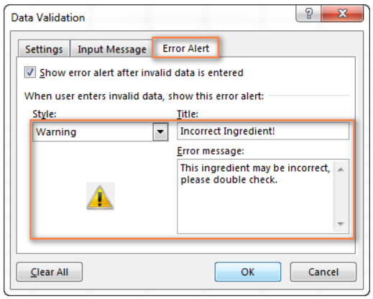

## DROP-DOWN LIST (DUPLICATE DATA)

On the whole, there are 4 ways to make a drop-down menu in Excel, and all of them have their own strong and weak points.

## DELETING DROP-DOWNLIST

Deleting an Excel drop-down list from all cells in the current sheet

* Select any cell containing your drop-down list.
* Click Data Validation on the Data tab.
* In the Data Validation window, on the Settings tab, select the "Apply these changes to all other cells with the same settings" check box.

Once you check it, all of the cells referencing this Excel Data Validation list will get selected.

* lick the Clear All button to delete the drop-down list.
* Click OK to save the changes and close the Data Validation window.

If you created a dropdown [based on a range of cells](https://www.ablebits.com/office-addins-blog/2014/09/24/excel-drop-down-list/#dropdown-list-from-cells) or [based on a named range](https://www.ablebits.com/office-addins-blog/2014/09/24/excel-drop-down-list/#dropdown-list-named-range), the source list will also remain intact. To remove it, open the worksheet containing the drop-down list's items, and delete them.

# PIVOT TABLE

Being able to quickly analyze data can help you make better business decisions. But sometimes it’s hard to know where to start, especially when you have a lot of data. PivotTables are a great way to summarize, analyze, explore, and present your data, and you can create them with just a few clicks. PivotTables are highly flexible and can be quickly adjusted depending on how you need to display your results. You can also create PivotCharts based on PivotTables that will automatically update when your PivotTables do. Pivot table cannot work with unstructured data.

Before you get started:

* Your data should be organized in a tabular format, and not have any blank rows or columns.
* Tables are a great PivotTable data source, because rows added to a table are automatically included in the PivotTable when you refresh the data, and any new columns will be included in the PivotTable Fields List. Otherwise, you need to either manually update the data source range or use a dynamic named range formula.
* Data types in columns should be the same. For example, you shouldn't mix dates and text in the same column.
* PivotTables work on a snapshot of your data, called the cache, so your actual data doesn't get altered in any way.

To insert a Pivot Table, select the data range and then go to Insert menu tab. Here you will find PivotTable and Recommended Pivot tables option. Select 1 as per requirement.

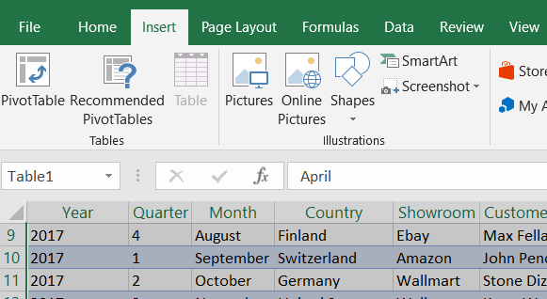

In Pivot table, sum is the default calculation type. If the column contains blanks or NA or Error then it will default to COUNT.

## PIVOT TABLE FIELDS

Pivot table has 4 fields

* Filters
* Columns
* Rows
* Values

In the Field Name area at the top, select the check box for any field you want to add to your PivotTable.

* By default, non-numeric fields are added to the Row area
* Date and time fields are added to the Column area,
* Numeric fields are added to the Values area.

You can also manually drag-and-drop any available item into any of the PivotTable fields, or if you no longer want an item in your PivotTable, simply drag it out of the Fields list or uncheck it. Being able to rearrange Field items is one of the PivotTable features that makes it so easy to quickly change its appearance.

Dates are numbers in Excel. If the table column contains a year such as 2017 or 2018 and are formatted as numeric or number it will be interpreted as 09/07/1905 and 10/07/1905 respectively.

## THE DATA MODEL OPTION

Added to the 2013 release of Excel, the Data Model feature allows you to relate multiple Excel tables together and then build PivotTables from the related tables. Using this approach, you can effectively build a PivotTable from multiple Excel-based data sources, as long as you maintain those sources as tables. Steps to cerate the PIVOT table using data model are mentioned below:

1. CREATING THE DATA MODEL

Before you can build a PivotTable from multiple tables, you must first add the tables to the Data Model. To do so, first ensure that each of the data sources you wish to include in your PivotTable are stored in Excel Workbook as tables, if not, convert each data range to a table by clicking in the data range and then choosing Format as Table from the Home tab of the Ribbon. Next, click on any cell in any one of the tables in the workbook and create PivotTable

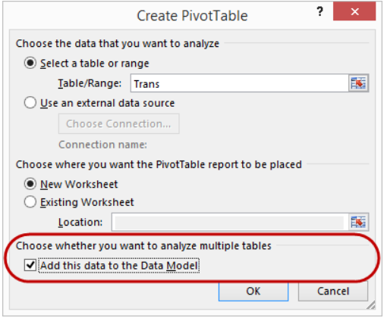

1. ESTABLISHING RELATIONSHIPS

Upon closing the Create PivotTable dialog box, Excel displays a window similar to that pictured in Figure 2. Clicking All in the PivotTable Field List causes Excel to show all of the tables included in the Data Model. In the example shown, two tables exist in the Data Model – Product and Trans. The horizontal line drawn between the two tables indicates that these tables are not related. Relating the tables together “joins” them based on the presence of a common field (column) that resides in each table.

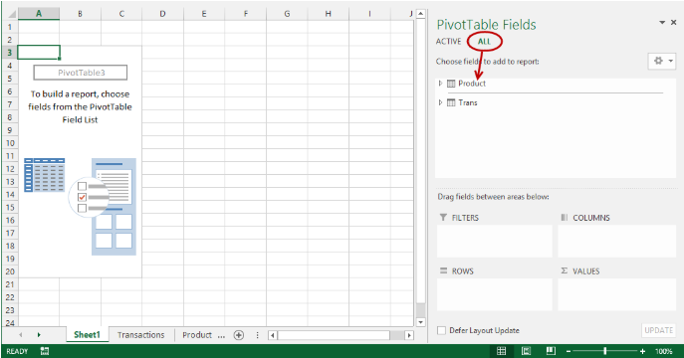

To relate two tables together, click Relationships from the PivotTable Tools Analyze tab of the Ribbon to open the Manage Relationships dialog box. In the Manage Relationships dialog box, click New to open the Create Relationships dialog box. In the Create Relationships dialog box, select the tables you want to relate together on the left side of the dialog box and the common fields that exist between the two tables on the right side of the dialog box. Figure 3 depicts this process. Click OK to complete the process of relating the tables.

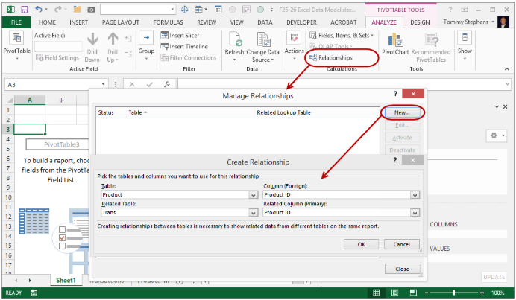

1. BUILDING A PIVOTTABLE

With the tables related, the process of building the PivotTable is virtually identical to that of building a PivotTable from a non-related, single data source.

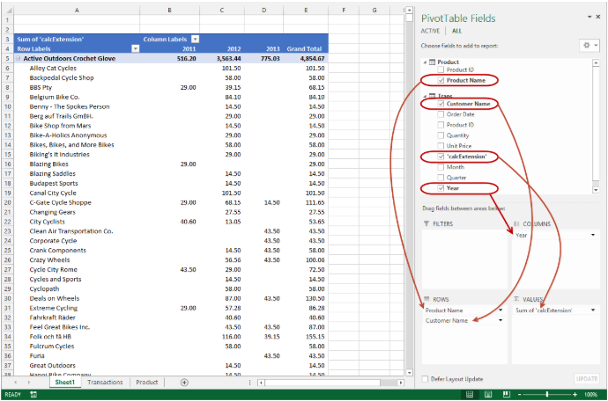

## PIVOT TABLE OPTIONS

Sometimes the pivot data source contains blank cells, instead of leaving these cells blank, you can change a pivot table option, to show a zero, or other characters, in those cells:

Pivot table options can be accessed from settings on the Ribbon or Pivot Table Options dialog box.

To access this, right-click on any cell in the pivot table and click PivotTable Options.

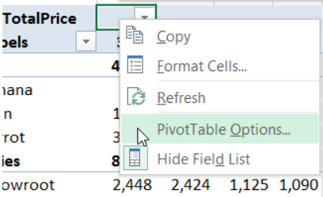

To change what appears in empty cells, follow these steps:

* Right-click a cell in the pivot table, and in the popup menu, click PivotTable Options.
* In the PivotTable Options dialog box, click the Layout & Format tab
* In the Format section, add a check mark to For Empty Cells, Show
* In the text box, type a zero, or other characters, such as N/A
* Click OK to close the dialog box.

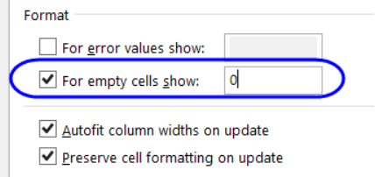

The pivot table will change, to show the characters that you entered. In the screen shot below, N/A shows in the empty cells.

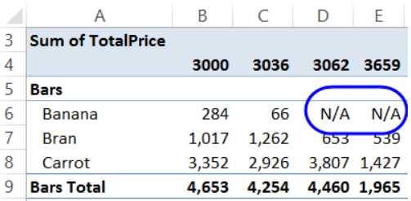

You can also use the ‘Autofit Column widths on update’ option to either fix with or make it change on update as per requirement.

## SUMMARIZING DATA IN PIVOT

When you add a field to the pivot table's values area, 11 different functions, such as Sum, Count and Average, are available to summarize the data.

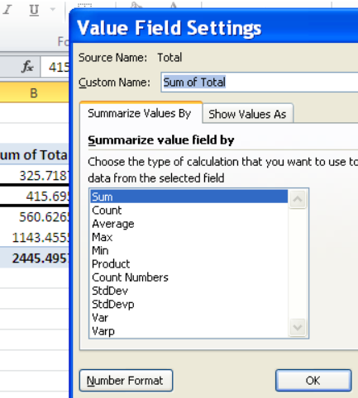

The summary functions in a pivot table are similar to the worksheet functions with the same names, with a few differences as noted in the descriptions that follow.

When you add a numerical field to the pivot table's Values area, Sum or Count will be the default summary function. The default function can't be changed -- it is applied based on the field's contents:

* If the field contains numbers, Sum will be the default
* If the field contains text or blank cells, Count will be the default

After a field has been added to the pivot table, to select a different summary function, follow these steps:

* Right-click on a cell in the Value field that you want to change.
* In the pop-up menu, click Summarize Values By
* Click on the Summary Function that you want to use

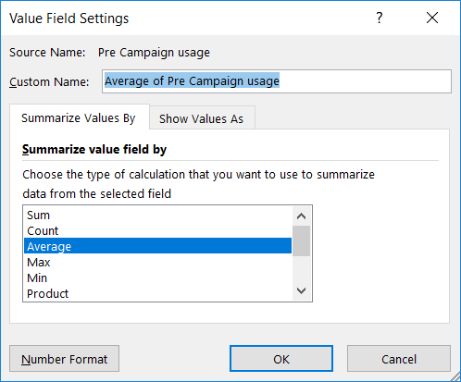

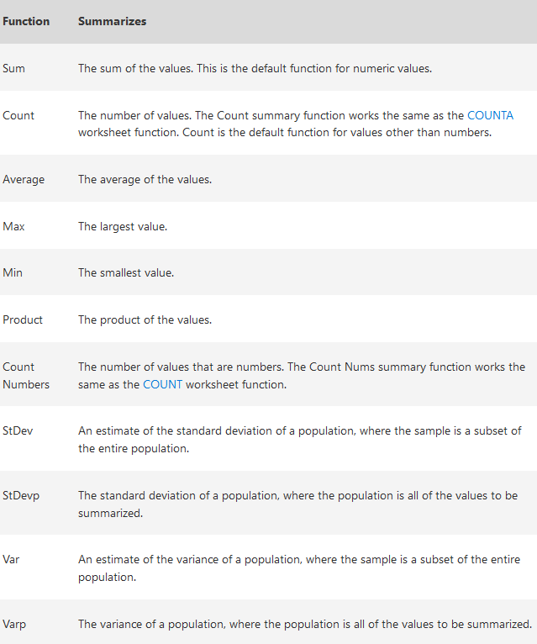

Show value as box has following options:

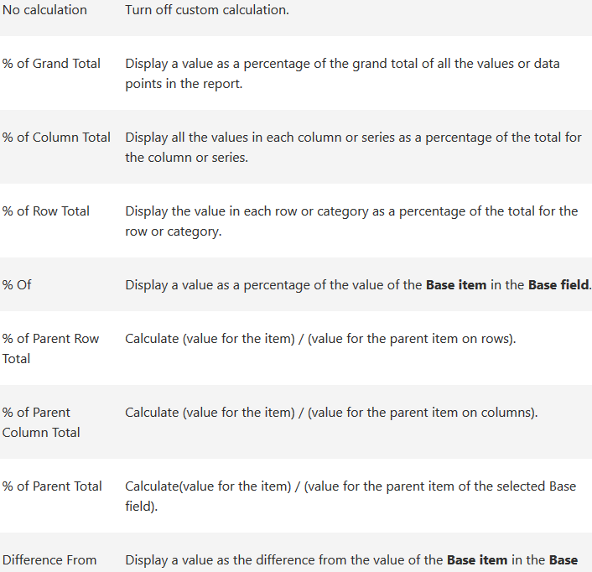

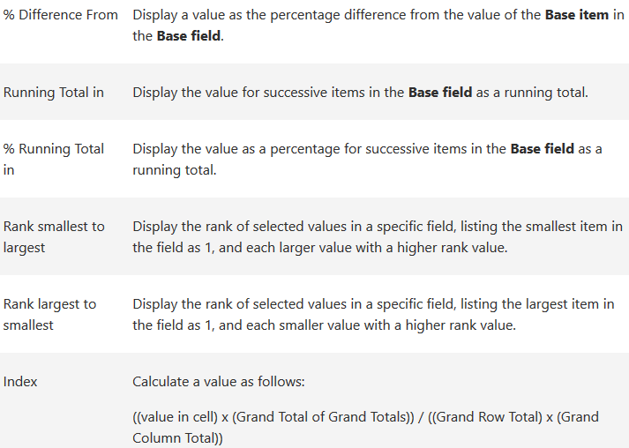

## CALCULATED FIELD

In a pivot table, you can create a new field that performs a calculation on the sum of other pivot fields. Calculated fields are usually used to create column labels and calculated items can be used to create row labels.

Features

* For calculated fields, the individual amounts in the other fields are summed, and then the calculation is performed on the total amount.
* Calculated fields are automatically available in all pivot tables that are based on the same pivot cache

Limitations

* Calculated field formulas cannot refer to the pivot table totals or subtotals
* Calculated field formulas cannot refer to worksheet cells by address or by name.
* Sum is the only function available for a calculated field.
* Calculated fields are not available in an OLAP-based pivot table.

For example: The sales reps will earn a 3 percent bonus on their Total Sales. To show the bonuses, you can add a calculated field to the pivot table. In this example, the formula will multiply the Total field by 3%.

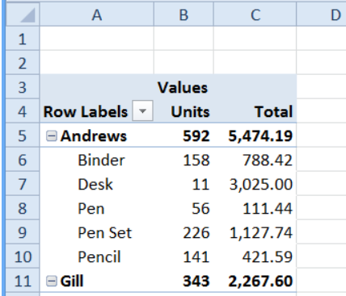

To add a calculated field, select a cell in the pivot table, and on the Excel Ribbon, under the PivotTable Tools tab, click the Options tab (Analyze tab in Excel 2013).

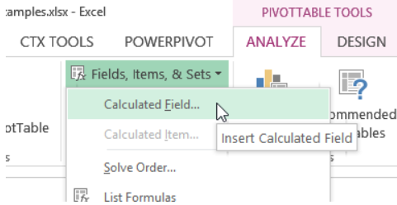

Enter the formula as required

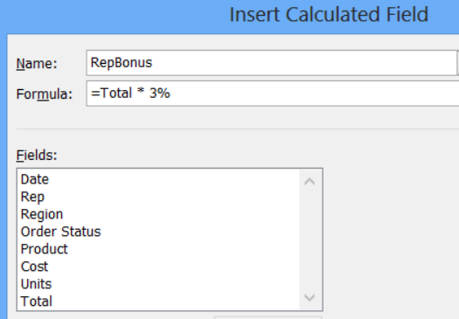

The RepBonus field appears in the Values area of the pivot table, and in the field list in the PivotTable Field List

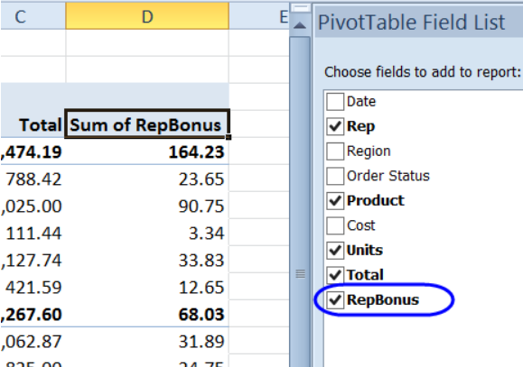

PROBLEM WITH CALCULATED FIELD TOTALS

When you create a calculated field, you might expect to see a sum of the calculated amounts, in the pivot table's subtotal and grand total rows. However, the calculated field uses the same calculation in the subtotal and grand total rows, instead of showing a sum. Hence Cannot refer to Grand Total/ Sub Total columns & cells in sheet.

For example, in the Bonus calculated field, shown above, the total bonus for Andrews is 164.23, instead of 70.13 (23.65+33.83+12.65). This happens because Excel uses the same calculation in the Total and Subtotal rows, instead of summing.

We cannot directly put text in Pivot table/ calculated field but we can use custom format to achieve same. For example, 0 and 1 can be custom formatted to TRUE and FALSE. The custom columns can’t be used in calculations.

## CALCULATED ITEM

In addition to the existing items (row labels) in a pivot table field, you can create one or more calculated items

If you create a calculated item in a field, you will:

* NOT be able to move the field to the Report Filters area
* NOT be able to add multiple copies of a field to the Values area.
* Extra items might be created in the pivot tables, such as cities appearing in all regions, with zero values.

In this example, the pivot table contains an Order Status field, and the orders currently have the following types of status:

* Shipped
* Pending
* Backorder
* Cancelled

In the pivot table, you could create a calculated item, named Sold, to sum all the units that have been sold, for orders with a status of Shipped, Pending, or Backorder.

Follow these steps to create a calculated item:

* In the pivot table, select a cell that contains an Order Status item. For example, select cell A5, that contains the Backorder item.
* On the Ribbon's Options tab, click Calculations

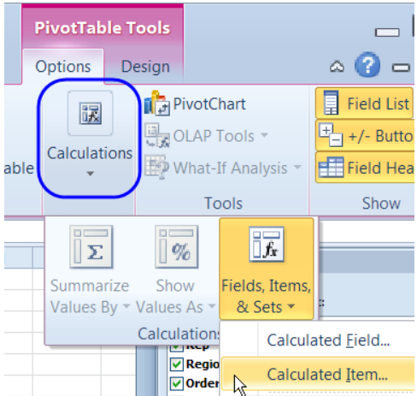

Type a name for the Calculated Item and move to the Formula box.

=Shipped + Pending + Backorder

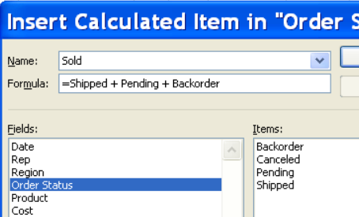

The new calculated item, Sold, is added to the Row area in the pivot table. However, the Grand Totals have increased, because the Sold item duplicates the values from other items.

## GRAND TOTALS

The selected summary function will automatically be used in the subtotals and grand totals for that field. However, we can select a different function for the totals.

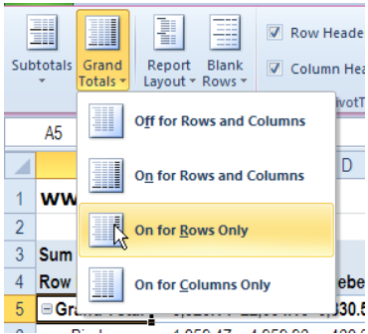

The Grand & Sub totals are calculated on the source data, not on the values showing in the pivot table. For example, if a field uses the MAX summary function, and the subtotal shows the AVERAGE, it will be an average from the values in the source data, not an average of the MAX values in pivot table column (To calculate the Average of the Max values, you could use formulas outside of the pivot table, or create a new pivot table, based on the original one).

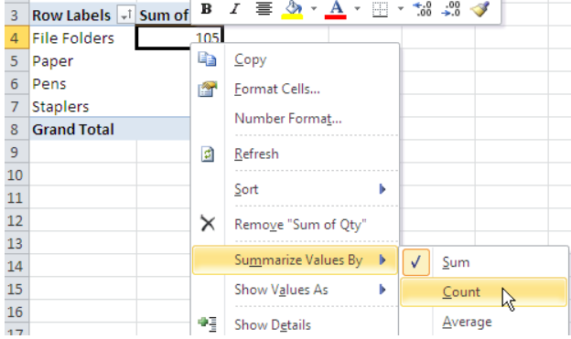

There's no setting that allows you to display the grand total at the top of an Excel pivot table. However, we can use another field that acts as the grand total and display it at the top.

## SUBTOTALS

If your pivot table has only one field in the Row Labels area, you won't see any Row subtotals.

In the pivot table shown below, Service is in the Row Labels area, Lead Tech is in the Column Labels area, and Labour Cost is in the Values area. Because Service is the only field in the Row Labels area, it has no subtotal.

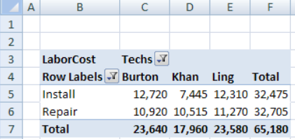

When you add another field to the Row Labels area, a subtotal is automatically created for the first field. In this example, the District field is added to the Row Labels area, below the Service field.

* The Service field is an Outer Field, because there is a field below it (District).
* The District field is an Inner Field, because there is NO field below it.

Because Service is now an Outer Field, it automatically has a subtotal after each Service type. Each subtotal shows the name of the Service type, and "Total", such as Install Total.

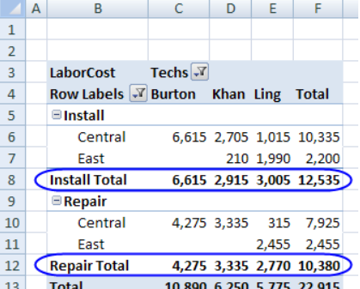

If you add another field to the Row Labels area, below the District field, the new field becomes the Inner Field, and District changes to an Outer Field.

In the pivot table below, the Technician Count field was added below District, and the District field now has a subtotal after each District name.

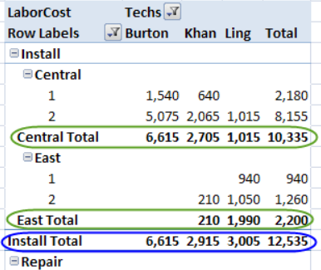

Notes:

* Column fields are not affected by the setting for Subtotals. Column subtotals always appear at the bottom of the group.
* The labels for the outer Row fields are always above the labels for the related inner fields, even when the subtotals are at the bottom of the group.

The position of the subtotals is also affected by the Report Layout applied to the pivot table.

* In Compact Form and Outline Form, you can show the subtotals at the top or bottom of the group.
* In Tabular Form, the labels for the outer Row fields are on the same row as the first label for the related inner fields, and the subtotals can only be shown at the bottom of the group

When a subtotal is added to a pivot table, its Summary Function is set to Automatic. With that setting, the subtotal automatically uses the same Summary Function as the Value fields in each column.

In the pivot table shown above, the Value fields are using the SUM function, so the subtotals also show the SUM of the values.

In the pivot table shown below, the Value fields have been changed to the MAX function, so the subtotals also show the MAX of the values. A few of the MAX values are highlighted in green, to show that the values and both subtotals are the same.

Even though the Summary Function has been changed to MAX, each subtotal still shows the name of the item, and "Total", such as Central Total, subtotal label changed

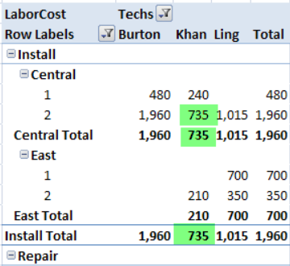

Instead of using the Automatic setting for subtotals, you can create a custom subtotal in a pivot table, either a single custom subtotal or multiple custom subtotals.

To create a custom subtotal:

* Right-click a label for the field in which you want to change the subtotal. In this example, right-click cell B5, which has the Install label.
* In the pop-up menu, click Field Settings
* In the Field Settings dialog box, click the Subtotals & Filters tab
* Under Subtotals, click Custom
* In the list of Summary Functions, click one or more function names
* Click OK to close the dialog box.

Note: The subtotals will be calculated on the source data, not on the values showing in the pivot table. For example, if a field uses the MAX summary function, and the subtotal shows the AVERAGE, it will be an average from the values in the source data, not an average of the MAX values. (To calculate the Average of the Max values, you could use formulas outside of the pivot table, or create a new pivot table, based on the original one.)

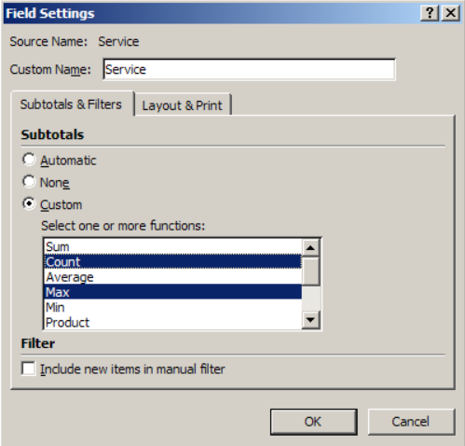

Automatic subtotals will appear for normal fields and calculated fields in a pivot table. However, custom subtotals will not appear for calculated fields. The custom subtotals will be blank for any calculated fields in the pivot table layout.

## REPORT LAYOUTS

When you create a new pivot table, it is automatically formatted with the Compact Form layout, by default. After you create the pivot table, you can change to one of the other layouts. Three layouts are available for pivot tables:

* Compact Form
* Outline Form
* Tabular Form

NOTE: There is no way to change this setting, to make one of the other layouts the default.

To change the layout:

* Select a cell in the pivot table.
* On the Ribbon, under the PivotTable Tools tab, click the Design tab.
* At the left, in the Layout group, click the Report Layout command
* Click the layout that you want to uses, e.g. Show in Outline Form

The pivot table will change to the selected layout.

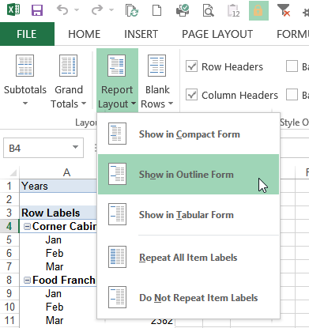

### COMPACT FORM

The default report layout for a pivot table is Compact Form, shown below. There are two Row fields -- Customer and Date.

The Compact Form layout may be useful when you want to reduce the pivot table width and aren't concerned about the Row field headings.

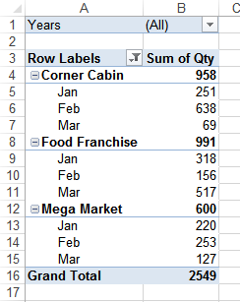

ROW LABELS

* In Compact Form, each Row label is in a separate row.
* The Row field label is always above the labels for the inner fields
* Each Row label is slightly indented, from the field above it, to differentiate the fields
* The Row labels cannot be repeated.
* The indentation can be changed, in PivotTable Options, on the Layout & Format tab

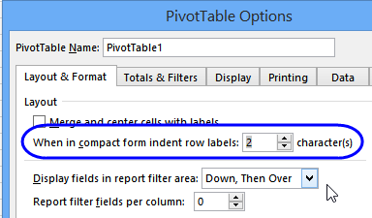

ROW FIELDS

* In Compact Form, all the Row fields are in a single column.
* There is a generic heading, Row Labels, in the Row Field column

SUBTOTALS

* In Compact Form, Subtotals can be shown at the Top or Bottom of each group.
* This setting affects all the Row fields
* For Column fields, Subtotals are always shown at the Bottom
* The Row label remains at the top, even if Subtotals are at the bottom. go to top

### OUTLINE FORM

In Outline Form, each Row field is in a separate column, as you can see in the pivot table below. There are two Row fields -- Customer and Date.

The Outline Form layout may be useful when you want to show all the field names as heading labels and aren't concerned about the width of the pivot table

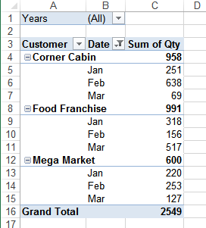

ROW LABELS

* In Outline Form, each Row label is in a separate row.
* The Row field label is always above the labels for the inner fields
* The Row labels can be repeated.

ROW FIELDS

* In Outline Form, each Row field is in a separate column.
* Each Row field shows its name in the column heading

SUBTOTALS

* In Outline Form, Subtotals can be shown at the Top or Bottom of each group.
* This setting affects all the Row fields
* For Column fields, Subtotals are always shown at the Bottom
* The Row label remains at the top, even if Subtotals are at the bottom go to top

### TABULAR FORM

In Tabular Form, each Row field is in a separate column, as you can see in the pivot table below. There are two Row fields -- Customer and Date. The Row labels are not in a separate row.

The Tabular Form layout may be useful when you want to show all the field names as heading labels and aren't concerned about the width of the pivot table but want to reduce the number of rows.

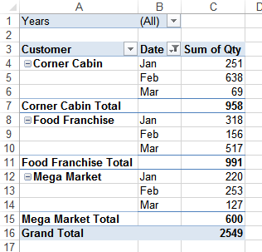

ROW LABELS

* In Tabular Form, Row labels for the outer fields are on the same row as the first label for the related inner fields.
* The Row labels can be repeated.

ROW FIELDS

* In Tabular Form, each Row field is in a separate column.
* Each Row field shows its name in the column heading

Subtotals

* In Tabular Form, Subtotals can only be shown at the Bottom of each group.
* This setting affects all the Row fields
* For Column fields, Subtotals are always shown at the Bottom.

## GROUPING DATA IN PIVOT

In a pivot table, you can group dates, number and text fields. For example, group order dates by year and month, or group test scores in bands of 10. You can manually select text items in a pivot table field and group the selected items. This lets you quickly see subtotals for a specific set of items in your pivot table.

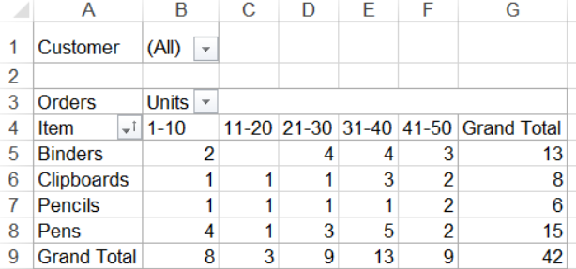

### GROUP BY DATE

To group the items in a Date field

* Right-click on one of the dates in the pivot table.
* In the popup menu, click Group

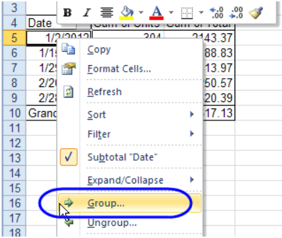

* In the Grouping dialog box, select one or more options from the 'By' list.
* To limit the dates that are grouped, you can set a Start and End date, by typing the dates in the 'Starting at' and 'Ending at' boxes
* Click OK to close the dialog box.

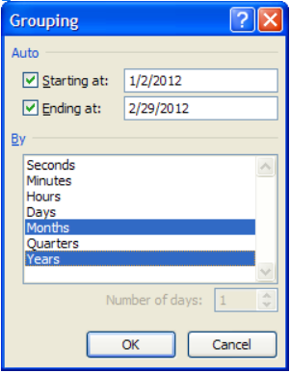

GROUPING DATES BY WEEK

To group the items in a Date field by week

* Right-click on one of the dates in the pivot table.
* In the popup menu, click Group
* In the Grouping dialog box, select Days from the 'By' list.
* For 'Number of days', select 7
* The week range is determined by the date in the 'Starting at' box, so adjust this if necessary. In the example below, January 1, 2012, was entered as the starting date.
* Click OK

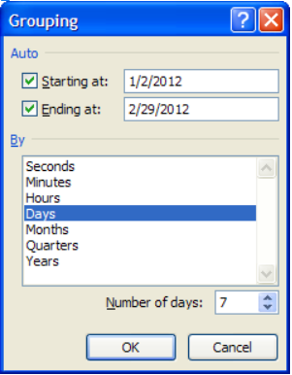

When a date field is grouped, new items are added, for all the dates before the start date and after the end date. These items start with a "<" or a ">" symbol, such as "<1/3/2013" and ">12/30/2014" and are based on the first and last date in the source data.

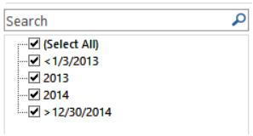

There is no way to remove these extra items, but you could change the captions, to replace the text with space characters. Or, add new fields in the source data, to calculate the year and year/month, for each date, and use the new fields in the pivot table, instead of grouping.

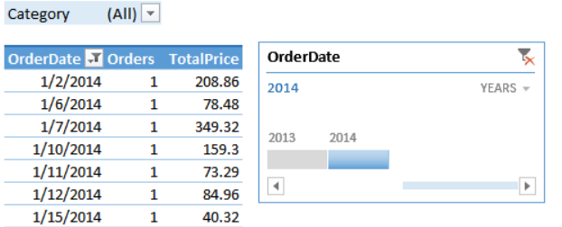

In Excel 2013, you can use the Timeline filter, to quickly filter by year, quarter, month or day.

### GROUPING NUMBERS

Instead of listing numbers individually in a Row field, you can group them, to create a concise summary of the data.

In this example, the original pivot table shows the units sold, per product. In column C, it shows the number of orders where that quantity was sold.

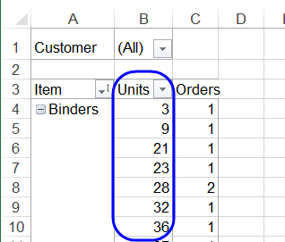

To summarize the orders, group the units by tens. So, instead of 3 and 9 appearing in separate rows, they'll be summarized in the grouping 1-10.

To group the numbers:

* Right-click on one of the unit numbers in the pivot table.
* In the popup menu, click Group
* In the Grouping dialog box, enter 1 in the Starting At box
* In this example, the highest number of units is 50, and you can type a higher number, if necessary.
* Click OK, to apply the grouping

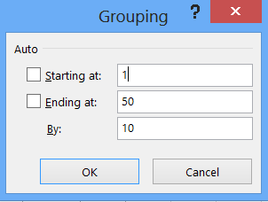

In the pivot table, the Units now appear in groups -- 1 - 10, 11 - 20, etc.

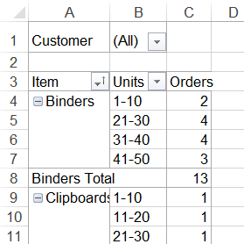

To make a more concise layout, you could move the grouped units field to the Columns area, as headings.

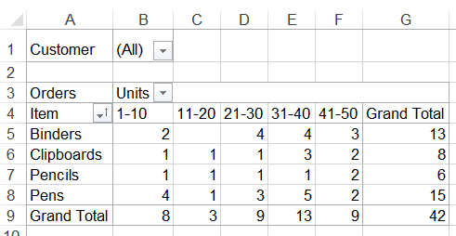

### GROUPING TEXT

The Grouping dialog box isn't available if you try to group items in a text field. Instead, you can manually group the items.

* Select the items that you want to group
* Right-click on one of the selected items, and click Group

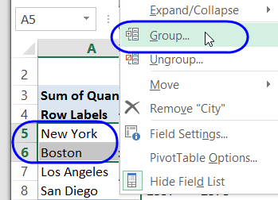

This creates a new field in the field list, with the original field name and a number, such as City2

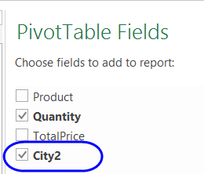

The new field is positioned above the original field in the pivot table layout, and the grouped items have a generic name, such as Group1.

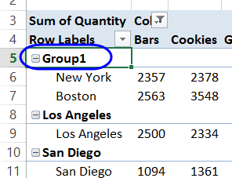

To rename the group:

* Click on the heading cells with the default name, e.g. Group1
* Type a new name, such as Campaign A.

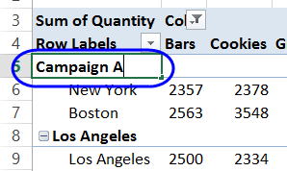

To add more items to a group:

* Select all of the items in the group
* Press the Ctrl key, and select the items that you want to add to the group
* Right-click on one of the selected items, and click Group
* NOTE: If the group was renamed, that name will be overwritten with a default name.

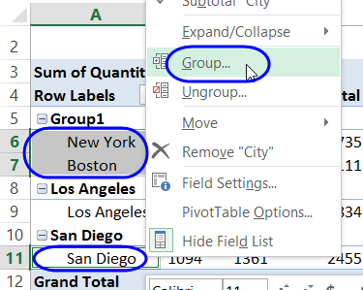

UNGROUPING TEXT ITEMS

After you manually group text items, you might want to ungroup some, or all, of the groups in a pivot field. To ungroup a single group:

* Right-click on an item in the group
* Click Ungroup, and the group reverts to individual items.

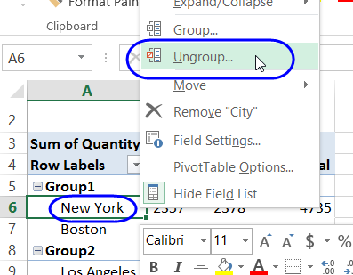

PROBLEMS WHEN GROUPING DATA

If you try to group a date or number field, you may see an error message that says, "Cannot group that selection." This might be caused by the Data Model, or cells that are blank, or previously grouped items. See the details below.

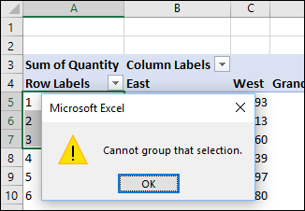

When you created the pivot table, if you checked the box to "Add this data to the Data Model", you won't be able to group the items. Instead of a normal pivot table, it is an OLAP-based Power Pivot, and the grouping feature is not available.

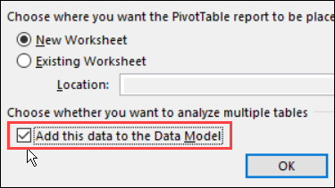

BLANK CELLS OR TEXT

In a normal pivot table (not in the data model), the grouping problem usually occurs when the field contains records with

* A blank cell in a date/number field, or
* A text entry in a date/number field.

To fix the problem

* For blank cells, fill in the date/number (use a dummy date/number if necessary).
* If there is text in the date/number field, remove it.
* If numbers are being recognized as text, use one of the techniques to change text to real numbers. Then return to this pivot table tutorial and try the grouping steps.

PREVIOUS GROUPING

If you don't have blank cells or text in the date column, there may be a grouped field left over from the previous time that you grouped the data.

* Check the field list, to see if there's a second copy of the date field, e.g. Date2.
* If there is, add it to the row area, and ungroup it.
* Then, you should be able to group the date field again.

GROUPING IN ONE PIVOT TABLE AFFECTS ANOTHER

If you create two pivot tables based on the same Excel Table in Excel 2007, when you change the grouping in one pivot table, the same grouping appears in the other pivot table.

Because you created the two pivot tables from the same source data, by default they use the same pivot cache, the grouped items are the same in both tables.

To use different grouping in each pivot table, you'll need to create a separate pivot cache for each pivot table.

Use the following method, suggested in the Excel newsgroups by Dave Peterson.

To create a separate pivot cache for the second pivot table:

* Cut the second pivot table and paste it into a new workbook.
* Change the grouping of the second pivot table.
* Cut the second pivot table from the new workbook and paste it back into the original workbook.

## SLICER

Slicers are a powerful new way to filter pivot table data. It's easy to add a Slicer:

Select a cell in the pivot table

On the Ribbon's Insert tab, click Slicer.

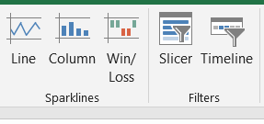

In the list of pivot table fields, add check marks for the slicer(s) you want to create

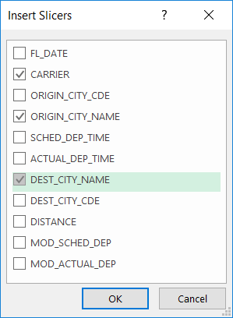

And slicers will be inserted to the sheet as shown below:

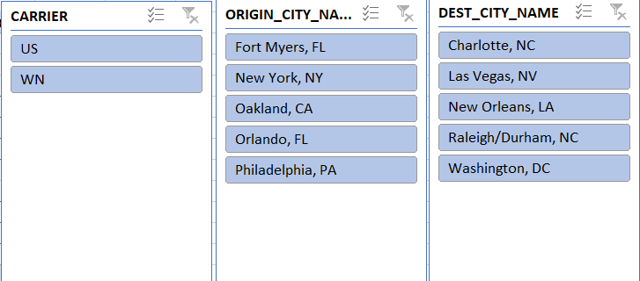

Right click on the slicer and below options will be displayed

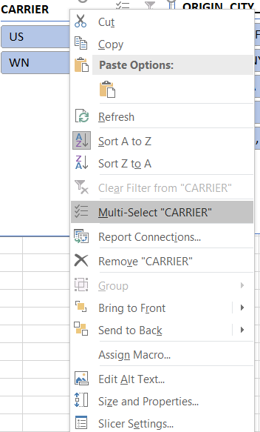

Multi-Select option will allow you to select multiple values in slicer. You can select an array of items by clicking the left mouse button and doing a dragging motion downwards/upwards within the Slicer.

Move and resize the slicers, if necessary, so they fit on the empty areas of the worksheet

Click on an item in a Slicer, to filter the pivot table. Other Slicers will show related items at the top.

insert slicer

## TIMELINE

Instead of adjusting filters to show dates, you can use a PivotTable Timeline—a dynamic filter option that lets you easily filter by date/time and zoom in on the period you want with a slider control. Click Analyze > Insert Timeline to add one to your worksheet.

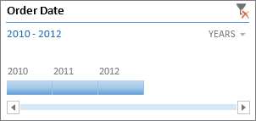

Much like a slicer for filtering data, you can insert a Timeline one time, and then keep it with your PivotTable to change the range of time whenever you like.

Here’s how:

* Click anywhere in a PivotTable to show the PivotTable Tools ribbon group, then click Analyze > Insert Timeline.

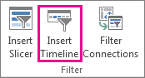

* In the Insert Timeline dialog box, check the date fields you want, and click OK.

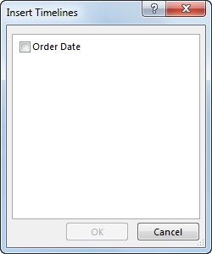

USE A TIMELINE TO FILTER BY TIME PERIOD

With your Timeline in place, you’re ready to filter by a time period in one of the four time’s levels (years, quarters, months, or days).

Click the arrow next to the time level shown and pick the one you want.

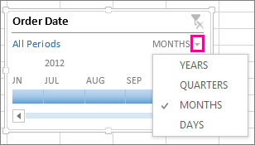

Drag the Timeline scroll bar to the time period you want to analyze.

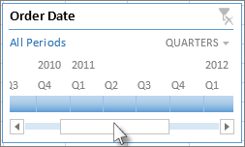

In the timespan control, click a period tile and drag to include additional tiles to select the date range you want. Use the timespan handles to adjust the date range on either side.

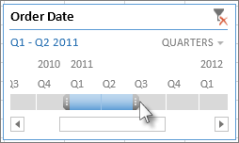

USE A TIMELINE WITH MULTIPLE PIVOTTABLES

Provided your PivotTables are using the same data source, you can use a single Timeline to filter multiple PivotTables. Select the Timeline, then on the ribbon, go to Options > Report Connections, and select the PivotTables you want to include.

CLEAR A TIMELINE

To clear a timeline, click the Clear Filter button Clear Filter button.

Tip: If you want to combine slicers with a timeline to filter the same date field, you can do that by checking the Allow multiple filters per field box in the PivotTable Options dialog box (PivotTable Tools > Analyze > Options > Totals & Filters tab).

CUSTOMIZE A TIMELINE

When a timeline covers your PivotTable data, you can move it to a better location and change its size. You can also change the timeline style, which may be useful if you have more than one timeline.

* To move the timeline, simply drag it to the location you want.
* To change the size of the timeline, click it, and then drag the sizing handles to the size you want.
* To change the style of the timeline, click it to display the Timeline Tools, and then pick the style you want on the Options tab.

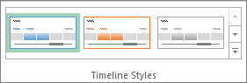

## DATE ISSUE IN PIVOT TABLE

Problem: Imagine a pivot table where the dates need to be categorized by Year-Month. For example, if today's date was 2014.08.13, and you needed a column header displayed as "2014-08". The trouble is the formula displays the year as 1905.

Assume Cell A3 contains the date: 08/13/2014 21:21 and is formatted as Date Value. Notice cell D3, which is supposed to show only they year, shows as 1905 when it clearly should be 2014,

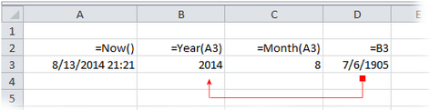

D3 was improperly assembled from a "sub-date," using a formula =B3 *and* it was formatted as a date-cell. This is a mistake.

Do not use intermediate or sub-dates for any date-calculation or format. Always point to a full-date cell. Most people are trying to format a cell as 2013-08 (YYYY-MM) and they are trying to assemble the constituent parts "YYYY" + "MM" to get the result. This will fail.

We can use TEXT function to solve this problem:



## DEFER LAYOUT UPDATE

When a Pivot Table is inserted in the excel sheet, in PivotTable Fields below you can see a checkbox Deferred Layout Update. PivotTables are updated each time a field is added, removed, or moved to a different position. For PivotTables based on large data sets, these actions can take some time to complete, meaning, for example, you end up waiting 10 times if you create a new a PivotTable and add 10 fields.

We can enable the Deferred Layout Update and drag and move fields between areas according to our requirement. The PivotTable report will not update unless we click on the Update button below at the corner of the PivotTable Fields. This technique will save your lot of time.

## PIVOT CHARTS

All pivot charts are based on pivot tables, so in order to have a pivot chart you must also have a pivot table.

If you’re creating a pivot chart from scratch, first select a cell in PIVOT TABLE, then go to the Insert tab and click the Pivot Table menu. From the menu, choose Pivot Chart.

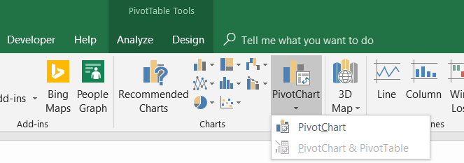

After clicking on PivotChart option below dialogue box is presented to user

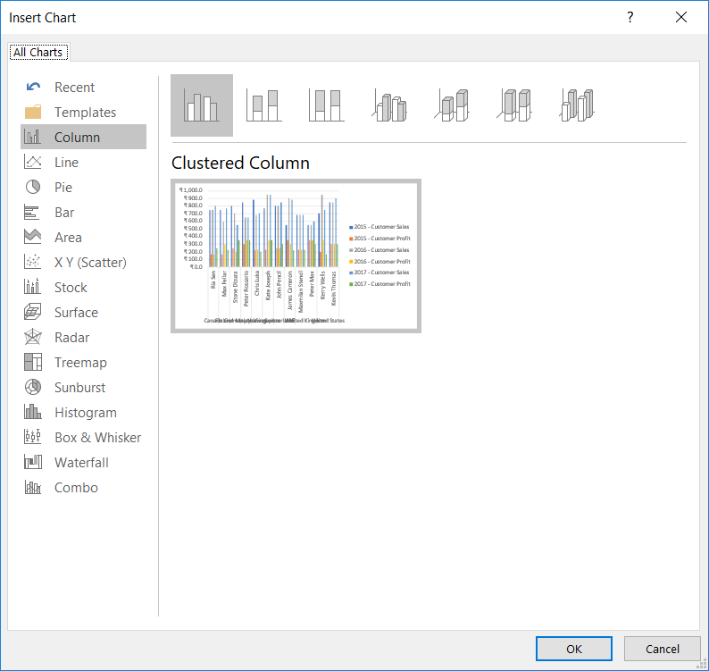

On clicking OK, a chart is inserted on the sheet

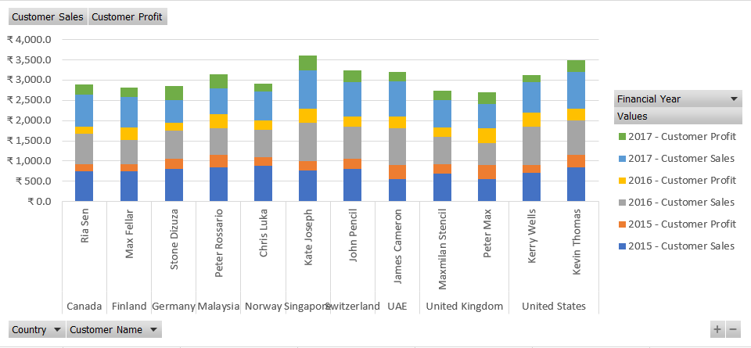

The names in the field list pane are slightly different when the chart is selected - Row Labels are called Axis fields, and Column labels are referred to as Legend Fields.

If we select the pivot chart and move Region from the Axis field area to the Legend field area, both the pivot chart and the pivot table are reconfigured. If we select the pivot table and move Region back to the Row Labels area, we reverse the change.

# CHARTS

Charts and graphs elevate your data by providing an easy-to-understand visualization of numeric values. While the terms are often used interchangeably, they are slightly different. Graphs are the most basic way to represent data visually, and typically display data point values over a duration of time. Charts are a bit more complex, as they allow you to compare pieces of a data set relative to the other data in that set. Charts are also considered more visual than graphs, since they often take a different shape than a generic x- and y-axis.

People often use charts and graphs in presentations to give management, client, or team members a quick snapshot into progress or results. You can create a chart or graph to represent nearly any kind of quantitative data — doing so will save you the time and frustration of poring through spreadsheets to find relationships and trends.

It’s easy to create charts and graphs in Excel, especially since you can also store your data directly in an Excel Workbook, rather than importing data from another program. Excel also has a variety of preset chart and graph types so you can select one that best represents the data relationship(s) you want to highlight.

## CHART AND GRAPH TYPE IN EXCEL

Excel offers a large library of chart and graph types to help visually present your data. While multiple chart types might “work” for a given data set, it’s important to select a chart type that best fits with the story you want the data to tell. Of course, you can also add graphical elements to enhance and customize a chart or graph. In Excel 2016, there are five main categories of charts or graphs:

* **Column Charts:** Some of the most commonly used charts, column charts, are best used to compare information or if you have multiple categories of one variable (for example, multiple products or genres). Excel offers seven different column chart types: clustered, stacked, 100% stacked, 3-D clustered, 3-D stacked, 3-D 100% stacked, and 3-D, pictured below. Pick the visualization that will best tell your data’s story.

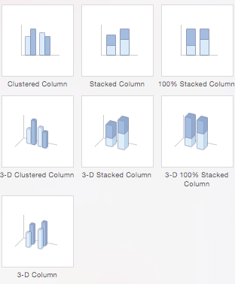

* **Bar Charts:** The main difference between bar charts and column charts are that the bars are horizontal instead of vertical. You can often use bar charts interchangeably with column charts, although some prefer column charts when working with negative values because it is easier to visualize negatives vertically, on a y-axis.



* **Pie Charts:** Use pie charts to compare percentages of a whole (“whole” is the total of the values in your data). Each value is represented as a piece of the pie so you can identify the proportions. There are five pie chart types: pie, pie of pie (this breaks out one piece of the pie into another pie to show its sub-category proportions), bar of pie, 3-D pie, and doughnut.

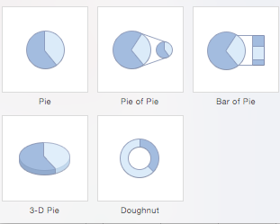

* **Line Charts:** A line chart is most useful for showing trends over time, rather than static data points. The lines connect each data point so that you can see how the value(s) increased or decreased over a period of time. The seven-line chart options are line, stacked line, 100% stacked line, line with markers, stacked line with markers, 100% stacked line with markers, and 3-D line.

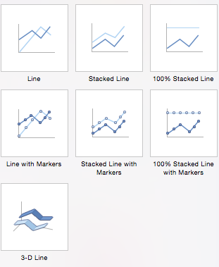

* **Scatter Charts:** Similar to line graphs, because they are useful for showing change in variables over time, scatter charts are used specifically to show how one variable affects another. (This is called correlation.) Note that bubble charts, a popular chart type, is categorized under scatter. There are seven scatter chart options: scatter, scatter with smooth lines and markers, scatter with smooth lines, scatter with straight lines and markers, scatter with straight lines, bubble, and 3-D bubble.

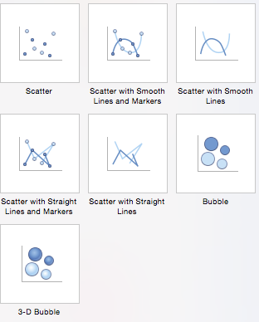

There are also four minor categories. These charts are more use case-specific:

* **Area:** Like line charts, area charts show changes in values over time.
* **Stock:** Traditionally used to display the high, low, and closing price of stock, this type of chart is used in financial analysis and by investors.
* **Surface:** Use a surface chart to represent data across a 3-D landscape. This additional plane makes them ideal for large data sets, those with more than two variables, or those with categories within a single variable.
* **Radar:** When you want to display data from multiple variables in relation to each other use a radar chart. All variables begin from the central point. The key with radar charts is that you are comparing all individual variables in relation to each other — they are often used for comparing strengths and weaknesses of different products or employees.

Other popular charts in excel

* **Waterfall chart:** which is essentially a series of column graphs that show positive and negative changes over time. There is no Excel presets for a waterfall chart, but you can download a template to help make the process easier.

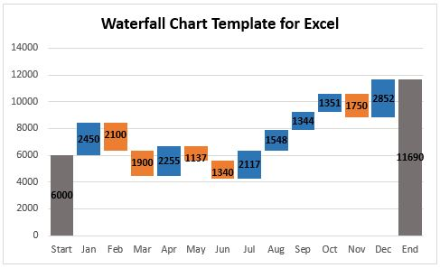

* **Combo Chart (Dual axis chart):** A combo (or combination chart) is a chart that plots multiple sets of data using two different chart types. A typical combo chart uses a line and a column.

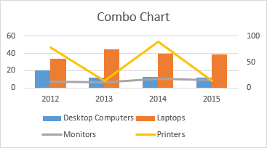

* **Step Charts:** are useful for showing values that don’t change steadily from one point to the next, but that instead are constant for a period of time, then jump to the next level, and are constant for another period of time. For example, step charts are good for showing how things like postal rates or interest rates change over time.

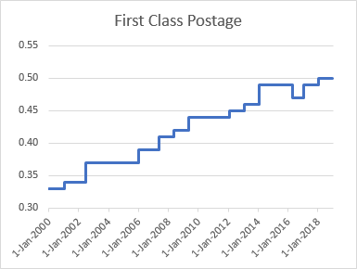

## CHART AND GRAPH BEST PRACTICES

Although Excel provides several layout and formatting presets to enhance the look and readability of your chart, using them won’t ensure that you maximize the effectiveness of your chart. Below are the top five best practices to make your chart or graph as clear and useful as possible:

* **Make It Clean:** Cluttered graphs — those with excessive colors or texts — can be difficult to read and aren’t eye catching. Remove any unnecessary information so your audience can focus on the point you’re trying to get across.
* **Choose Appropriate Themes:** Consider your audience, the topic, and the main point of your chart when selecting a theme. While it can be fun to experiment with different styles, choose the theme that best fits your purpose.
* **Use Text Wisely:** While charts and graphs are primarily visual tools, you will likely include some text (such as titles or axis labels). Be concise but use descriptive language, and be intentional about the orientation of any text (for example, it’s irritating to turn your head to read text written sideways on the x-axis).
* **Place Elements Intelligently:** Pay attention to where you place titles, legends, symbols, and any other graphical elements. They should enhance your chart, not detract from it.
* **Sort Data Prior to Creating the Chart:** People often forget to sort data or remove duplicates before creating the chart, which makes the visual unintuitive and can result in errors.

## CREATE A CHART

To create a line chart, execute the following steps.

1. Select the range A1:D7.

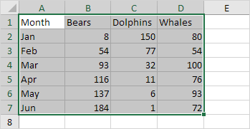

1. On the Insert tab, in the Charts group, click the Line symbol.

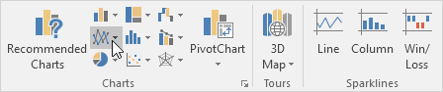

1. Click Line with Markers.

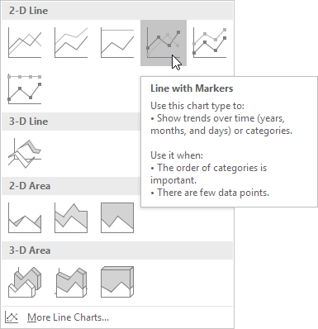

Result:

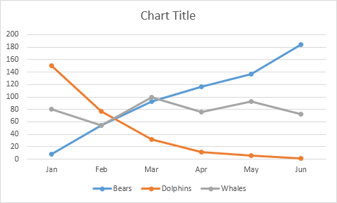

Note: Enter a title by clicking on Chart Title. For example, Wildlife Population.

## CHANGE CHART TYPE

You can easily change to a different type of chart at any time.

* Select the chart.
* On the Design tab, in the Type group, click Change Chart Type.

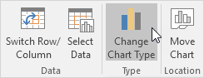

* On the left side, click Column.

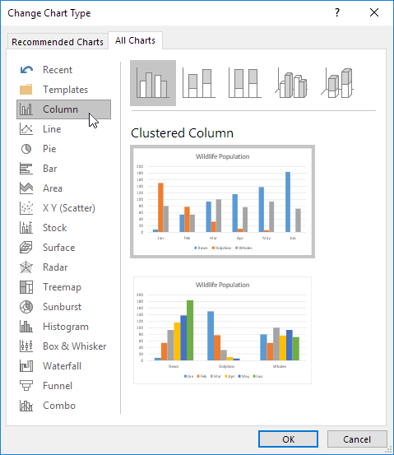

* Click OK.

Result:

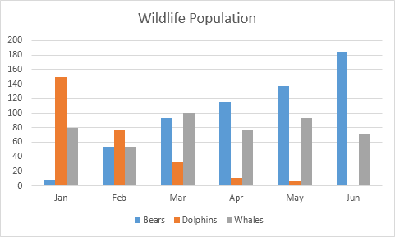

## SWITCH ROW/COLUMN

If you want to display the animals (instead of the months) on the horizontal axis, execute the following steps.

1. Select the chart.
2. On the Design tab, in the Data group, click Switch Row/Column.

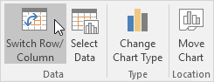

Result:

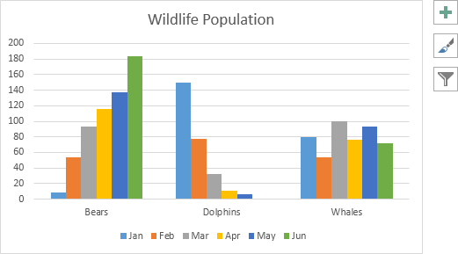

## LEGEND POSITION

To move the legend to the right side of the chart, execute the following steps.

1. Select the chart.
2. Click the + button on the right side of the chart, click the arrow next to Legend and click Right.

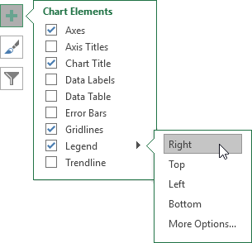

Result:

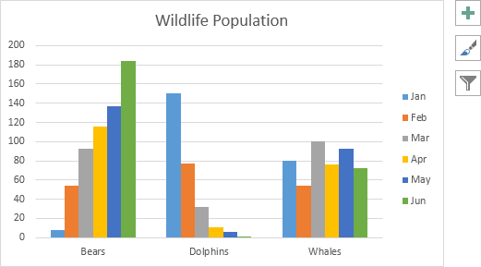

## DATA LABELS

You can use data labels to focus your readers' attention on a single data series or data point.

1. Select the chart.
2. Click a green bar to select the Jun data series.
3. Use your arrow keys to select the population of Dolphins in June (tiny green bar).
4. Click the + button on the right side of the chart and click the check box next to Data Labels.

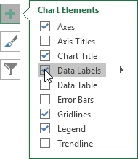

# DASHBOARD

An Excel dashboard is one pager (mostly, but not always necessary) that helps managers and business leaders in tracking key KPIs or metrics and take a decision based on it. It contains charts/tables/views that are backed by data.

A dashboard is often called a report, however, not all reports are dashboards.

Dashboards track KPIs, metrics, and other data points in one visual, central place. They give you a high-level view of work, helping you make quick decisions and keeping everyone up to date. A dashboard’s visual nature simplifies complex data and provides an at-a-glance view of current status or performance in real time.

Dashboards are made up of tables, charts, gauges, and numbers. They can be used in any industry, for almost any purpose. For example, you could make a project dashboard, financial dashboard, marketing dashboard, and more.

## HOW DOES IT DIFFER FROM A REPORT?

A report would only collect and show data in a single place. For example, if a manager wants to know how the sales have grown over the last period and which region were the most profitable, a report would not be able to answer it. It would simply report all the relevant sales data. These reports are then used to create dashboards (in Excel or PowerPoint) that will aid in decision making.

A dashboard, on the other hand, would instantly answer important questions such which regions are performing better and which products should the management focus on. These dashboards could be static or interactive (where the user can make selections and change views and the data would dynamically update).

## BEFORE BUILDING THE DASHBOARD

Before you start building your dashboard, first take some time to reflect on why you need a dashboard, what purpose it will serve, where the data will come from, and what you capabilities you do and don’t need.

It might also be helpful to mock up your Excel dashboard on a piece of paper. Draw boxes for each data type to get a sense of the layout and add quick sketches of the type of graphs you want to include. This mockup will help get everyone on the same page and let you get approval from stakeholders before you start spending time and money on the actual dashboard.

## QUESTIONS TO ASK YOURSELF

* Why are you creating this dashboard?

Are you trying to prove or disprove a hypothesis? Is this dashboard for a specific task, like showing status of a project, or does it need to achieve a broader goal, like measuring business performance? Understanding why you are building the dashboard will help guide the design and data.

* Do you need to track certain KPIs?

Your dashboard should only highlight data that adds value. Make sure you understand the most important KPIs and create the dashboard around those metrics. Anything outside those main KPIs aren’t necessary.

* Who needs to see the dashboard?

Is this for a colleague, manager, stakeholder, external vendor, or C-level executive? How do these people prefer to digest information? How much time do they have to look at this dashboard? Think about who you’re making the dashboard for and keep their preferences in mind.

* Where will the data come from?

Do you need to manually import data into your dashboard or will you use an integration or connector to automatically sync and refresh data? What other tools do you use to gather data?

* How up to date does the dashboard need to be?

Can you update your dashboard weekly or monthly, or does it always need to show real-time, updated information? Depending on what you chose, this will change the way you build your dashboard.

* What format does the dashboard need to be in?

Are you emailing a static dashboard or providing a link to a dynamic one? Does the dashboard need to be embedded in presentations or decks? Do you want to share read-only access or do you want to provide editing capabilities to certain people?

## HOW TO DESIGN THE DASHBOARD

* Dashboard elements

What do you want to include on your dashboard? You can choose from static tables, pivot tables, dynamic charts, Excel gauge widgets, or non-charting objects, like auto-shape objects. Do you want to add a lot of small charts or a couple big charts? Identifying the elements, you want to add to your dashboard will help you group similar data together and give you an idea of the layout.

* Dashboard background color

How much color do you want to incorporate in your dashboard? Do you want to add a dashboard background color to make the dashboard elements pop? Do you want to color-codes similar charts?

* Enhancing the dashboard UI

How important is ease of use? Do you want to spend time enhancing the dashboard UI? You could add hierarchy to the layout for easy navigation, add drop-down lists, add labels to each graph with auto-shape objects, or use freeze panes to prevent users from scrolling.

## MAKING A DASHBOARD

Here’s a step-by-step to create Excel dashboard:

1. How to Bring Data into Excel

Before creating dashboards in Excel, you need to import the data into Excel. You can copy and paste the data, or if you use CommCare, you can create an Excel Connection to your export. But, the best way is to use ODBC (or Live Data Connector). ODBC can connect your apps to Excel, passing real-time data from your app to Excel. As data is updated in your app, your Excel dashboard will also be updated to reflect the latest information. This is a perfect option if you track and store data in another place, and prefer creating a dashboard in Excel. Data can be imported two different ways: in a flat file or a pivot table.

1. Set Up Your Excel Dashboard File

Once you have added your data, you need to structure your workbook. Open a new Excel Workbook and create two to three sheets (two to three tabs). You could have one sheet for your dashboard and one sheet for the raw data (so you can hide the raw data). This will keep your Excel workbook organized. In this example, we’ll have two tabs.

1. Create a Table with Raw Data

In the Raw Data sheet, import or copy and paste your data. Make sure the information is in a tabular format. This means that each item or data point lives in one cell.

1. Analyze the Data

Before building the dashboard, take some time to look at your data and figure out what you want to highlight. Do you need to display all the information? What kind of story are you trying to communicate? Do you need to add or remove any data?

Once you have an idea of your dashboard’s purpose, think about the different tools you can use. Options include:

* + Excel formulas like SUMIF, OFFSET, COUNT, VLOOKUP, GETPIVOTDATA and others
  + Pivot tables
  + Excel tables
  + Data validation
  + Auto-shapes
  + Named ranges
  + Conditional formatting
  + Charts
  + Excel dashboard widgets
  + Macros

1. Build the Dashboard
2. Customize with Macros, Color, and More

Customize Chart Colors and Font

Create a Dynamic Chart

If you want to add interactivity to your dashboard, you have a couple different options.

**DROP-DOWN LIST/DATA VALIDATION LIST:** If you have an advanced knowledge of Excel and understand VLOOKUP and formulas, you can use a drop-down list (also known as a data validation list) to create interactive charts. With this drop-down list, viewers can select the criteria they want to filter on and the chart will automatically change to reflect that criteria. For more information on creating a data validation list with VLOOKUP, click here.

**MACROS:** You can write a Macro using Excel’s coding language (called Visual Basic) to automate a task. For example, instead of manually sifting through a lot of data and moving data to different sheets, a Macro can automate the process for you. You can also use Macros to create a button on your dashboard. When you click that button and select a certain criterion, all the charts will automatically change to represent that specific criteria.

**SLICERS**: If you want to add another layer of filtering to your pivot table, you can use slicers. Slicers are visual filters and with just one click, you can filter the pivot table report (a report filter requires several clicks to filter). Slicers contain a set of buttons that let you filter the data and also show you which filter you are viewing. You can use these slicers to create an interactive chart. Set up a pivot table and add a slicer for a certain filter/criterion. Create a chart from the pivot table and move the slicer next to the chart. Now, when you select different buttons on your slicer, your chart will change dynamically.

## INTERACTIVE TOOLS FOR DASHBOARD

There are many interactive tools that you can use to make your Excel dashboard dynamic and user-friendly. Here are some of these:

* **Scroll Bars:** Use scroll bars to save your workbook real estate. For example, if you have 100 rows of data, you can use a scrollbar with only 10 rows in the dashboard. A user can use the scroll bar if he/she wished to have a look at the entire data set.
* **Check Boxes:** Check Boxes allow you to make selections and update the dashboard. For example, suppose I have a training dashboard and I am the company's CEO, I would want to look at the overall company dashboard. But if I am the sales head, I would only want to look at the performance of my department. In such a case, you can create a dashboard with checkboxes for different divisions of the company.
* **Drop Down List:** A drop-down list allows a user to make an exclusive selection. You can use this drop-down selection to update the dashboard. For example, if you are showing data by department, you can have the department names in the drop down.

## CHARTS TO VISUALIZE DATA IN AN EXCEL DASHBOARD

Charts not only make your Excel dashboard visually appealing, but also make it easy to consume and interpret. Here are some tips while using charts in an Excel Dashboard:

* **Select the right Chart:** Excel gives you a lot of charting options and you need to use the right chart. For example, if you have to show a trend, you need to use a line chart, but if you want to highlight the actual values, bar/column chart could be a right choice. While a lot of experts advise against using a pie chart, I would suggest you use your discretion. If your audience is used to seeing pie charts, you may as well use these.
* **Use combination charts:** I highly recommend using combination charts as these allow the user to compare values and draw meaning insights. For example, you can show the sales figure as a column chart and growth as a line chart.

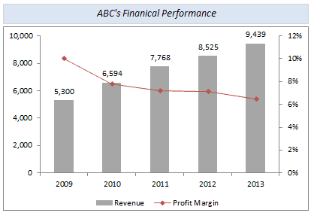

* **Use dynamic charts:** If you want to allow the user to make selections and want the chart to update with it, use dynamic charts. Now a dynamic chart is nothing but a regular chart whose data updates in the back-end when you make selections.



* **Use Sparklines to make your data more meaningful:** If you have a lot of data in your dashboard/report, you can consider using Sparklines to make it visual. A sparkline is a tiny chart that resides in a cell and can be created using a data set. These are useful when you want to show a trend over time and at the same time save space on your dashboard. Here is a detailed guide on creating and using Sparklines in Excel.

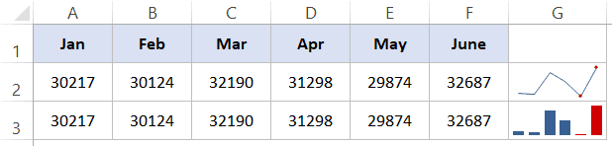

* **Use contrasting colors to highlight data:** This is a generic charting tip where you should highlight data in a chart so it’s easy to understand. For example, if you have sales data, you can highlight the year with lowest sales value in red.

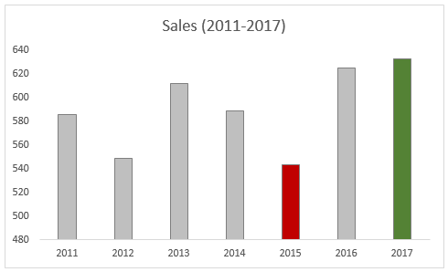

## DASHBOARDS DO'S AND DON'TS

Let’s first start with the Don’ts. Here are some of the things I recommend you avoid while creating an Excel dashboard. Again, these would vary based on your project and stakeholder but are valid in most of the cases.

* **Don’t Clutter Your Dashboards:** Just because you have data and charts doesn’t mean it should go in your dashboard. Remember the objective of the dashboard is to help identify a problem or aid in taking decisions. So, keep it relevant and remove everything that doesn’t belong there. I often ask myself if something is just good to have to absolutely must have. The I go ahead and remove all the good-to-haves.
* **Don’t use volatile formulas:** As it will slow down the calculations.
* **Don’t keep extra data in your workbook:** If you need that data, create a copy of the dashboard and keep it as the backup.

Now let’s have a look at some Do’s

* **Numbering your Charts/Section:** Your dashboard is not just a random set of charts and data points. Instead, it’s a story where one thing leads to the other. You need to make sure your audience follow the steps in the right order, and therefore it’s best to number these. While you may be able to guide them when you’re presenting live, it’s a great help when someone uses your dashboard at a later stage or takes a print out of it.
* **Restrict Movement in the dashboard area:** Hide all rows/columns to make sure the user doesn’t accidentally scroll away.
* **Freeze Important rows/column:** Use freeze panes when you want some rows/columns to be always visible on the dashboard.
* **Make Shapes/Charts Stick:** Make sure your shapes/charts or interactive controls don’t hide or resize when someone hides/resizes the cells. You can also use the Excel Camera tool to take a snapshot of charts/tables and place it in the Excel dashboard (these images are dynamic and update when the back-end chart/table updates).
* **Provide a User Guide:** If you have a complex dashboard, it’s a good idea to create a separate worksheet and highlight the steps. It will help people use your dashboard even when you’re not there.
* **Save Space with Combination Charts:** Use combination charts (such as bullet charts, thermometer charts, and actual vs target charts) to save your worksheet space.
* **Use Symbols & Conditional Formatting:** Use symbols and conditional formatting to add a layer of analysis to your dashboard (but don’t overdo it either).

## DASHBOARD BEST PRACTISES

1. As a best practice, divide you Excel workbook into three parts:

* Data - This could be one or more than one worksheet that contain the raw data.
* Calculations - This is where you do all the calculations. Again, you may have one or more than one sheet for calculations.
* Dashboard - This is the sheet that has the dashboard. In most of the cases, it is a single page view that shows analysis/insights backed by data.

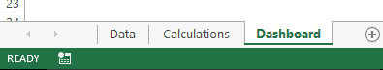

1. EXCEL TABLE - THE SECRET SAUCE OF AN EFFICIENT EXCEL DASHBOARD

The first thing I do with the raw data is to convert it into an Excel Table.

Excel Table offers many advantages that are crucial while creating an Excel dashboard.

To convert tabular data into an Excel table, select the data and go to Insert --> Tables --> Table.

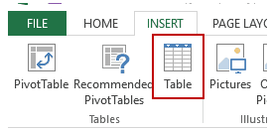

Here are the benefits of using an Excel Table for your dashboard:

* When you convert a tabular data set into an Excel table, you don’t need to worry about data getting changed at a later stage. Even if you get additional data, you can simply add it to the table without worrying about the formulas getting screwed up. This is really helpful when I create plug-and-play dashboards.
* With an Excel Table, you can use names of the columns instead of the reference. For example, instead is C2:C1000, you can use ‘Sales’.

## DASHBOARD – TELLING A STORY

The last step is to review your final product and make sure it tells a compelling story. Is it painting the picture you want it to? This is when you step back and take a bird’s-eye view of your data, the key messages, and compare that to the original purpose of the dashboard. If it’s not telling the story you want to tell, consider redesigning it, changing the data, or doing whatever is necessary to get your point across.

# SPARKLINE IN EXCEL

Sparklines are tiny charts that reside in a cell in Excel. These charts are used to show a trend over time or the variation in the dataset.

You can use these sparklines to make your bland data look better by adding this layer of visual analysis. While Sparklines are tiny charts, they have limited functionality (as compared with regular charts in Excel).

Despite that, Sparklines are great as you can create these easy to show a trend (and even outliers/high-low points) and make your reports and dashboard more reader-friendly.

Unlike regular charts, Sparklines are not objects. These reside in a cell as the background of that cell.

## TYPES OF SPARKLINES IN EXCEL

In Excel, there are three types of sparklines:

* Line
* Column
* Win-loss

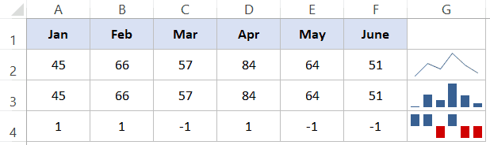

The first one in G2 is a line type sparkline, in G3 is a column type and in G4 is the win-loss type.

Here are a few important things to know about Excel Sparklines:

* Sparklines are dynamic and are dependent on the underlying dataset. When the underlying dataset changes, the sparkline would automatically update. This makes it a useful tool to use when creating Excel dashboards.
* Sparklines size is dependent on the size of the cell. If you change the cell height or width, the sparkline would adjust accordingly.
* While you have sparkline in a cell, you can also enter a text in it.
* You can customize these sparklines – such as change the color, add an axis, highlight maximum/minimum data points, etc. We will see how to do this for each sparkline type later in this tutorial.

## INSERTING SPARKLINES IN EXCEL

Let's say that you want to insert a line sparkline (as shown below).

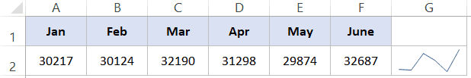

Here are the steps to insert a line sparkline in Excel:

* Select the cell in which you want the sparkline.
* Click on the Insert tab.

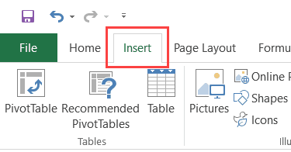

* In the Sparklines group click on the Line option.



* In the ‘Create Sparklines' dialog box, select the data range (A2:F2 in this example).

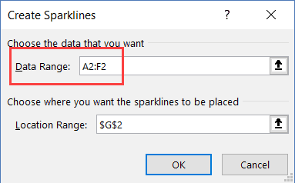

* Click OK.

This will insert a line sparkline in cell G2.



To insert a ‘Column' or ‘Win-loss' sparkline, you need to follow the same above steps, and select Columns or Win-loss instead of the Line (in step 3).

While the above steps insert a basic sparkline in the cell, you can do some customization to make it better. When you select a cell that has a Sparkline, you'll notice that a contextual tab – Sparkline Tools Design – becomes available. In this contextual tab, you'll find all the customization option for the selected sparkline type.

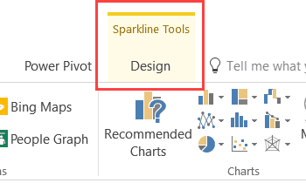

## EDITING THE DATASET OF EXISTING SPARKLINES

You can edit the data of an existing sparkline by using the Edit Data option. When you click on the Edit Data drop down, you get the following options:

* Edit Group Location & Data: Use this when you have grouped multiple sparklines and you want to change the data for the entire group (grouping is covered later in this tutorial).
* Edit Single Sparkline's Data: Use this to change the data for the selected sparkline only.

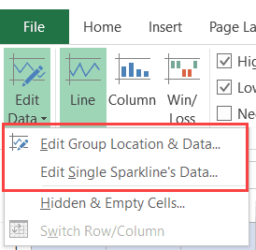

Clicking on any of these options open the Edit Sparklines dialog box where you can change the data range.

## HANDLING HIDDEN AND EMPTY CELLS

When you create a line sparkline with a dataset that has an empty cell, you will notice that the sparkline shows a gap for that empty cell.

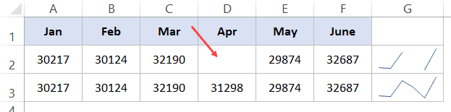

In the above dataset, the value for April is missing which creates a gap in the first sparkline. Here is an example where there is a missing data point in a column sparkline.

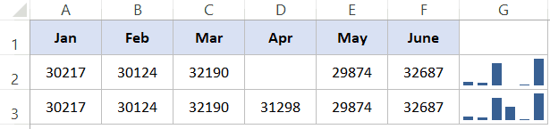

You can specify how you want these empty cells to be treated. Here are the steps:

* Click the cell that has the sparkline.
* Click the Design Tab (a contextual tab that becomes available only when you select the cell that has a sparkline).
* Click on the Edit Data option (click on the text part and not the icon of it).
* In the drop-down, select ‘Hidden & Empty Cells' option.

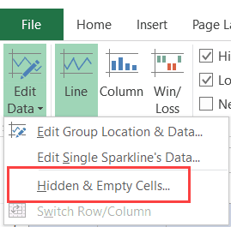

* In the dialog box that opens, select whether you want to show
  + Empty cells as gaps
  + Empty cells as zero
  + Connect the before and after data points with a line [this option is available for line sparklines only].

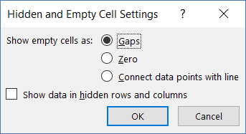

In case the data for the sparkline is in cells that are hidden, you can check the ‘Show data in hidden rows and columns' to make sure the data form these cells is also plotted. If you don't do this, data from hidden cells will be ignored. Below is an example of all three options for a line sparkline:

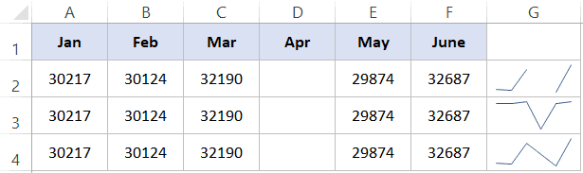

* Cell G2 is what happens when you choose to show a gap in the sparkline.
* Cell G3 is what happens when you choose to show a zero instead.
* Cell G2 is what happens when you choose to show a continuous line by connecting the data points.

You can do the same with column and win-loss sparklines as well (not the connecting data point option).

## CHANGING THE SPARKLINE TYPE

If you want to quickly change the sparkline type – from line to column or vice versa, you can do that using the following steps:

* Click the sparkline you want to change.
* Click the Sparkline Tools Design tab.
* In the Type group, select the sparkline you want.

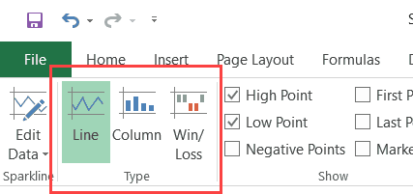

# PROTECTION AND SECURITY

Worksheet protection in Excel is not a security feature. It's is not actually intended to prevent people from accessing data in a password-protected worksheet. Why? Because Microsoft Excel uses a very simple encryption algorithm for worksheet protection. Even when you protect your Excel worksheet with a password, that password is very easy to break.

## PROTECT SHEET

To protect a sheet in Excel 2016, 2013 and 2010, perform the following steps.

* Right click a worksheet tab at the bottom of your screen and select Protect Sheet… from the context menu.

Or, click the Protect Sheet button on the Review tab, in the Changes group.

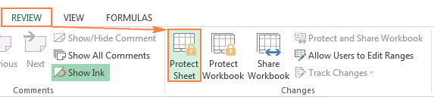

* In the Protect Sheet dialog window, do the following:

To password protect your Excel sheet, type a password in the corresponding field.

Select the actions you allow the users to perform. By default, the following 2 options are selected: Select locked cells and Select unlocked cells. If you leave only these two options selected, the users of your sheet, including yourself, will be able only to select cells (both locked and unlocked).

To allow some other actions such as sorting, filtering, formatting cells, deleting or inserting rows and columns, check the corresponding boxes.

If you don't check any action, users will only be able to view the contents of your Excel sheet.

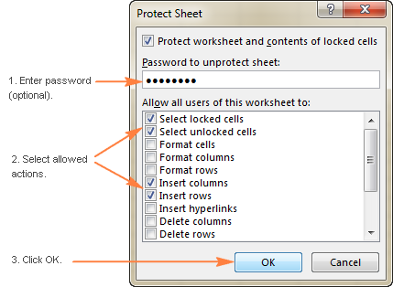

## UNPROTECT EXCEL SHEET

As you have just seen, it's very easy to password protect a sheet in Excel. Unprotecting a spreadsheet is even easier, provided that you know the password. Though, unlocking an Excel spreadsheet without password is no big deal either :)

If you know the password for the protected sheet, removing protection is a matter of seconds. Just do any of the following:

Right-click the sheet tab, and select Unprotect Sheet… from the context menu.

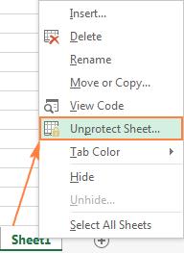

On the Review tab, in the Changes group, click Unprotect Sheet.

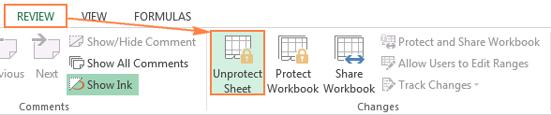

On the Home tab, in the Cells group, click Format, and select Unprotect Sheet from the drop-down menu.

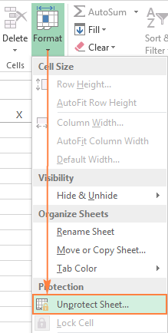

If you are dealing with a password-protected worksheet, Excel will ask you to enter the password. Type the password and click OK.

If the worksheet was not protected with password, clicking the Unprotect Sheet button is all it takes to unlock the sheet.

## PROTECTING WORKBOOK

Apart from protecting the sheet contents, you may also want lock the entire workbook to prevent users from adding, moving, renaming or deleting worksheets, and viewing hidden sheets. To protect the workbook, perform the following steps:

On the Review tab, in the Changes group, click the Protect Workbook button.

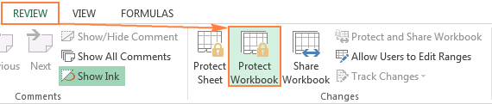

Under Protect workbook for, select one of the two options, or both:

Check the Structure box to protect the structure of a workbook. This will prevent the following actions:

* Viewing hidden worksheets.
* Renaming, moving, hiding or deleting sheets.
* Inserting new sheets and chart sheets. However, users will be able to insert a chart in an existing worksheet.
* Moving or copying sheets to another workbook.

Check the Windows box to retain the size and position of workbook windows. This will prevent users from moving, resizing, minimizing, or closing the workbook windows.

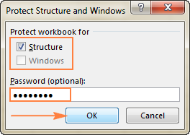

## UNLOCK A PROTECTED WORKBOOK

To remove the workbook protection, do the following:

* Click the Protect Workbook button again (in a locked workbook, it is highlighted in green like in the screenshot below):

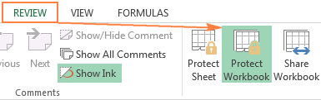

* Type the password if prompted.
* Save the workbook.

Important note! Protecting the workbook structure should not be confused with workbook-level password encryption that can prevent other users from opening or/and modifying your workbook.

## PROTECT WORKBOOK FROM OPENING

If you store your workbooks in a shared location such as a company local network, and you want to prevent other users from viewing your Excel files, you can encrypt your workbook with password that won't even let other people open it.

* In the workbook you want to encrypt, click File > Info, click the Protect Workbook button, and select Encrypt with Password in the drop-down menu.

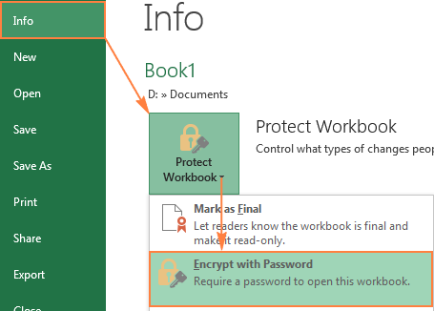

* The Encrypt Document window will appear, you enter a password in the Password box, and click OK.

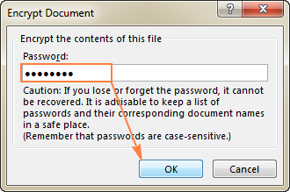

* Retype the password in the Re-enter password box, and click OK.
* Save your workbook.

## PROTECT WORKBOOK FROM MODIFYING

If you don't mind other users opening your Excel file but you want to prevent them from making any changes to your workbook, perform the following steps.

* In your Excel workbook, click the Save As button, and then click the Tools button at the bottom of the window.
* In the Tools drop-down menu, select General Options.

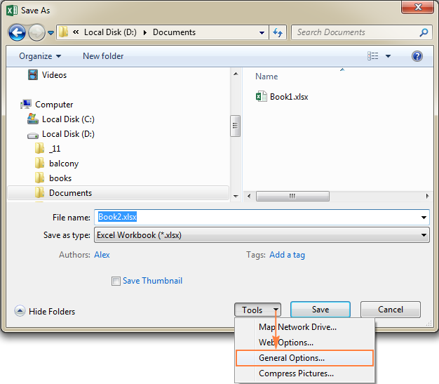

* In the General Options dialog window, type a password in the Password to modify box. Additionally, you can select the Read-only option, which is recommended.

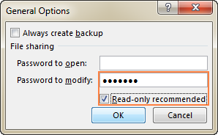

Tip. If you want to protect your Excel file both from modifying and opening, type the passwords in the Password to open and Password to modify boxes. It can be the same password of two different ones.

* Retype the password in the Confirm Password dialog, and click OK. If you've entered 2 passwords in the previous step, you will be asked to confirm both.
* Finally, click the Save button in the Save As dialog.

# WHAT IF ANALYSIS

What-if-analysis in Excel is a tool in Excel that helps you run reverse calculations, sensitivity analysis and scenarios comparison.

Decision making is a crucial part of any business or job role. When you can take decisions, which are informed based on data, the outcome of the business or project or task is always more in control. Thus, what if analysis is used by almost every data analyst and especially middle to higher management professionals, to make better, faster and more accurate decisions based on data.

What-if-Analysis in excel has 3 options

* Goal Seek – Reverse calculations
* Data Table – Sensitivity analysis
* Scenario Manager – Comparison of scenarios

## GOAL SEEK

Let’s consider a simple dataset, where the invoice amount is Rs. 10,000, on which there is 9% CGST and 9% SGST, which thus amounts to a total of Rs. 11,800.

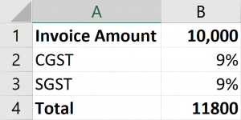

The customer asks you for a discount of Rs. 800 and thus the final amount should be Rs. 11,000. Now, the equation in simple terms is, X + 18% = 11000, where X is the invoice amount, 18% is the total GST.

To find out, how much + 18% = 11000, we will use Goal Seek in What if analysis.

* Place your cursor on the ‘Total’ cell
* Under the ‘Data’ tab, click on ‘What-If-Analysis’, then on ‘Goal Seek’

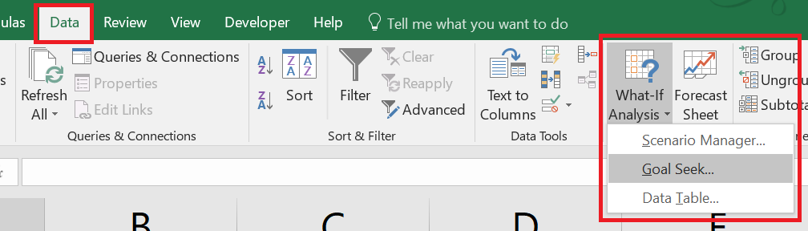

* In ‘Set Cell’, B4 will automatically be selected as you had kept your cursor on it.
* In ‘To value’, enter the desired value, 11000 in this case.
* In ‘By changing cell’, choose the value that needs to be changed, invoice amount in this case. Thus, cell B1 is selected.
* Press Ok

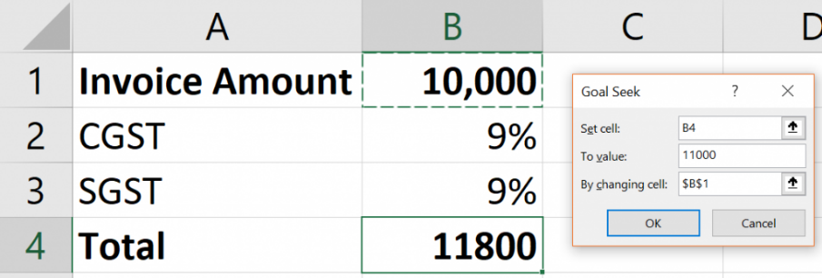

Excel will reverse calculate and immediately give you the value Rs. 9,322, which + 18% equals exactly to Rs. 11,000

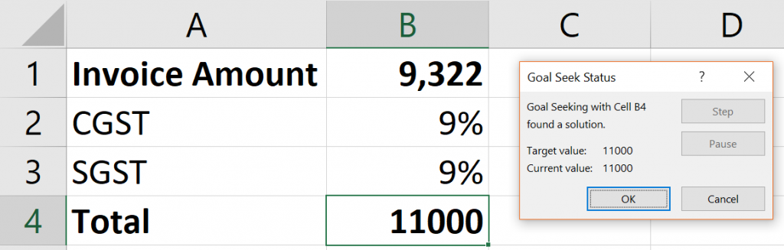

This was a very simple example of using Goal Seek in what-if analysis. You can use Goal Seek even for more complex models, let’s take an example of a Car loan model.

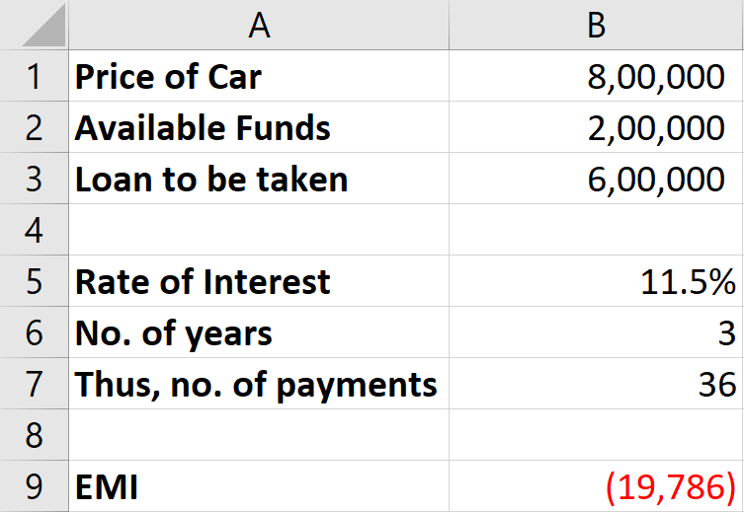

The ‘EMI’ calculated Rs. 19,786 is the outgoing amount per month. The value is negative as money is going out of your pocket.

But, you have a budget of only Rs. 17,000 per month. So, how much can you afford as ‘Price of Car’?

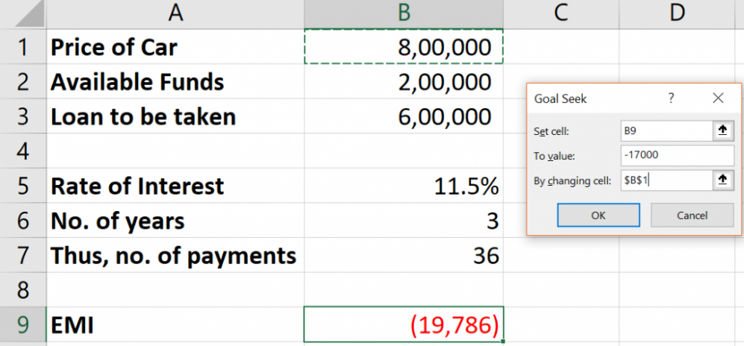

Put the Goal Seek values as above and you will know the Price of Car that you can afford. This was calculations at multiple levels that Goal Seek in What-if analysis did, as it had to consider Available funds, ROI, Number of payments to reverse calculate and give you the answer.

## DATA TABLE IN WHAT-IF ANALYSIS

Data Table is used for Sensitivity analysis. What this means is basically, either 1 or 2 of the inputs in your model are changing, you want to know output based on each change.

Let’s take the same Car loan example as earlier. Now, after applying the Goal Seek, you know you can afford to buy a car worth Rs. 7,15,526 instead of Rs. 8,00,000.

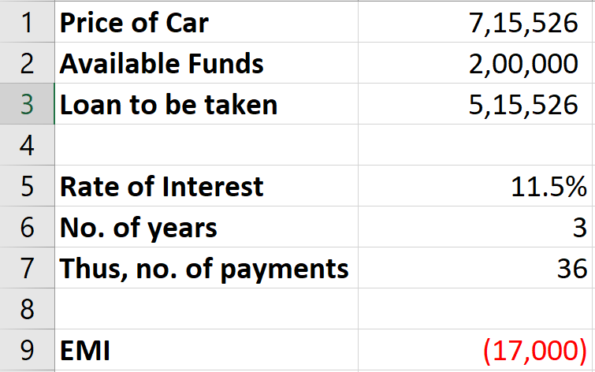

### DATA TABLE (ONE WAY/ ONE INPUT)

Then you go to the Car showrooms and research on more cars available. You find out 5 cars that you like, you want to know what would be the EMI amount for each of the car?

Car 1 – Rs. 5,54,000

Car 2 – Rs. 5,96,000

Car 3 – Rs. 6,24,000

Car 4 – Rs. 7,36,000

Car 5 – Rs. 7,94,000

We can use what if analysis data table to find this. Since only 1 input is changing, that is, Price of Car, we will use 1-input data table. Make this structure in your Excel sheet next to your model.

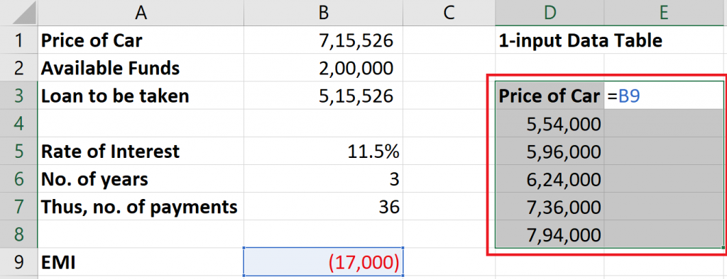

In E4, put =B9. Basically, you are pointing to the formula that is used to calculate the EMI. Thus, here you have informed Excel that you want to calculate the resulting EMI for each value, using the formula in B9. Now select this structure you have created and go to ‘Data table’ under what-if analysis in Data tab.

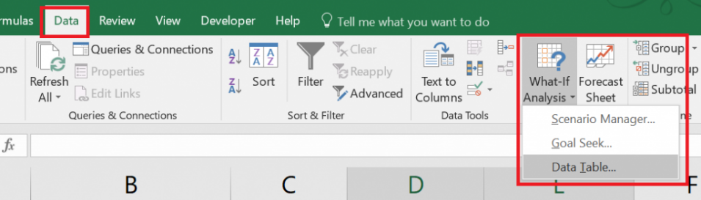

Since our options of Prices of Cars are put vertically in a column, we will use Column input cell. Select cell B1 to inform Excel that the 5 values are Price of Car values. Press OK

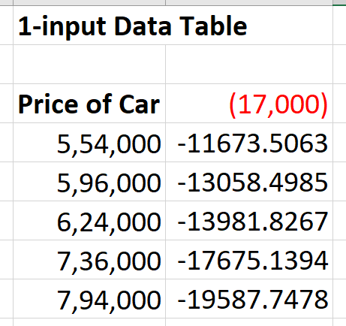

Excel has calculated for you, the EMI for each change in Price of Car.

### TWO WAY DATA TABLE

Similarly, you can have 2 inputs varying and still get the respective outputs. So now you think about what if I change the duration of the loan, and compare for all these 5 cars?

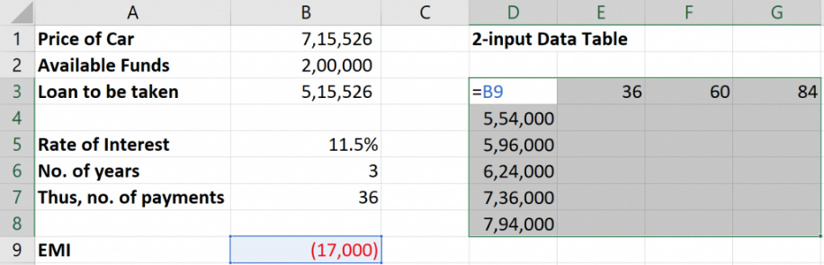

Go to Data Table and select Row input cell as ‘No. of payments in months’ and Column input cell as ‘Price of car’

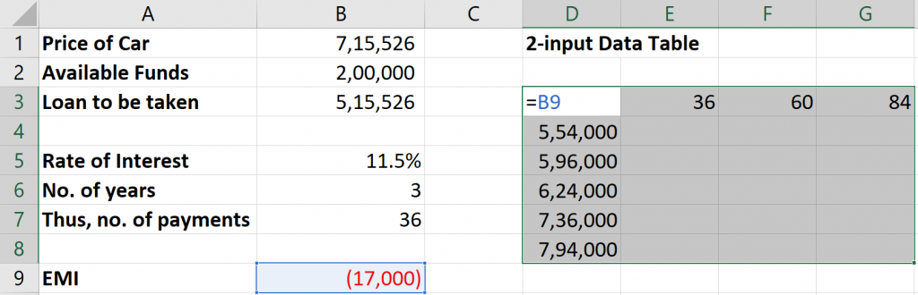

You will get the EMI amount for each combination in no time, without much effort or any complicated formulas.

## SCENARIO MANAGER

Let’s say you are working in a Car Showroom in the Sales department. You have been given the task to plan the sales for the next quarter. You must build multiple scenarios and prepare a comparison of all the scenarios.

You make a model as below and then want to create multiple scenarios based on number of cars that you will be able to sell for each of the cars.

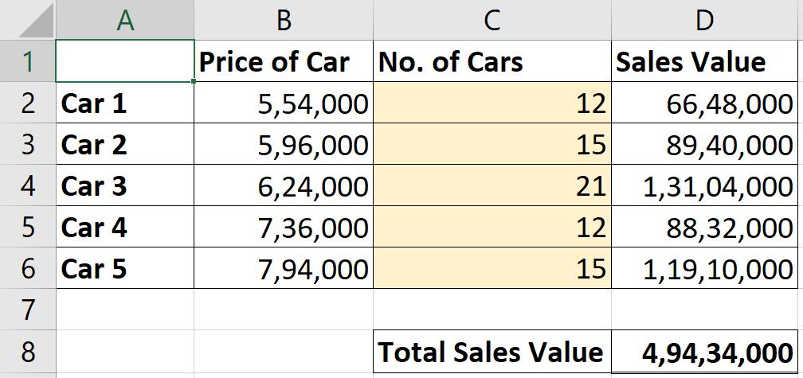

Under What-if analysis, go to scenario manager Click on ‘Add’. Let’s start building our 1st scenario

* Scenario Name – Best Case
* Changing Cells – select cells C2:C6 as these are the No. of cars that you will be able to sell, basically the variable cells
* Press OK
* Enter values for each Car

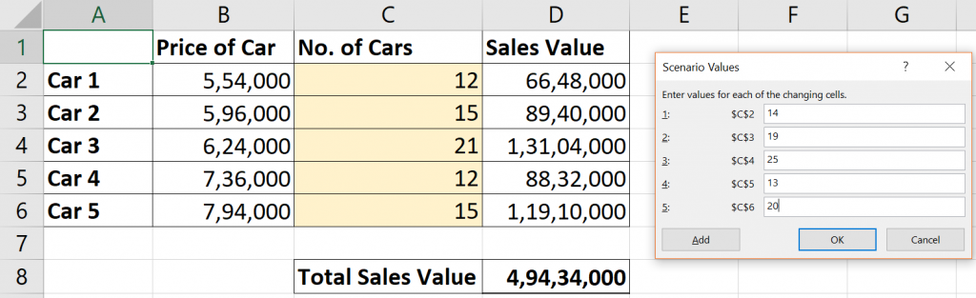

Similarly add 1 more Scenario and name it as ‘Worst Case’. The changing cells will of course remain the same. I have put in the below values for Worst case.

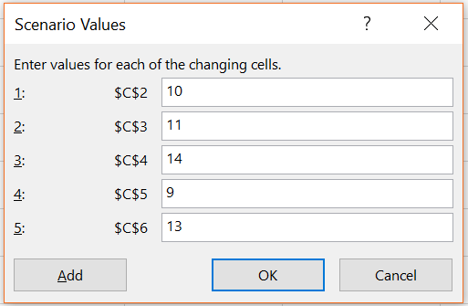

Note: You can create many more scenarios like this.

COMPARE THE SCENARIOS

Now that your scenarios are created, let’s compare them. In the Scenario Manager window, click on Summary.

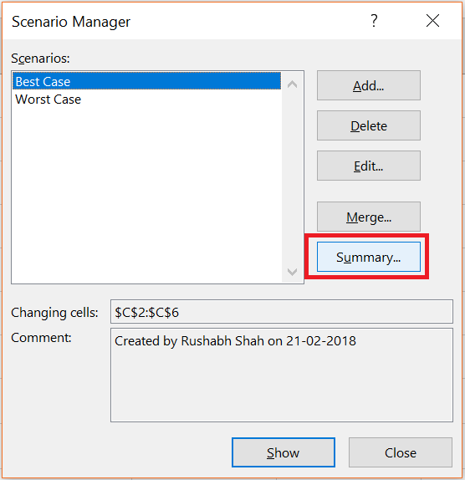

You will now be asked for ‘Result cells’. Choose the Total Sales Value, cell D8, as that’s what you want to compare. If you want to compare more outputs, you can choose multiple cells here too.

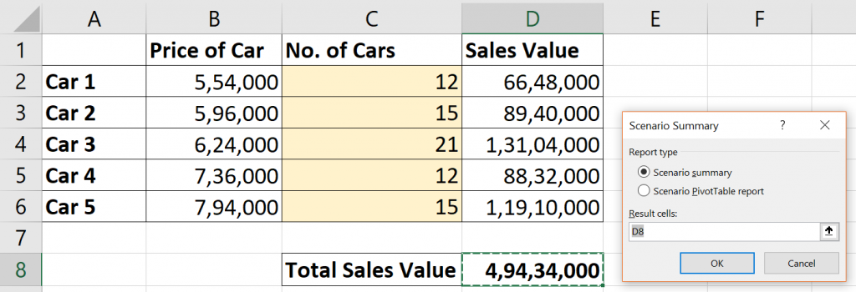

A new Sheet will be created automatically on pressing OK which will give you a comparison of the Current values in your Sheet + the 2 scenarios you created.

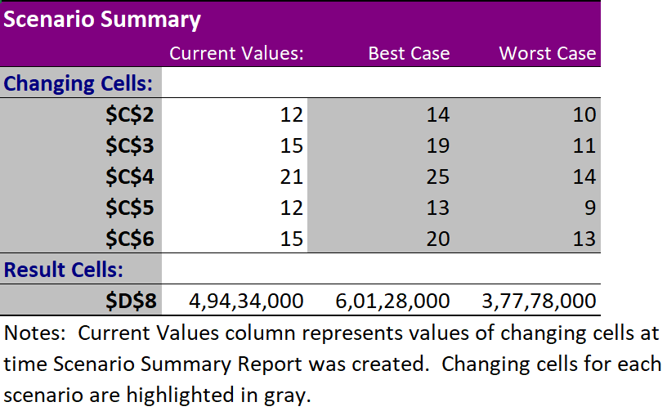

Thus, in best case, the Total Sales is over Rs. 6 CR. Worst Case is 3.77 CR. Now you can take your business decisions based on this output.

## CONCLUSION

Thus, we can conclude that what-if analysis is an integral part of the tools any data analyst or middle to senior management uses. Using the 3 tools in what if, you can analyze data much quickly than if you try to do the same using formulas, thereby allowing you to take faster and accurate decisions.

* Goal seek is for Reverse calculations.
* Data Table is for 1 or 2 inputs changing, resulting changes in output.
* Scenario Manager is to compare multiple business scenarios based on multiple inputs changing.

# FORECASTING

Microsoft can’t predict the future — but it can sure try. Excel’s time series forecasting abilities take data you’ve provided and extrapolate potential future data. It’s not perfect, but it can give you an idea of what your data is really telling you. A tiny glimpse into the future, if you will.

There are two different ways to forecast in Excel. First, you can use several forecast functions directly within the cells of your spreadsheet. The second method, which uses a graphical interface, is easier to use, so we’ll be focusing on that.

If you really want to know how to use the functions, you can check out Microsoft’s guide to Excel forecast functions. But we recommend sticking with the Forecast Sheet button.

## HOW DOES EXCEL FORECAST DATA?

Before we get started, it’s important to understand what you’re getting when you use Excel to forecast data.

The forecast function uses a process called triple exponential smoothing (ETS) to take your existing data and make predictions based on the patterns present. ETS weights the previous values in your series so that more recent values are more heavily weighted and further past values are less weighted.

## FORMATTING DATA FOR FORECASTING

Excel forecast functions require your data to be in a specific format to work correctly. You’ll need at least two columns.

The first is a timeline. This needs to contain dates, times, or a series of numbers that specify temporal change.

The important thing here is that the intervals need to be consistent. You can’t have sales from the first of the January, the first of February, the first of March, the first of April, the fifteenth of April, and the first of May. Though you could replace those dates with numbers, the forecasting might not be as accurate when done this way.

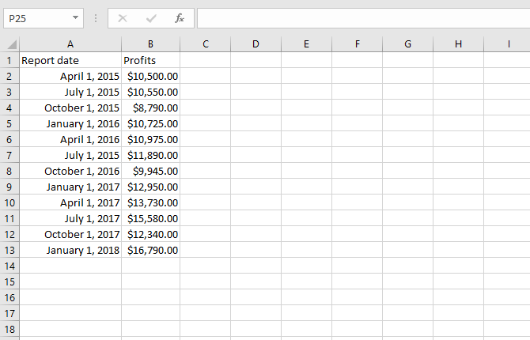

The second column is your data. This is what you’re going to be forecasting into the future. To provide an example of data forecasting, I created a spreadsheet with fictional monthly sales numbers.

## SIMPLE FORECASTING

To get started on your Excel forecast, highlight your data, then go to Data > Forecast Sheet.

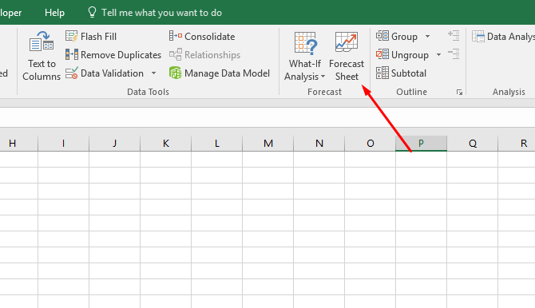

Once you’ve clicked the Forecast Sheet button, you’ll see a nicely formatted graph that contains your data in blue along with predictive data in orange.

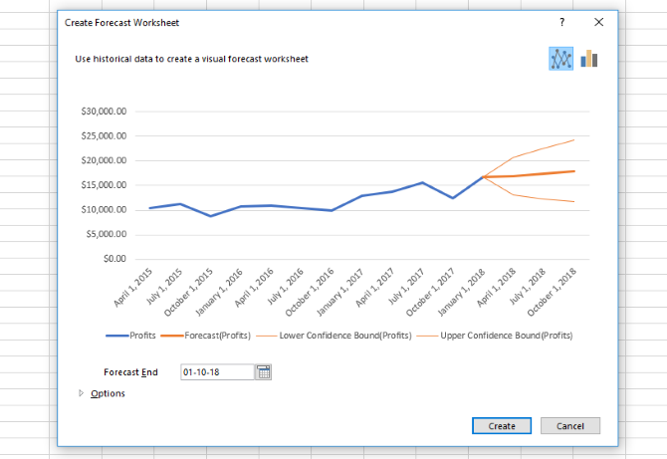

Hit Create in the new window, and you’ll get a more permanent version of that graph alongside a table of predicted values. That table also includes 95% confidence intervals (which are also represented on the graph).

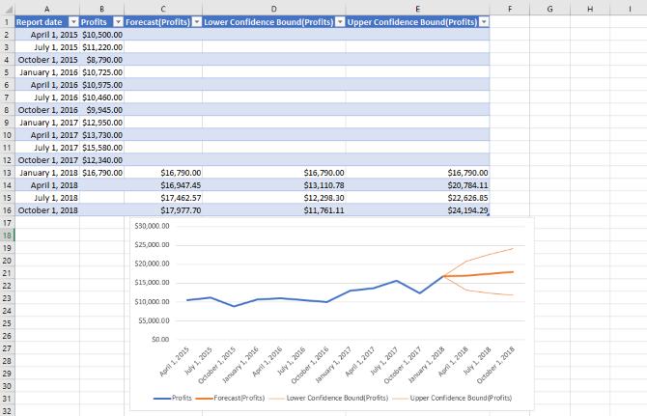

This is already very valuable. But by tweaking some settings, you can customize the data that you get for even better predictions.

## CUSTOMIZING THE EXCEL FORECAST

In the Create Forecast Sheet window, you see only a single dropdown menu by default: Forecast End.

The **Forecast End** date lets you choose how far into the future to forecast. Keep in mind that the further you go, the more error you’re likely to see.

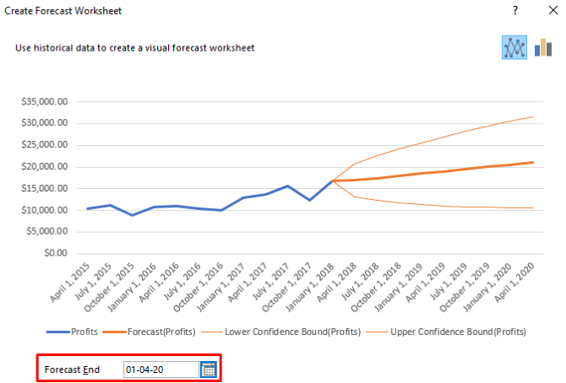

In the image above, you can see an extended forecast, with the confidence interval expanding over time. To access the other forecasting options, click Options at the bottom of the window. We’ll go over each option individually.

**Forecast Start** lets you choose when Excel starts forecasting the data. In almost every case, you’ll want this to be from the very last point in your timeline.

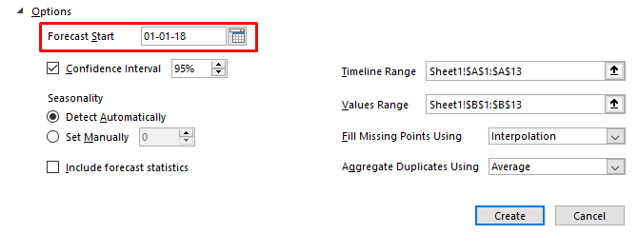

You may want to set it earlier to see if Excel’s predictions match the real data, just to check. But in general, you can safely ignore this option.

**Confidence Interval** lets you turn the confidence interval lines on or off and choose whether to calculate it. Most of the time, 95 percent is the standard value for the confidence interval.

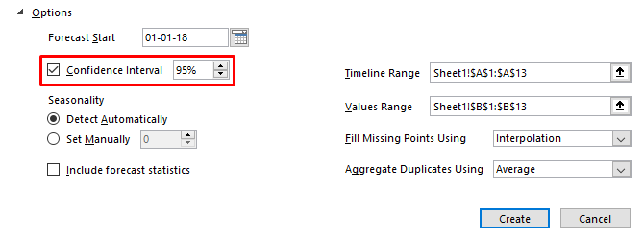

This means that Excel is 95 percent confident that the predicted value will fall between those two lines.

**Seasonality** defines the repeating nature of your timeline. Most of the time, Excel will calculate this automatically. In other cases, you’ll want to change it yourself.

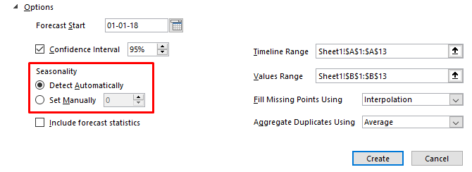

In our sample spreadsheet, for example, changing the seasonality to 4 results in much better data (we used 4 because there are four points in each repeating cycle). Here’s what the forecast looked like with automatic seasonality detection:

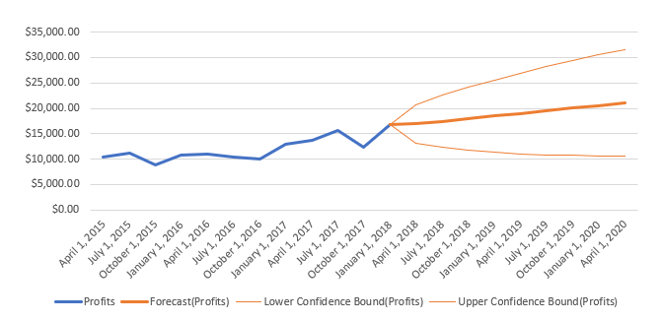

And here’s what it looks like after I changed the seasonality to 4:

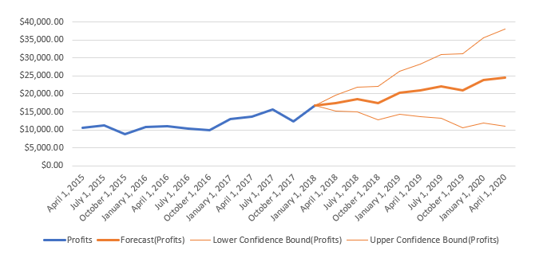

This better reflects the typical downturn in sales around October. It’s worth trying in your own spreadsheet to make sure you’re getting the best data possible.

Just be sure that your seasonality number is accurate. If you’re using monthly data, the seasonality is 12. Weekly data over the course of a year will be 52. If it’s weekly over half a year, use 26.

If you check **Include forecast statistics**, Excel will give you additional basic statistics in your final sheet.

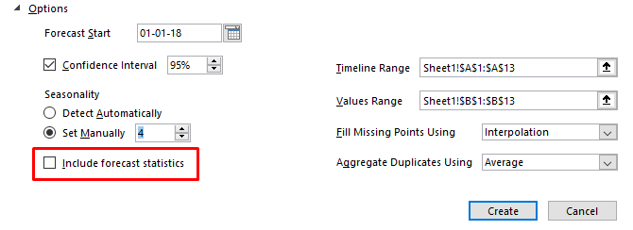

Here are the statistics you’ll get:

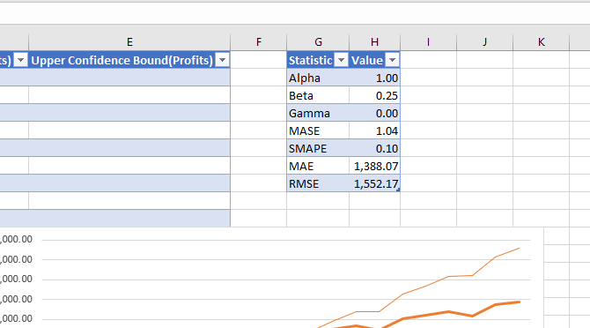

**Timeline Range and Values Range** are the columns where you’ve entered your data. You can adjust these if Excel is picking up the wrong data, but you probably won’t need to.

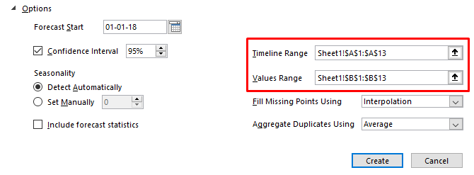

Before we talk about **Fill Missing Points Using**, we have to talk about missing data in forecasting. The forecast function will work even if you don’t have all of the data points in the timeline. Even if you’re missing some information, Excel will still run the forecast.

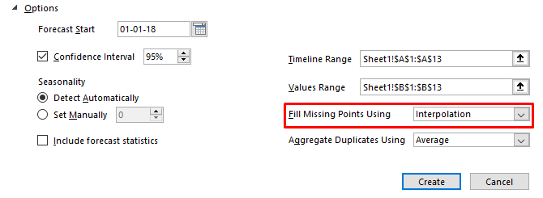

The standard method for filling the missing points is interpolation, which uses weighted averages of the missing point’s neighbouring values. This is a good option, especially considering it’s your only one.

If you don’t want Excel to interpolate, you can choose Zeroes in the dropdown to insert zeroes in the missing data spaces. But if those missing values aren’t likely to actually be zeroes, you’ll throw off your forecast.

The Aggregate Duplicate Values dropdown concerns a specific case in your data. When there are two entries for a single time point in your data, Excel averages the two to determine the final value. You can change that to count, median, sum, or a variety of other operations.

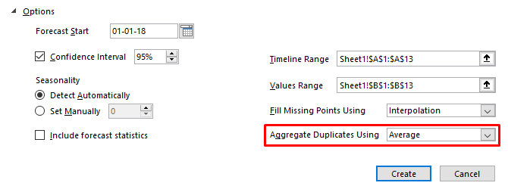

Once you’ve set all the options the way you want them, hit Create and you’ll get Excel’s best guess at how your data will look in the future, with a graph and a table full of predicted values.

# TRENDLINE

Trendlines show which direction the trend of your data is going, and gives you the trajectory as well. It can also be very helpful to extend the line beyond existing data to communicate a forecast of future trends. Trend lines can be added to a variety of charts, including bar charts, line charts, scatter plots and more, but they’re not an option for 3-D charts, pie charts or other similar chart configurations.

This example teaches you how to add a trendline to a chart in Excel.

1. Select the chart.

2. Click the + button on the right side of the chart, click the arrow next to Trendline and then click More Options.

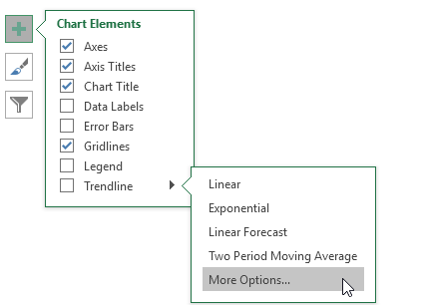

The Format Trendline pane appears.

3. Choose a Trend/Regression type. Click Linear.

4. Specify the number of periods to include in the forecast. Type 3 in the Forward box.

5. Check "Display Equation on chart" and "Display R-squared value on chart".

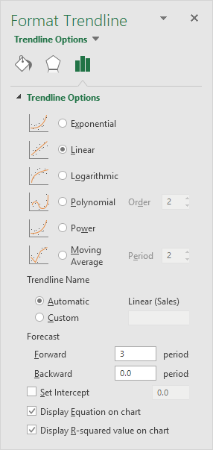

Result:

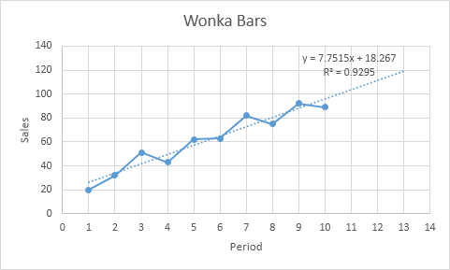

Excel uses the method of least squares to find a line that best fits the points. The R-squared value equals 0.9295, which is a good fit. The closer to 1, the better the line fits the data. The trendline predicts 120 sold Wonka bars in period 13. You can verify this by using the equation. y = 7.7515 * 13 + 18.267 = 119.0365.

# TESTS OF SIGNIFICANCE

Once sample data has been gathered through an observational study or experiment, statistical inference allows analysts to assess some claim about the population from which the sample has been drawn. The methods of inference used to support or reject claims based on sample data are known as **TESTS OF SIGNIFICANCE**. Every test of significance begins with a Null Hypothesis(H0).

**NULL HYPOTHESIS:** H0 represents a theory that has been put forward, either because it is believed to be true or because it is to be used as a basis for argument, but has not been proved. For example, in a clinical trial of a new drug, the null hypothesis might be that the new drug is no better, on average, than the current drug. We would write H0: there is no difference between the two drugs on average.

**ALTERNATIVE HYPOTHESIS:** The alternative hypothesis, HA, is a statement of what a statistical hypothesis test is set up to establish. For example, in a clinical trial of a new drug, the alternative hypothesis might be that the new drug has a different effect, on average, compared to that of the current drug. We would write Ha: the two drugs have different effects, on average. The alternative hypothesis might also be that the new drug is better, on average, than the current drug. In this case we would write Ha: the new drug is better than the current drug, on average.

Important points:

* The final conclusion once the test has been carried out is always given in terms of the null hypothesis. We either "reject H0 in favor of HA" or "do not reject H0"; we never conclude "reject HA", or even "accept Ha".
* If we conclude "do not reject H0", this does not necessarily mean that the null hypothesis is true, it only suggests that there is not sufficient evidence against H0 in favor of HA; rejecting the null hypothesis then, suggests that the alternative hypothesis may be true.

Hypotheses are always stated in terms of population parameter, such as the mean. An alternative hypothesis may be one-sided or two-sided. A one-sided hypothesis claims that a parameter is either larger or smaller than the value given by the null hypothesis. A two-sided hypothesis claims that a parameter is simply not equal to the value given by the null hypothesis -- the direction does not matter.

Hypotheses for a one-sided test for a population mean take the following form:

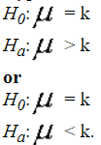

Hypotheses for a two-sided test for a population mean take the following form:

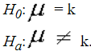

Two questions arise about any hypothesized relationship between two variables:

1. What is the probability that the relationship exists
2. If it does, how strong is the relationship

There are two types of tools that are used to address these questions:

* The first is addressed by tests for statistical significance.
* The second is addressed by Measures of Association.

Tests for statistical significance are used to address the question - what is the probability that what we think is a relationship between two variables is really just a chance occurrence?

If we selected many samples from the same population, would we still find the same relationship between these two variables in every sample? If we could do a census of the population, would we also find that this relationship exists in the population from which the sample was drawn? Or is our finding due only to random chance?

Tests for statistical significance tell us what the probability is that the relationship we think we have found is due only to random chance. They tell us what the probability is that we would be making an error if we assume that we have found that a relationship exists.

We can never be completely 100% certain that a relationship exists between two variables. There are too many sources of error to be controlled, for example, sampling error, researcher bias, problems with reliability and validity, simple mistakes, etc.

But using probability theory and the normal curve, we can estimate the probability of being wrong, if we assume that our finding a relationship is true. If the probability of being wrong is small, then we say that our observation of the relationship is a statistically significant finding.

Statistical significance means that there is a good chance that we are right in finding that a relationship exists between two variables. But statistical significance is not the same as practical significance. We can have a statistically significant finding, but the implications of that finding may have no practical application. The researcher must always examine both the statistical and the practical significance of any research finding.

For example, we may find that there is a statistically significant relationship between a citizen's age and satisfaction with city recreation services. It may be that older citizens are 5% less satisfied than younger citizens with city recreation services. But is 5% a large enough difference to be concerned about?

Often times, when differences are small but statistically significant, it is due to a very large sample size; in a sample of a smaller size, the differences would not be enough to be statistically significant.

# STEPS IN TESTING FOR STATISTICAL SIGNIFICANCE

Below are the steps one should follow to carry out test of significance:

1. State the Research Hypothesis
2. State the Null Hypothesis
3. Select a probability of error level (alpha level)
4. Select and compute the test for statistical significance
5. Interpret the results

## STATE THE RESEARCH HYPOTHESIS

A research hypothesis states the expected relationship between two variables. It may be stated in general terms, or it may include dimensions of direction and magnitude. For example,

* General: The length of the job training program is related to the rate of job placement of trainees.
* Direction: The longer the training program, the higher the rate of job placement of trainees.
* Magnitude: Longer training programs will place twice as many trainees into jobs as shorter programs.

OR

* General: Graduate Assistant pay is influenced by gender.
* Direction: Male graduate assistants are paid more than female graduate assistants.
* Magnitude: Female graduate assistants are paid less than 75% of what male graduate assistants are paid.

## STATE THE NULL HYPOTHESIS

A null hypothesis usually states that there is no relationship between the two variables. For example,

* There is no relationship between the length of the job training program and the rate of job placement of trainees.
* Graduate assistant pay is not influenced by gender.

A null hypothesis may also state that the relationship proposed in the research hypothesis is not true. For example,

* Longer training programs will place the same number or fewer trainees into jobs as shorter programs.
* Female graduate assistants are paid at least 75% or more of what male graduate assistants are paid.

Researchers use a null hypothesis in research because it is easier to disprove a null hypothesis than it is to prove a research hypothesis. The null hypothesis is the researcher's "straw man." That is, it is easier to show that something is false once than to show that something is always true. It is easier to find disconfirming evidence against the null hypothesis than to find confirming evidence for the research hypothesis.

## TYPE I AND TYPE II ERRORS

Even in the best research project, there is always a possibility (hopefully a small one) that the researcher will make a mistake regarding the relationship between the two variables. There are two possible mistakes or errors.

* **TYPE I ERROR**: This occurs when the researcher assumes that a relationship exists when in fact the evidence is that it does not. In a Type I error, the researcher should accept the null hypothesis and reject the research hypothesis, but the opposite occurs. The probability of committing a Type I error is called alpha.
* **TYPE II ERROR:** This occurs when the researcher assumes that a relationship does not exist when in fact the evidence is that it does. In a Type II error, the researcher should reject the null hypothesis and accept the research hypothesis, but the opposite occurs. The probability of committing a Type II error is called beta.

Generally, reducing the possibility of committing a Type I error increases the possibility of committing a Type II error and vice versa, reducing the possibility of committing a Type II error increases the possibility of committing a Type I error.

Researchers generally try to minimize Type I errors, because when a researcher assumes a relationship exists when one really does not, things may be worse off than before. In Type II errors, the researcher misses an opportunity to confirm that a relationship exists, but is no worse off than before.

In this example, which type of error would you prefer to commit?

* Research Hypothesis: El Nino has reduced crop yields in County X, making it eligible for government disaster relief.
* Null Hypothesis: El Nino has not reduced crop yields in County X, making it ineligible for government disaster relief.

If a Type I error is committed, then the County is assumed to be eligible for disaster relief, when it really is not (the null hypothesis should be accepted, but it is rejected). The government may be spending disaster relief funds when it should not, and taxes may be raised.

If a Type II error is committed, then the County is assumed to be ineligible for disaster relief, when it really is eligible (the null hypothesis should be accepted, but it is rejected). The government may not spend disaster relief funds when it should, and farmers may go into bankruptcy.

In this example, which type of error would you prefer to commit?

* Research Hypothesis: The new drug is better at treating heart attacks than the old drug
* Null Hypothesis: The new drug is no better at treating heart attacks than the old drug

If a Type I error is committed, then the new drug is assumed to be better when it really is not (the null hypothesis should be accepted, but it is rejected). People may be treated with the new drug, when they would have been better off with the old one.

If a Type II error is committed, then the new drug is assumed to be no better when it really is better (the null hypothesis should be rejected, but it is accepted). People may not be treated with the new drug, although they would be better off than with the old one.

## SELECT A PROBABILITY OF ERROR LEVEL (ALPHA LEVEL)

Researchers generally specify the probability of committing a Type I error that they are willing to accept, i.e., the value of alpha. In the social sciences, most researchers select an alpha=.05. This means that they are willing to accept a probability of 5% of making a Type I error, of assuming a relationship between two variables exists when it really does not. In research involving public health, however, an alpha of .01 is not unusual. Researchers do not want to have a probability of being wrong more than 0.1% of the time, or one time in a thousand.

If the relationship between the two variables is strong (as assessed by a Measure of Association), and the level chosen for alpha is .05, then moderate or small sample sizes will detect it. As relationships get weaker, however, and/or as the level of alpha gets smaller, larger sample sizes will be needed for the research to reach statistical significance.

## COMPUTE THE TEST FOR STATISTICAL SIGNIFICANCE

To know whether samples taken from population can be used to infer about population, we should know their significance. To carry out test of significance we should do hypothesis testing using any of the following:

* T – Test also known as T Student Test (mean)
* Chi – Square Test (Frequency)
* Fishers Z -Test (Variance)

## INTERPRET THE RESULTS

If the computed value for Chi Square equals or exceeds the value indicated in the table for the given level of alpha and degrees of freedom, then the researcher can assume that the observed relationship between the two variables exists (at the specified level of probability of error, or alpha), and reject the null hypothesis. This gives support to the research hypothesis.

The computed value of Chi Square, at a given level of alpha and with a given degree of freedom, is a type of "pass-fail" measurement. It is not like a measure of association, which can vary from 0.0 to (plus or minus) 1.0, and which can be interpreted at every point along the distribution. Either the computed value of Chi Square reaches the required level for statistical significance or it does not.

It is important to note that Chi Square, like other tests for statistical significance:

1) Does not indicate the strength of an association between two variables

2) Does not indicate the direction of an association between two variables

3) Does not indicate the probability of a Type I error

4) Does not consider the reliability and validity of the research

5) Does not provide absolute, conclusive proof of a relationship

<http://blog.minitab.com/blog/adventures-in-statistics-2/understanding-hypothesis-tests-why-we-need-to-use-hypothesis-tests-in-statistics>

Significance Levels

Confidence interval

Critical region

Type I error and Type II error

## BE CAUTIOUS WHEN INTERPRETING THE P-VALUE

It can be very satisfying to work out the p-value after a long experiment, see that it's below the threshold, reject the null hypothesis and assume the experiment is done and dusted. But the truth is that researchers still need to use care when deciding how to interpret the p-value.

It is an error to assume that a very small p-value means a strong result or large effect. The p-value gives probabilistic information about our result, nothing more. You will need to conduct further investigation to understand the magnitude of any relationships in your experiment.

While determining significant results statistically, remember that it's impossible to use statistics to prove that the difference in levels of two parameters is zero. The only thing that the statistical analysis can state is that the experiment failed to find any difference.

It's commonly said that "statistical significance is not the same as biological significance." What this means is that statistics is only a tool that can attempt to describe complex, concrete biological systems, but can't capture every extra factor that may come into play.

Lastly, a result may be statistically significant but still not practically significant, meaning it's still not large enough to warrant any change or action in the "real world." Again, the p-value is not the final say, but needs to be interpreted carefully.

# P VALUE

A P value is used in hypothesis testing to help you support or reject the null hypothesis. The p value is the evidence against a null hypothesis. The smaller the p-value, the strong the evidence that you should reject the null hypothesis.

P values are expressed as decimals although it may be easier to understand what they are if you convert them to a percentage. For example, a p value of 0.0254 is 2.54%. This means there is a 2.54% chance your results could be random (i.e. happened by chance). That’s pretty tiny. On the other hand, a large p-value of .9(90%) means your results have a 90% probability of being completely random and not due to anything in your experiment. Therefore, the smaller the p-value, the more important (“significant”) your results.

When you run a hypothesis test, you compare the p value from your test to the alpha level you selected when you ran the test. Alpha levels can also be written as percentages.

Graphically, the p value is the area in the tail of a probability distribution. It’s calculated when you run hypothesis test and is the area to the right of the test statistic (if you’re running a two-tailed test, it’s the area to the left and to the right).

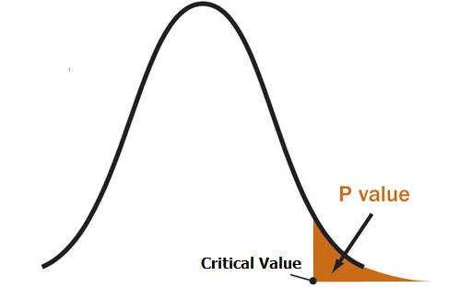

## P VALUE VS ALPHA LEVEL

Alpha levels are controlled by the researcher and are related to confidence levels. You get an alpha level by subtracting your confidence level from 100%. For example, if you want to be 98 percent confident in your research, the alpha level would be 2% (100% – 98%). When you run the hypothesis test, the test will give you a value for p. Compare that value to your chosen alpha level. For example, let’s say you chose an alpha level of 5% (0.05). If the results from the test give you:

* A small p (≤ 0.05), reject the null hypothesis. This is strong evidence that the null hypothesis is invalid.
* A large p (> 0.05) means the alternate hypothesis is weak, so you do not reject the null.

## P VALUES AND CRITICAL VALUES

The p value is just one piece of information you can use when deciding if your null hypothesis is true or not. You can use other values given by your test to help you decide. For example, if you run an f test two sample for variances in Excel, you’ll get a p value, an f-critical value and a f-value.

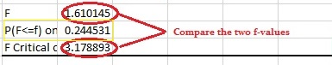

In the above image, the results from the f-test show a large p value (.244531, or 24.4531%), so you would not reject the null. However, there’s also another way you can decide: compare your f-value with your f-critical value. If the f-critical value is smaller than the f-value, you should reject the null hypothesis. In this particular test, the p value and the f-critical values are both very large so you do not have enough evidence to reject the null.

## WHAT IF I DON’T HAVE AN ALPHA LEVEL?

In an ideal world, you’ll have an alpha level. But if you do not, you can still use the following rough guidelines in deciding whether to support or reject the null hypothesis:

* If p > .10 → “not significant”
* If p ≤ .10 → “marginally significant”
* If p ≤ .05 → “significant”
* If p ≤ .01 → “highly significant.”

# CONFIDENCE INTERVAL

Roughly speaking, a confidence interval is range of numbers within which we believe the true population parameter to fall.

The confidence interval is the plus-or-minus figure usually reported in newspaper or television opinion poll results. For example, if we use a confidence interval of 4 and 47% percent of our sample picks an answer (Lest say option A) we can be “sure” that if we had asked the question to the entire relevant population between 43% (47-4) and 51% (47+4) would have picked that answer (i.e. option A). Confidence intervals are our results, usually numbers.

If the test result fall between the confidence interval range we say that NULL Hypothesis is TRUE. If the result fall outside confidence range we can reject the NULL Hypothesis.

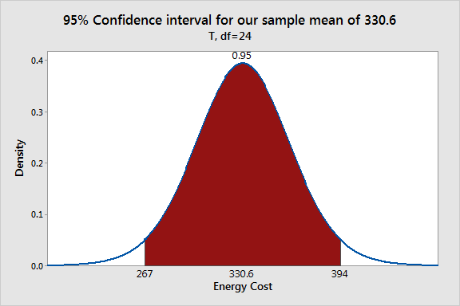

If we plot the confidence interval for the energy cost example, we can see that the confidence interval is (267 – 394). Hence looking at the confidence interval we can reject the null hypothesis (mean = 260) as 260 does not lie in the range.

# CONFIDENCE LEVEL

Confidence levels are expressed as a percentage (for example, a 95% confidence level). It means that if we repeat an experiment or survey over and over again, 95 percent of the time our results will match the results we get from a population.

Hence when we put the confidence level and the confidence interval together, we can say that you are 95% sure that the true percentage of the population is between 43% and 51%.

Example: You survey a group of pet owners to see how many cans of dog food they purchase a year. You test your statistics at the 99 percent confidence level and get a confidence interval of (200,300). That means you think they buy between 200 and 300 cans a year. You’re super confident (99% is a very high level!) that your results are sound, statistically.

# HYPOTHESIS TESTS IN STATISTICS

Hypothesis testing is an essential procedure in statistics. A hypothesis test evaluates two mutually exclusive statements about a population to determine which statement is best supported by the sample data. When we say that a finding is statistically significant, it’s thanks to a hypothesis test. Let’s take an example.

## THE SCENARIO

An economist wants to determine whether the monthly energy cost for families has changed from the previous year, when the mean cost per month was $260. The economist randomly samples 25 families and records their energy costs for the current year as shown below:

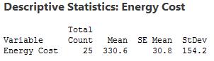

## THE NEED FOR HYPOTHESIS TESTS

Why do we even need hypothesis tests? After all, we took a random sample and our sample mean of 330.6 is different from 260. That is different, right? Unfortunately, the picture is muddied because we’re looking at a sample rather than the entire population.

Sampling error is the difference between a sample and the entire population. Thanks to sampling error, it’s entirely possible that while our sample mean is 330.6, the population mean could still be 260. Or, to put it another way, if we repeated the experiment, it’s possible that the second sample mean could be close to 260. A hypothesis test helps assess the likelihood of this possibility!

PLOT SAMPLING DISTRIBUTION TO SEE IF OUR SAMPLE MEAN IS UNLIKELY

For any given random sample, the mean of the sample almost certainly doesn’t equal the true mean of the population due to sampling error. For our example, it’s unlikely that the mean cost for the entire population is exactly 330.6. In fact, if we took multiple random samples of the same size from the same population, we could plot a distribution of the sample means.

A sampling distribution is the distribution of a statistic, such as the mean, that is obtained by repeatedly drawing a large number of samples from a specific population. This distribution allows you to determine the probability of obtaining the sample statistic.

Fortunately, I can create a plot of sample means without collecting many different random samples! Instead, I’ll create a probability distribution plot using the t-distribution, the sample size, and the variability in our sample to graph the sampling distribution.

Our goal is to determine whether our sample mean is significantly different from the null hypothesis mean. Therefore, we’ll use the graph to see whether our sample mean of 330.6 is unlikely assuming that the population mean is 260. The graph below shows the expected distribution of sample means.

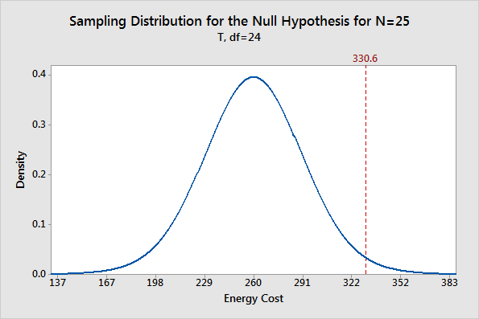

You can see that the most probable sample mean is 260, which makes sense because we’re assuming that the null hypothesis is true. However, there is a reasonable probability of obtaining a sample mean that ranges from 167 to 352, and even beyond! The takeaway from this graph is that while our sample mean of 330.6 is not the most probable, it’s also not outside the realm of possibility.

## THE ROLE OF HYPOTHESIS TESTS

We’ve placed our sample mean in the context of all possible sample means while assuming that the null hypothesis is true. Are these results statistically significant?

As you can see, there is no magic place on the distribution curve to make this determination. Instead, we have a continual decrease in the probability of obtaining sample means that are further from the null hypothesis value. Where do we draw the line?

This is where hypothesis tests are useful. A hypothesis test allows us quantify the probability that our sample mean is unusual.

# SAMPLE VS SAMPLING DISTRIBUTION

The sample distribution is the distribution of the observed values of a single sample. It’s sometimes called the empirical cumulative distribution function

Sampling distribution usually refers to the distribution of a statistic under repeated sampling from the population under study (e.g., sampling distribution of the mean).

A random sample is drawn from a population of similar items with a fixed objective. One computes different 'statistics ' from the sample, such as the average, variance, correlation, etc. to estimate certain characters of the population. Also, sometimes certain Test Statistics are computed, such as the 'Student's 't', Chi Square or F etc. for testing hypotheses about population characters.

By repeating or replicating the sampling, and computing the test statistics each time, these statistics behave as a variable and a distribution for it is generated. This distribution is known as the " sampling distribution" of the statistic.

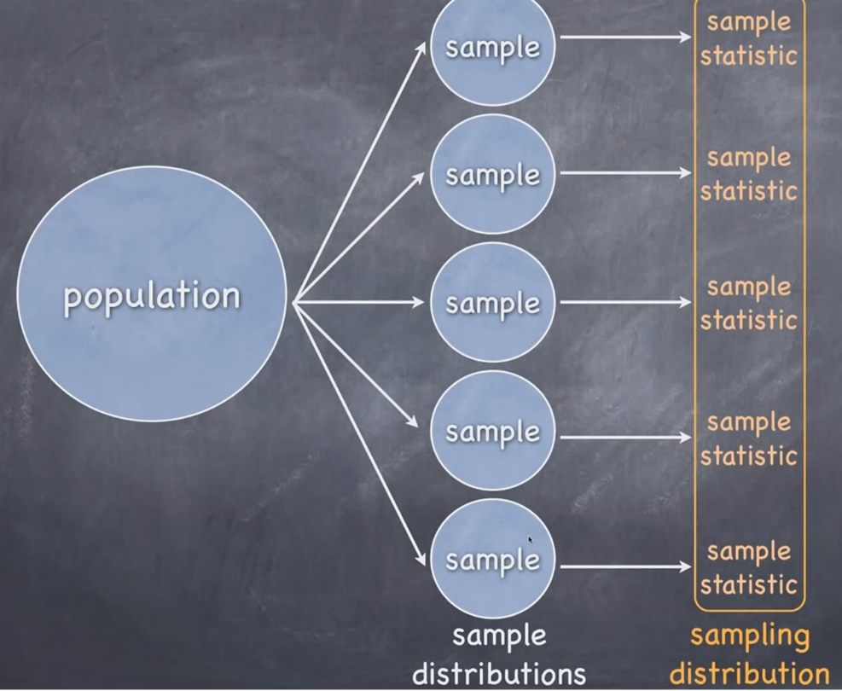

For example, let’s say we want to calculate average height of women’s in US. For this we will take a random sample of 1000 women’s and conduct our survey. Let say we do the survey in some states of US

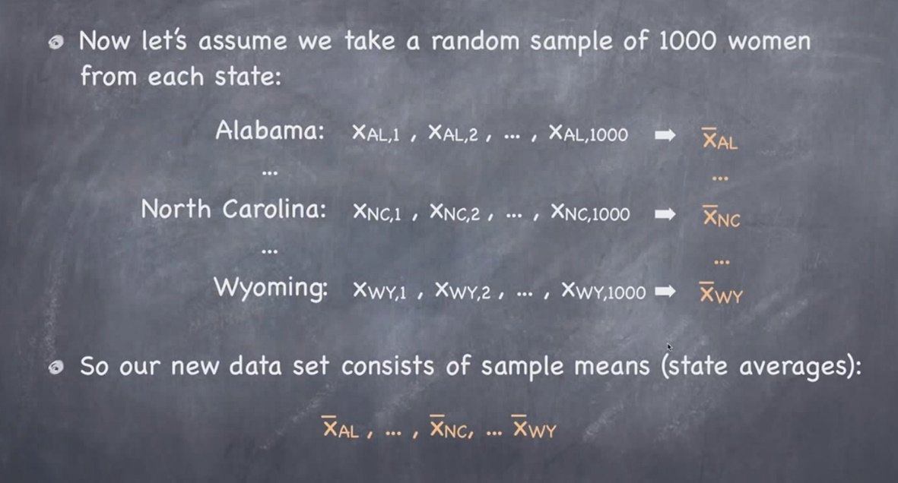

If we plot the data in sample XAL then it will be called sample distribution and if we plot XAL, XNC & XWY then it will be called sampling distribution.

Sample distribution vs sampling distribution

# DESCRIPTIVE STATS IN EXCEL